**Nillumbik Shire Council**

**State of Environment Report**

**2014**

Contents

Executive Summary 1

Biodiversity 1

Water 3

Energy and Greenhouse Emissions 3

Waste 4

Community Engagement 5

Council operations 5

Scorecard 7

Introduction 8

Environmental Sustainability Objectives and Targets 10

Roadside Management Plan 2012 10

Biodiversity Strategy 2012 10

Environmental Education Strategy 2012 11

Green Wedge Management Plan 2010-2025 11

Climate Change Action Plan 2010-2015 12

Rabbit Action Plan 2009 (under review) 13

Weed Action Plan 2008 (under review) 13

Integrated Water Management Plan 2013 14

Waste Services Statement 2015 15

1. Biodiversity 16

1.1. Pressures on our biodiversity 17

1.2. Condition of our biodiversity 17

1.3. Responding to Biodiversity 47

2. Water 48

2.1. Pressures on our Water 48

2.2. Condition of our Water 49

2.3. Responding to Water 53

3. Energy and Greenhouse Emissions 54

3.1. Pressures on our Energy Use 54

3.2. Condition of our Energy Use and Greenhouse Emissions 55

3.3. Responding to Energy Use 60

4. Waste 61

4.1. Pressures on Waste 62

4.2. Condition of our Waste 62

4.3. Responding to Waste Issues 66

5. Community Engagement 67

5.1. Pressures on our Community 67

5.2. Condition of our Community 68

5.3. Responding to Community 72

6. Council Operations 73

6.1. Pressures on our Council operations 73

6.2. Condition of Council operations 74

6.3. Responding to Council operations 94

7. Appendix 95

8. Glossary 102

# Executive Summary

In presenting this report, Council reasserts its desire and commitment to progress towards environmental sustainability for Nillumbik through the systematic implementation of Council’s adopted environmental sustainability action plans and strategies including the following.

• Environment Charter

• Roadside Management Plan 2012

• Biodiversity Strategy 2012

• Environmental Education Strategy 2012

• Ecologically Sustainable Development Policy 2012

• Green Wedge Management Plan 2010-2015

• Climate Change Action Plan 2010-2015 (under review)

• Rabbit Action Plan 2009 (under review)

• Weed Action Plan 2008 (under review)

• Integrated Water Management Plan 2013

• Waste Services Statement 2015.

The major findings in the State of Environment Report are summarised below and a scorecard is also provided for quick reference.

## Biodiversity

The Shire of Nillumbik contains 1031 indigenous flora species, 64 of which are listed as significant species. Many of these are delicate terrestrial orchids, including some not found anywhere else. Supporting and often relying upon these plants is an equally impressive array of 350 indigenous fauna species, 70 of which are listed as significant species including the distinctive Brush-tailed Phascogale, Lace Monitor, Common Dunnart, Eltham Copper Butterfly, Barking Owl and Powerful Owl. However, the Shire also contains 609 introduced flora species and 37 introduced fauna species.

A recent study *Nillumbik’s Sites of Significance* (Abzeco Ltd Pty) identified areas of core and low to moderate (buffer) habitat across the Shire. 51 Sites of Significance were recorded and 19,257 ha identified as ‘Core Habitat’ and 9,142 ha identified as ‘Low-moderate Habitat’.

During survey work undertaken as part of the Nillumbik Conservation Corridors project 35 new populations/ records of threatened species were recorded. Of particular interest was one new record of a Long-nosed Bandicoot, which was identified in Strathewen and is a species that had not been seen in the area since 1967.

After significant concern for the viability of the Eltham Copper Butterfly with very low numbers recorded between 2011 and 2013, survey results in 2014 are indicating a more positive trend with population numbers improving, however they are less than half of the 2006 records.

Land clearing continues to occur at a faster rate than revegetation. Although biodiversity projects and programs are protecting and improving components of the natural environment, the pressure of incremental loss of vegetation is significant. With the introduction of the Nillumbik Over-the-Counter Native Vegetation Offset Program it is anticipated that some of these losses will be offset within the Shire.

The significance of Council reserves is under constant threat from a range of processes such as weed invasion, predation by and competition with pest animals, pressure from residential development, altered fire regimes and habitat destruction. On an annual basis Council develops works programs for a number of these reserves including activities such as weed control, revegetation, fire prevention, trail maintenance, fencing and pest animal management to protect and enhance their biodiversity and community values.

The condition of waterways has varied little between 2004 and 2010, with the condition of waterways ranging from very poor to good. There has been an improvement in the health of the Yarra River moving from poor in 2004 to moderate in 2010.

Council has a broad range of responses to pressures on the state of the environment in Nillumbik, which includes the application of planning controls and local laws, the development and implementation of environmental strategies, as well as community education and engagement with the community in positive environmental action.

Overall engagement in biodiversity conservation programs is increasing with landowners engaged at a variety of levels from onground works, covenanting of land, detailed surveying and community-based initiatives through Landcare and Friends of Groups. The incremental loss of native vegetation remains a significant pressure on biodiversity in the Shire. These changes have been evident through the aerial photography modelling that has been completed. Whilst there is a downward trend in the removal of vegetation from 156.9 ha in the 2007-2009 period compared to 49 ha in the 2009-12, the amount of removal is still of concern.

## Water

Significant reductions have been made in both residential and non-residential water consumption in the Shire when compared to the baseline of 2000/01 with a 31 per cent reduction in residential water use and a nine per cent reduction in non-residential water use compared to 2013/14. However, although reductions in consumption have been made when compared to the baseline year of 2000/01, water use has increased from 2011/12 to 2013/14.

Yarra Valley Water attributes the increase in residential water consumption to the lifting of water restrictions following the drought. During 2011/12, Stage 1 water restrictions were still in place and were lifted in 2012/13. Yarra Valley Water also state that 2012/13 and 2013/14 were both hotter than the 30 year average and higher water usage would be associated with these weather patterns.

Performance and condition of septic tank systems in the Shire continues to be a pressure. In most instances complaints about septic tank systems has steadily increased over the last eight years. These systems were potentially causing harm to public health and/or the environment. Since the last reporting period 80 unsewered properties in Eltham North and Research were connected to the sewer by Yarra Valley Water, with North Warrandyte scheduled for 2015/16. There is a reduction over time in the number of septic systems being installed.

## Energy and Greenhouse Emissions

Despite population growth within the Shire, emissions from energy consumption have reduced by six per cent across the residential, commercial and industry sectors. The main drivers have been:

* The significant increase in the installation of rooftop solar and solar hot water systems across the Shire.
* Heightened awareness of new energy saving appliances and technology such as LED lighting.
* The price signal from retailers motivating consumers to adopt measures to reduce rising energy bills, especially electricity bills.
* The introduction of advanced meters and monitoring technologies to enable residents and businesses to readily monitor electricity usage.

A growing population and limited public transport is increasing our dependency on the car. The overall increase of 5.6 per cent in vehicle use reflects an increase in population as well as limited availability of public transport. The purchase of light commercial vehicles has increased by 10 per cent, most likely in response to marketing campaigns promoting utes as fashionable, and generous tax concessions.

Within Nillumbik there are 26km of regional trails and 24km of local trails exist as part of the shared trails network for commuter and recreational use. This is an increase of 13km or 35 per cent since 2013.

## Waste

The Resident Satisfaction Survey has shown that Council’s waste service is one of the top services they are most satisfied with and rate the importance of the kerbside collection as high. The current GRO kerbside service will continue to operate and contamination issues will continue to be addressed. Contamination of the green bin has shown some improvement, with the Shire wide bin inspections to continue. This program will also be adopted for the yellow recycling bin service to reduce high levels of contamination.

Overall there has been a decrease in the amount of waste tonnage collected each year despite an increase in households. There has been a slight improvement in the amount of contamination in green bins, but this remains an issue for both green and recycling bins. Council will continue to raise awareness through bin inspections and education programs.

Opportunities for increasing the recycling options at the Recycling and Recovery Centre will continue to be sought and expansion of the site will be incorporated into the master planning for the Operations Centre and Plenty Landfill.

## Community Engagement

Overall the data reflects a steady increase in community participation in a range of environmental education activities offered by Council. The school education program and attendance at Council events and festivals have provided a valuable learning opportunity for the community. Two new events, the Eltham Copper Butterfly Festival and the Open Farm Day, were successfully added to Council’s event program to broaden opportunities for wider community engagement.

Since the last State of Environment Report, an additional three Friends Groups have established and are actively providing valuable volunteer work in Nillumbik bushland reserves. The number of Landcare Groups has not changed since the last reporting period. Council has focused on working with the existing Landcare Groups to provide targeted action through the Nillumbik Landcare Network and Conservation Corridors Program.

Previous investment in educational publications has provided a strong suite of resources for reprint and distribution.

The increasing participation and engagement in environmental initiatives in Nillumbik is showing a positive trend. This positive trend in participation will hopefully lead to improvements in community water, energy use and biodiversity data in the long term.

## Council operations

Overall the data reveals a downwards trend in energy (electricity and gas) consumption for Council facilities and an upwards trend in water consumption since 2011/12. Electricity and gas consumption for Council sites was following an upwards trend until 2011/12 followed by a steady decline until 2013/14. This decline has been driven by a significant investment in energy efficiency projects and the installation of solar over the past couple of years.

During the same time period the focus on water efficiency projects has been lower. The implementation of the Integrated Water Management Plan has seen a couple of large stormwater harvesting and treatment projects implemented including the Hurstbridge Wetlands and Civic Drive Precinct project. These projects primarily deliver water quality benefits, although the wetlands and lake at Hurstbridge also provide alternatives to potable water for sports ground irrigation.

A Utilities Billing Management System introduced in 2014 will allow Council to monitor and analyse electricity, gas and water consumption, identify anomalies in the billing cycle and enable a coordinated approach across the organisation. This will ensure that Council can stay on top of issues such as leaks and billing errors. It will also enable the analysis of building usage patterns, so that the choice and management of equipment and fittings can be more efficient.

There have been a number of changes to Council’s fleet since 2012 including replacement of the waste vehicle fleet and the purchase of an additional sweeper. The biggest change is in the use of unleaded fuel.

## Scorecard

The following Scorecard indicates at a glance how things are progressing.

***Status:***  ☺ Positive 😐 Neutral ☹ Negative

***Trend:*** + Improving 0 no change - Declining

|  |  |  |
| --- | --- | --- |
| **Biodiversity** | | |
| ***Status*** | ***Trend*** | ***Indicator*** |
| ☺ | 0 | No identified loss of species. |
| 😐 | + | Eltham Copper Butterfly numbers were in decline, but now recovering. |
| ☺ | + | 63 new occurrences of 19 threatened species. |
| ☺ | + | First record of Long-nosed Bandicoot in Strathewen area since 1967. |
| ☹ | + | Amount of native vegetation removed has declined but still 49 ha lost in the 2009-2012 period. |
| ☺ | + | Community engagement in biodiversity programs is increasing. |
| ☺ | + | Three new Friends of groups have started since 2012. |
| **Water** | | |
| ☺ | - | 31% reduction in residential water use since 2000/01, but has increased since 2011/12. |
| ☺ | - | 9% reduction in non-residential water use since 2000/01, but has increased since 2011/12. |
| ☺ | + | 155 properties with new access to sewer in Eltham North and Research and commencement of works in North Warrandyte to provide access to a further 1,050 properties. |
| ☹ | - | By 2011/12 a 65% reduction in Council water use from a 2001 baseline was achieved, which exceeded the target by 20%. Council water use has now increased by 45% since 2012/13. |
| ☺ | + | Stormwater harvesting and recycling capacity was increased through construction of the Hurstbridge wetland in 2014, which will save an estimated 7ML of potable water per year. |
| **Energy and Greenhouse Emissions** | | |
| ☺ | + | 6% reduction in community greenhouse emissions. |
| ☺ | + | 2,561 solar panel systems installed in Nillumbik. |
| ☺ | + | 21 solar panel systems installed by Council. |
| ☹ | + | Council’s electricity consumption increased from 2007/08 to 2011/12 by 13.45% but this had been reduced to a 4.3% increase by 2013/14. |
| ☹ | + | The target for a 20% reduction in energy consumption by 2015 compared to 2006 levels was not achieved. However, there has been a 4% reduction in Council electricity consumption and 5% reduction in Council gas consumption over the year to June 2014. This has resulted in a 3.7% reduction in Council greenhouse gas emissions over that year. |
| ☺ | 0 | 100 per cent accredited offsets are purchased for building energy use offsets each year. |
| ☹ | - | Council’s fleet emissions increased 4.5% in the year to June 2014. |
| **Waste** | | |
| ☺ | + | Garbage collected is down 6.5% since 2010-11. |
| ☺ | 0 | 63.4% of waste is being diverted from landfill assuming all green bin material is processed. |

# Introduction

This is the second State of Environment Report prepared by Nillumbik Shire Council.

The State of Environment (SoE) Report provides a snapshot of the condition of the environment, pressures impacting upon the environment and the response by Council to address these pressures.

The SoE Report helps Council to understand its current position, the direction Council is heading, and how far Council is from where it would like to be. By analysing these trends, Council can focus its resources to reduce further environmental deterioration and hopefully reverse it, assess how useful the current efforts are in protecting our environment, and help guide distribution of resources in the future.

This SoE Report documents Council’s progress during the period of 1 January 2012 to 31 December 2014 towards implementing the Nillumbik Environment Charter. The Report addresses the priority environmental sustainability themes of:

1. **Biodiversity**
2. **Water**
3. **Energy and Greenhouse Emissions**
4. **Waste**
5. **Community**
6. **Council operations**

For each environmental sustainability theme, this Report provides statements outlining condition (using the state, pressure and response model), environmental indicators and a comparison with previous data to identify trends.

The Nillumbik Environment Charter states that “Council is committed to enhancing biodiversity, encouraging sustainable built form, reducing our environmental impact and continuing education around environmental sustainability”. Council has a number of related environmental sustainability action plans that identify how to put the above commitment into action. These Action Plans are listed below and the main objectives and/or targets of these plans relevant to environmental sustainability are provided on the following pages.

* Roadside Management Plan 2012
* Biodiversity Strategy 2012
* Environmental Education Strategy 2012
* Green Wedge Management Plan 2010-2025
* Climate Change Action Plan 2010-2015 (under review)
* Rabbit Action Plan 2009 (under review)
* Weed Action Plan 2008 (under review)
* Integrated Water Management Plan 2013
* Waste Services Statement 2015

# Environmental Sustainability Objectives and Targets

### Roadside Management Plan 2012

| **The objectives of the Roadside Management Plan are to guide maintenance and construction techniques and planning decisions which may impact roadsides to:** |
| --- |
| * Ensure the safe and effective function of roadways. |
| * Protect service assets located on roadsides. |
| * Minimise the risk and impact of fire. |
| * Protect, maintain and enhance the diversity of indigenous vegetation, particularly significant species and habitat corridors for wildlife. |
| * Prevent further land degradation and erosion on roadsides and improve water quality. |
| * Maintain and enhance the visual amenity and landscape quality of the roadside. |
| * Recognise the importance of roadside trails for recreational opportunities. |
| * Protect the cultural and heritage values of the roadside. |
| * Prevent the further spread of weeds and soil-borne disease organisms. |

### Biodiversity Strategy 2012

| **Nillumbik’s ecosystems are healthy, resilient, productive and connected at a landscape-scale for the future.** |
| --- |
| * Improve monitoring, knowledge and information relating to significant species, communities and ecological processes. |
| * Conserve, maintain and enhance ecosystem services and processes. |
| * Improve decision-making and target investments to conserve biodiversity. |
| * Create a consistent and practical response to fire management and biodiversity recovery after bushfire. |
| * Support the community to take action to protect and enhance biodiversity. |

### Environmental Education Strategy 2012

| **Empowering our communities through environmental education to take action for a sustainable future.** |
| --- |
| * Develop, promote and deliver innovative and targeted environmental education programs. |
| * Achieve community awareness of ecological sustainability and increase skills and knowledge to enable the community to live sustainably. |
| * Implement a coordinated and integrated approach to environmental education program development and delivery across Council. |
| * Foster strong relationships that encourage wide community participation and dialogue. |

### Green Wedge Management Plan 2010-2025

| **In 2030, management of the Nillumbik Green Wedge will lead the way in economic, environmental and social sustainability.** |
| --- |
| * Conserve and enhance the natural values, landscapes and cultural heritage of the Nillumbik Green Wedge. |
| * Increase local and wider community understanding and enjoyment of the special nature of the Nillumbik Green Wedge. |
| * Maintain strong, connected and diverse communities. |
| * Achieve a diverse economic base in the Nillumbik Green Wedge that helps local communities to thrive, but does not impact negatively on natural and cultural values, or on the valued character of towns, settlements and landscapes. |
| * Minimise bushfire risk to human life. |
| * Involve communities and other stakeholders in delivering the Green Wedge Management Plan. |
| * Deliver the Green Wedge Management Plan and future actions in keeping with the guiding principles. |

### Climate Change Action Plan 2010-2015

| **Council’s operations:** |
| --- |
| * Achieve a 20 per cent reduction in building, electricity and gas consumption by 2015 compared to 2006 levels. |
| * Achieve a 20 per cent reduction in vehicle and plant fleet emissions by 2015 compared to 2006 levels. |
| * Achieve a 70 per cent reduction in street lighting energy consumption by 2015 compared to 2006 levels. |
| * Purchase 100 per cent accredited offsets for building use each year. |
| * Purchase 100 per cent accredited offsets for public lighting energy consumption from 2015 onwards. |
| * Establish offsets for all vehicle fleet fuel use from 2015 onwards. |
| * Develop and implement a Climate Change Adaptation Plan. |

| **Community:** |
| --- |
| * Achieve a 15 per cent increase from 2006 in renewable energy installations (e.g. solar hot water, photovoltaic systems) across our community by 2011, to be undertaken independently or through partnerships with other Councils. |
| * Help 100 homes or businesses have energy efficient operations, starting in 2010. |
| * Help establish and sustain the Walking School Bus at 12 local schools by 2015. |
| * Achieve 50 new developments committed to the STEPS/SDS sustainable development program. |
| * Implement programs to educate, inform and empower the community to make changes in their homes and neighbourhoods and influence political decision makers. |
| * Provide ongoing advocacy to the state and federal governments regarding issues relating to the community energy use sector. |

### Rabbit Action Plan 2009 (under review)

| **To achieve effective rabbit control in Nillumbik in order to protect areas of high biodiversity, productive agricultural land and community facilities under threat of damage by rabbits.** |
| --- |
| * To reduce the impact of rabbits on high value biodiversity, agricultural and community assets. |
| * To achieve community awareness of the rabbit problem and increase skills and knowledge to enable the community to undertake effective rabbit control. |
| * To foster cooperative rabbit control across property boundaries. |
| * To better understand the rabbit problem in Nillumbik and achieve continuous improvement in rabbit management. |

### Weed Action Plan 2008 (under review)

| **To reduce the risk of new weed species to Victoria establishing in Nillumbik:** |
| --- |
| * Facilitate a prompt response to new weed species. |
| **To achieve a significant reduction in the impact of existing weed problems on natural and other assets:** |
| * Establish and implement a systematic asset protection approach for weed management. |
| **To have a community aware of the threat of weeds, and able to act to control their spread:** |
| * Undertake community education about weeds and their management. * Support landholders to undertake weed management on their properties. |
| **To establish and maintain effective working partnerships for progressive weed management:** |
| * Maintain partnership between Council and landholders/ land managers. * Maintain partnerships between Council and community groups and volunteers. * Maintain partnerships between Council and industry. * Maintain partnerships between Council and public agencies. |

| **To achieve continuous improvement in weed management throughout Nillumbik:** |
| --- |
| * Review and update local weed lists. * Improve reporting and recording systems. * Ensure adequate resourcing for weed management. * Utilise best practice in operations. * Improve Council’s enforcement capabilities. |

### Integrated Water Management Plan 2013

| **Water security** |
| --- |
| The 2025 target for provision of alternative water to supply non-potable demands is:   * an increase of 7.5 ML/yr of stormwater used to supply non-potable demands across Council assets * an increase of 10 ML/yr of stormwater used across the private domain. |
| **Water quality** |
| A 45 per cent Best Practice target for stormwater quality by 2025. This equates to a reduction in:   * Total Suspended Solids (TSS) of 153,000 kg * Total Phosphorus (TP) by 200 kg * Total Nitrogen (TN) by 810 kg. |
| **Flow management targets** |
| **Diamond Creek catchment**   * Actively disconnecting impervious surfaces to achieve directly connected impervious surfaces of less than 2 per cent. |
| **Watsons Creek and Arthurs Creek catchments**   * No increase in directly connected impervious surfaces per cent. |
| **Plenty River and Yarra River catchments**   * No increase in directly connected impervious surfaces per cent. |

### Waste Services Statement 2015

| **Purpose** |
| --- |
| * The purpose of the Waste Service Statement is to provide a comprehensive overview of Council’s waste management arrangements including the legislative policy and context, a description of the services provided and identification of trends, issues and options in the delivery of services for the future. |

# Biodiversity

Biodiversity is the variety of all life forms - the different plants, animals and micro-organisms, the genes they contain and the ecosystems in which they live. Biodiversity underpins the ecological processes which make life on Earth possible, such as the provision of fresh air, clean water, nutrients and pollination of plants. It provides medicines, fertile soils and food, as well as recreational opportunities and cultural identity.

The Biodiversity section covers:

* Biodiversity Conservation.
* Roadsides Vegetation Conservation.
* Soils and Sustainable Agriculture.
* Waterway Health.

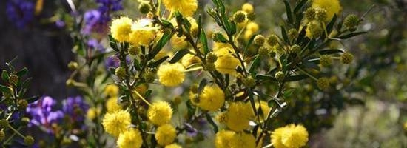

## Pressures on our biodiversity

Key localised pressures include:

* Increasing residential development pressure.
* Habitat destruction, modification and fragmentation.
* Agricultural land use.
* Environmental weeds.
* Climate change.
* Altered fire regimes.
* Exotic fauna.
* Soil compaction.
* Pathogens.
* Lack of understanding about ecological processes.
* Encroachment into areas of conservation significance.
* Altered water quality and flows.

## Condition of our biodiversity

The Shire of Nillumbik contains 1031 indigenous flora species, 64 of which are listed as significant species. Many of these are delicate terrestrial orchids, including some not found anywhere else. Supporting and often relying upon these plants is an equally impressive array of 350 indigenous fauna species, 70 of which are listed as significant species including the distinctive Bush-tailed Phascogale, Lace Monitor, Common Dunnart, Eltham Copper Butterfly, Barking Owl and Powerful Owl. However, the Shire also contains 609 introduced flora species and 37 introduced fauna species.

### Biodiversity conservation

**Per centage of intact vegetation by land tenure in Nillumbik**

The Department of Environment, Land, Water and Planning (DELWP) have assessed native vegetation across land tenure in Nillumbik using their modelled Native Vegetation Extent layer. Approximately 30,000 ha of remnant native vegetation still remains within the Shire, with the largest portion of intact vegetation on private land. Figure 1 provides the percentage of intact vegetation by land tenure in Nillumbik.

**Figure 1 – Percentage of intact vegetation by land tenure**

*Source: Department of Environment, Land, Water and Planning, Native Vegetation Extent model, Feb 2013*

**Conservation status Ecological Vegetation Classes**

In Victoria, native vegetation is classified according to Ecological Vegetation Classes (EVC). Each EVC has a Bioregional Conservation Status according to the degree of depletion in its extent and/or quality (refer to Figure 2). DELWP (then the Department of Sustainability and Environment) revised and updated the Bioregional Conservation Status of EVCs in November 2007 following revised native vegetation mapping.

EVC mapping shows approximately 46 per cent of the Shire (19,686 ha) supports remnant native vegetation of varying condition. The main EVCs in the Shire are:

* Grassy Dry Forest (least concern)
* Valley Grassy Forest (vulnerable)
* Heathy Dry Forest (least concern)
* Herb-rich Foothill Forest (least concern).

Although most of these classes are listed as least concern (as greater than 50 precent pre-European extent remains and subject to little to no degradation over a majority of this area), much of the Grassy Dry Forest within the Shire is of the Box-stringybark Woodland floristic community, which is regionally vulnerable to endangered. Small areas of other EVCs also exist in the Shire including:

* Box-Ironbark Forest (vulnerable)
* Gully Woodland (vulnerable)
* Riparian Forest (vulnerable)
* Plains Grassy Woodland (endangered)
* Creekline Herb-rich Woodland (endangered)
* Swampy Riparian Complex (endangered).

The Conservation Status for the Shire has not been updated since the last report. DELWP are currently doing a review of the Ecological Vegetation Classes (EVCs), which is due to be finalised in 2015.

**Figure 2 - Conservation Status of EVCs in Nillumbik (ha)**

**173 Agreement & Trust for Nature covenants**

A Trust for Nature (TfN) conservation covenant is a permanent, legally-binding agreement placed on a property's title to ensure native plants and wildlife on the property are protected forever. The agreement is voluntary, negotiated between Trust for Nature and each individual landowner. This is sometimes used as a planning permit requirement; however landowners can and do apply for this status on their land to protect these values into the long-term.

A Section 173 Agreement is a legal agreement made between Council and another party or parties, under Section 173 of the Planning and Environment Act (1987). A landowner is normally the other party to the Agreement, while in some cases a third party, such as a Referral Authority may also be involved. The legal agreement is predominately used to provide legal security to land management works as part of a planning permit.

A total of 101 Section 173 Agreements were registered between 1 January 2012 and 31 December 2014 and to date approximately 4,556 ha of land are covered by a Section 173 Agreement.

There are a total of 50 TfN conservation covenants in Nillumbik covering 431.67 ha.

There were 4 new TfN conservation covenants registered on title in the 2012-2014 calendar year periods covering 63.75 ha.

**Nillumbik Sites of Significance**

In 2014, Abzeco Pty Ltd, prepared the *Nillumbik Sites of Significance Review* on behalf of Council. The study assessed areas of significance as having core habitat or low-moderate (buffer) habitat. These areas are defined as:

* Core habitat: areas supporting a high cover and diversity of relatively ‘intact’ remnant indigenous vegetation. Core habitat areas are considered likely to be relied upon or are known to support species listed as rare or threatened in the region, have a high species richness and, as such, support the most significant stands of vegetation and fauna habitat in the Shire.
* Low-moderate (buffer) habitat: areas of low-moderate habitat often occur in association with areas of core habitat and in these instances are best described as buffer habitat. Buffer habitat may be an integral component of a Biolink and as such is likely to have considered a high priority for restoration efforts to maintain and improve habitat quality and connectivity.

Figure 3 shows geographically the areas of core and low to moderate (buffer) habitat across the Shire. The map shows a total of:

* 51 Sites of Significance.
* 19,257 ha identified as ‘Core Habitat’ and 9,142 ha identified as ‘Low-moderate Habitat’.

Council has some concern that the mapping of sites of significance at the State level is more generalised than that revealed by more intensive studies undertaken at the local level by Council’s consultants. This has somewhat undervalued some of the sites found in Nillumbik in the State biodiversity mapping system.

**Figure 3 –Core and Low-moderate (buffer) Habitat**

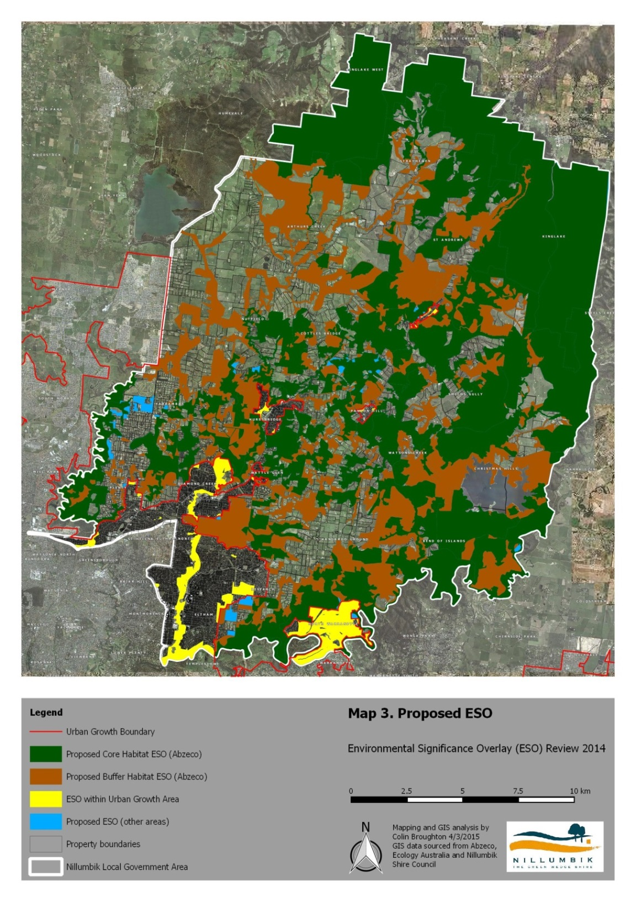

**Threatened species**

There are 19 nationally threatened species, 22 migratory species and 1 threatened ecological community listed for protection under the Environment Protection and Biodiversity Conservation Act 1999 (EPBC Act). Of the EPBC Act listed species found within the Shire, 6 flora species and 3 fauna species, have National Recovery Plans (source – [Department of Environment](http://www.environment.gov.au/cgi-bin/sprat/public/sprat.pl) species profiles and threats database).

There are also 52 species listed under the Flora and Fauna Guarantee Act 1998 (FFG Act) and 132 listed by DELWP as rare or threatened in Victoria, all of which have been identified as resident or reliant upon habitats that occur within the Shire. A total of 4 FFG Act listed flora species and 19 FFG Act listed fauna species have approved Action Statements (source – Department of Environment Land, Water and Planning [website](http://www.dse.vic.gov.au/)).

Tables 1 and 2 indicate the breakdown by category of species under the FFG Act and EPBC Act.

**Table 1 - Number of FFG listed, Critically Endangered, Endangered, Vulnerable, Near Threatened and Data Deficient Flora (vertebrate and invertebrate) species in Nillumbik**

|  |  |  |
| --- | --- | --- |
| **Victorian Advisory List of Rare or Threatened Flora found in Nillumbik** | | |
| **Category** | **Code** | **Number of sp. in Nillumbik** |
| Endangered | e | 8 |
| Vulnerable | v | 8 |
| Rare | r | 30 |
| Poorly Known | k | 17 |
| **Total** |  | **63** |
| **FFG Act listed flora species** | L | 7 |
|  |  |  |
| **EPBC Act listed flora species found in Nillumbik** | | |
| **Category** | **Code** |  |
| Critically Endangered | CE | 1 |
| Endangered | E | 4 |
| Vulnerable | VU | 3 |
| **Total** |  | **8** |
| **Total number of listed significant flora species in Nillumbik** | | **64** |

**Table 2 - Number of FFG listed, Critically Endangered, Endangered, Vulnerable, Near Threatened and Data Deficient Fauna (vertebrate and invertebrate) species in Nillumbik**

|  |  |  |
| --- | --- | --- |
| **Victorian Advisory List of Rare or Threatened Fauna found in Nillumbik** | | |
| **Category** | **Code** | **Number of sp. in Nillumbik** |
| Critically Endangered | cr | 2 |
| Endangered | e | 18 |
| Vulnerable | v | 28 |
| Regionally Extinct | rx | 1 |
| Near Threatened | nt | 18 |
| Data deficient | dd | 2 |
| **Total** |  | **69** |
| **FFG Act listed fauna species** | L | 45 |
|  |  |  |
| **EPBC Act listed fauna species found in Nillumbik** | | |
| **Category** | **Code** |  |
| Endangered | E | 5 |
| Vulnerable | V | 6 |
| **Total** |  | **11** |
| **Total number of listed significant fauna species in Nillumbik** | | **70** |

There has been no change to the data outlined in Table 1 and Table 2, since the last report.

Table 40 and 41 in the Appendix provides a full list of species listed under each category.

**Eltham Copper Butterfly**

The area around Eltham supports the largest of the few remaining populations of the threatened Eltham Copper Butterfly (ECB) in Victoria. Following the rediscovery of the ECB in the Eltham area in 1987, the ECB was listed as threatened under the Flora and Fauna Guarantee Act (1988) in May 1991. The early work undertaken by the local community to ensure the protection of the ECB and its habitat is a remarkable story now very much embedded in the social, cultural and natural heritage and identity of the Eltham community.

In 2010, monitoring of ECB larvae indicated that populations of the butterfly had plummeted to dangerously low levels. The reasons for the sudden change in the circumstances of the ECB were unclear but appeared to be related to the interaction of:

* Climate events (a sustained period of drought over several years, followed by higher than average rainfall), leading to a significant over-growth of vegetation at ECB sites.
* The long term impacts of an ecological burn at two of the major sites which did not have an appropriate level of follow-up vegetation management.

In 2012, the Friends of the ECB in partnership with Nillumbik Shire Council, Parks Victoria, the Friends of Diosma Road, the Friends of Woodridge Linear Reserve and Eltham East Primary School were successful in obtaining a grant from the Department of Sustainability and Environment of $459,000 over a four year period to undertake a range of works to protect and enhance the habitat of this significant species. The *Back from the Brink – a Recovery Project for the Eltham Copper Butterfly* project adopted an approach of on-ground works, monitoring and community engagement.

Larvae surveys undertaken in October and November 2014 have demonstrated an increase in the number of larvae of the ECB. From 2012 to 2014, ECB larvae counts at the Western ECB Reserve increased from 8 to 94, and at the Eastern ECB Reserve they increased from 17 in 2012, 4 in 2013 to 45 in 2014.

Figures 4 and 5 show the larvae count results for the Eastern and Western Eltham Copper Butterfly Reserves.

**Figure 4 – Western ECB Reserve larvae count results**

**Figure 5 – Eastern ECB Reserve larvae count results**

**Threatened species recovery**

Nillumbik’s Conservation Corridors project seeks to engage the local community through activities that foster a sense of connection, understanding and appreciation for natural areas and is driven by a collaboration of 9 of Nillumbik’s Landcare Groups and Nillumbik Shire Council, as well as Melbourne Water, Parks Victoria, Port Phillip and Westernport Catchment Management Authority(CMA), Urban Fringe Weed Management Initiative project, Royal Botanic Gardens (Melbourne) and Australasian Native Orchid Society. It specifically focuses on management works to promote the protection and improvement of habitat for rare and threatened species. To date, approximately 200 property owners have been involved in various aspects of the project. Works to protect threatened species range from weed control, pest animal control, specific management for the protection of orchids, fencing to reduce grazing pressure, flora and fauna surveys, training and workshops, nest box construction and the preparation of education material. In the 2012-2014 period this has consisted of 405 volunteer days, 368 project manager days and 204 contractor days to achieve the following works:

* 75 properties have been involved in rabbit control across 322 ha consisting of 93 contractor hours on 46 properties and 340 volunteer hours on 29 properties.
* 1392 contractor hours for high threat weed control across 45 properties, 537 hours for physical removal of weeds consisting of 181 contractor hours and 356 volunteer hours.
* 240 hours of specific management for the protection of orchids.
* 2531 plants for revegetation across two sites in Panton Hill and direct seeding revegetation of a 2 ha area in Arthurs Creek to connect key areas.

In addition to these works, in the 2012-2014 period:

* 45 landowners were involved in biodiversity surveys with 28 completed in 2014 and 17 to be completed in 2015.
* During these surveys 35 new populations/records of threatened species were recorded. This consisted of:
  + 1 new population of Clover Glycine
  + 4 new populations of Wine-lipped Spider-orchid
  + 1 new population of Crimson Spider Orchid
  + 1 new population of Arching Flax-lily
  + 4 new populations Pale Flower Crane’s-bill
  + 2 new records of Brush-tailed Phascogale
  + 1 new record of Lace Monitor
  + 1 new population Slender-tick Trefoil
  + 1 new population of Emerald-lip Greenhood
  + 1 new population of Large-leaf Cinnamon Wattle
  + 3 new populations of Floodplain Fireweed
  + 1 new population of Dandenong Ranges Cinnamon Wattle
  + 1 new population of Mountain Flat-pea
  + 1 new population of Matted Flax-lily
  + 1 new population of Valley Crane’s-bill
  + 4 new populations of Slender Stylewort
  + 5 new populations of Velvet Apple-berry.

Fauna monitoring surveys using motion sensing cameras were also conducted to assist landholders to better understand the fauna values of their properties and to identify areas that supported a key threatened species in the Shire, the Brush-tailed Phascogale. A total of 116 properties were involved in the surveys spanning an area of 1561 ha. During these surveys:

* 26 new records of Brush-tailed Phascogales were identified
* 1 new record of Common Dunnart was identified
* 1 new record of a Long-nosed Bandicoot was also identified in Strathewen, a species that had not been seen in the area since 1967.

Note these figures do not include survey work completed by Parks Victoria.

In association with the Royal Botanic Gardens and Australasian Native Orchid Society, the project is also propagating four threatened orchid species; the Rosella Spider Orchid, Wine-lipped Spider Orchid, Woodland Plume Orchid and Emerald-lip Greenhood. To date, germination of all four species has been successful in the laboratory and it is anticipated that a good number of seedlings for each species will be available for revegetation.

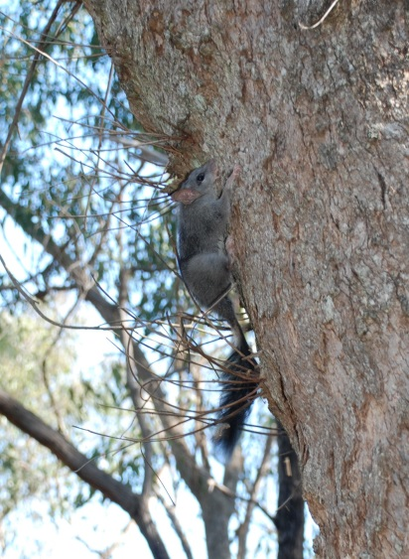

Brush-tailed Phascogale

*(Phascogale tapoatafa tapoatafa)*

**Native Vegetation Removal**

In 2011, Council undertook aerial photography interpretation to compare the difference in cover of native vegetation between 2007 and 2009 across the Shire. A similar assessment for the periods between 2009 and 2012 has now been completed using aerial photography (the 2012 aerial photos were the most recent at the time of the analysis). The following was mapped:

* The amount of detectable native vegetation removal.
* The amount of detectable exotic vegetation removal.
* The amount of detectable revegetation and the amount of detectable regeneration.

The information on exotic vegetation, revegetation and regeneration is a new indicator.

Between 2007 and 2009, within Nillumbik Shire:

* 156.9 ha of native vegetation was lost to clearing or development (with and without an approved planning permit). This occurred across 545 properties.
* Approximately 68.8 ha of vegetation was lost to unauthorised clearing (without an approved planning permit).

Between 2009 and 2012, within Nillumbik Shire:

* 49 ha of native vegetation was lost to clearing or development (with and without an approved planning permit) across 1,206 properties
* Approximately 28 ha of vegetation was lost due to unauthorised clearing (without an approved planning permit).

The aerial photography was completed in:

* April 2007
* October and November 2009
* October 2012.

**Table 3 - Area of approved and non-approved native vegetation removal between 2007 and 2012**

| **Permit status** | **Native vegetation removal (ha) 2007 – 2009** | **Native vegetation removal (ha)  2009 – 2012** | **% Change from 2007/09 – 2009/12** |
| --- | --- | --- | --- |
| Approved | 82.26 | 14.3 | -83% |
| Exempt | 5.81 | 5.0 | -14% |
| Not approved/no permit issued | 68.83 | 28.1 | -59% |
| Road reserve - permit status unknown | N/A | 1.6 | n/a |
| **Total:** | **156.9** | **49** | **-69%** |

This is a significant change in the amount of native vegetation that had been cleared during the two time periods, with considerably less in the latter period. However, the number of properties where vegetation clearance has occurred is significantly higher in 2009-12 (1,206) than in 2007 – 2009 (545). Approximately 50 per cent of the properties where clearance occurred between 2009-2012 fall within the urban parts of the Shire (Eltham, Eltham North, Diamond Creek and Greensborough).

One of the reasons for this large difference in the amount of vegetation clearance can be attributed to the response to the impact of the 2009 Black Saturday bushfires which was picked up in the 2007-2009 vegetation clearance study. Immediately following the bushfire there was significant clearance of burnt vegetation which was recorded as vegetation clearance.

**Table 4 – Total area of native vegetation removal between 2009 and 2012 by suburb**

| **Locality** | **Number of properties** | **Native vegetation removal Area (ha) 2009-2012** |
| --- | --- | --- |
| Arthurs Creek | 11 | 0.6 ha |
| Bend Of Islands | 11 | 1.2 ha |
| Christmas Hills | 21 | 5.6 ha |
| Cottles Bridge | 8 | 1.1 ha |
| Diamond Creek | 174 | 7.6 ha |
| Doreen | 11 | 0.5 ha |
| Eltham | 334 | 5.2 ha |
| Eltham North | 39 | 0.4 ha |
| Greensborough | 94 | 0.5 ha |
| Hurstbridge | 46 | 0.7 ha |
| Kangaroo Ground | 70 | 8.6 ha |
| North Warrandyte | 78 | 1.6 ha |
| Nutfield | 7 | 0.3 ha |
| Panton Hill | 19 | 1.6 ha |
| Plenty | 98 | 4.3 ha |
| Research | 53 | 1.0 ha |
| Smiths Gully | 5 | 0.1 ha |
| St Andrews | 33 | 2.8 ha |
| Strathewen | 23 | 2.5 ha |
| Watsons Creek | 6 | 0.2 ha |
| Wattle Glen | 31 | 0.9 ha |
| Yarrambat | 34 | 1.8 ha |
| **Total** | **1206** | **49.0 ha** |

As was the case in the 2007-2009 study, Grassy Dry Forest (21.3 ha), Valley Grassy Forest (12.7 ha) and Herb-rich Foothill Forest (5.8 ha) Ecological Vegetation Classes had the highest rate of clearance between 2009-2012.

**Figure 6 - Area (ha) of each Ecological Vegetation Classes (EVC) removed between 2009 and 2012**

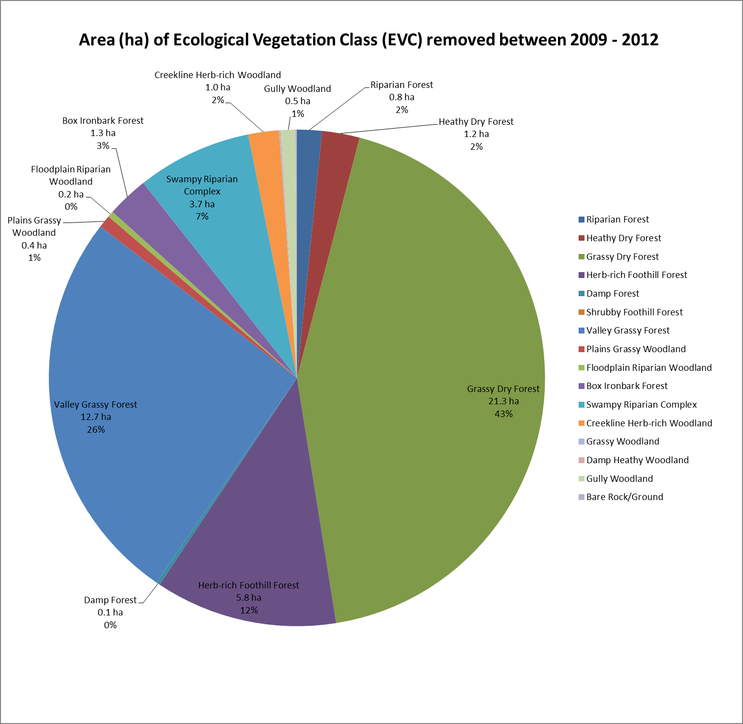

**Table 5 - Area (ha) of each Ecological Vegetation Classes (EVC) removed between 2009 and 2012**

| **Ecological Vegetation Class** | **Conservation Status** | **Area removed (ha)** |
| --- | --- | --- |
| Box-Ironbark Forest | Vulnerable | 1.3 |
| Creekline Herb-rich Woodland | Endangered | 1.0 |
| Damp Forest | Least concern | 0.1 |
| Floodplain Riparian Woodland | Endangered | 0.2 |
| Grassy Dry Forest | Least concern | 21.3 |
| Gully Woodland | Vulnerable | 0.5 |
| Heathy Dry Forest | Least concern | 1.2 |
| Herb-rich Foothill Forest | Least concern | 5.8 |
| Plains Grassy Woodland | Endangered | 0.4 |
| Riparian Forest | Vulnerable | 0.8 |
| Swampy Riparian Complex | Endangered | 3.7 |
| Valley Grassy Forest | Vulnerable | 12.7 |

**Permitted vegetation clearance**

For the 2014 calendar year the following permitted clearance under the Nillumbik Planning Scheme, Clause 52.17 was approved:

* 27 permits issued with offsetting conditions.
* 17.92 ha of native vegetation permitted for removal.

**Extent of vegetation removed**

The relevant provisions relating to vegetation clearance covered in Clause 52.17 of the Planning Scheme changed in December 2013, as such 2014 was the first calendar year of its application.

Table 6 outlines the vegetation removal recorded during this period. Please note that areas of native vegetation and scattered trees are dealt with separately under the Planning Scheme.

**Table 6 – Total area of permitted native vegetation removal 2014 under Clause 52.17**

|  | **Hectares (ha)** | **Number of scattered trees** |
| --- | --- | --- |
| **Private land (23 permits)** | 8.08 | 117 |
| **Roadsides/ public land** | 0.40 | 16 |
| **Total trees** | **N/A** | **133 trees** |
| **Subtotal (ha)** | **8.48 ha** | **9.44 ha**\* |
| **Total(ha)** | **17.92 ha** | |

*Note: the standard extent for a scattered tree is 0.071 ha (source: DELWP).

Most of the clearing that occurred on private land during this period was in response to applications seeking new dwellings, dwelling extensions and associated works. The scattered trees tally for private land was mostly associated with the removal of individual trees for building works or because they were considered hazardous.

**Condition of vegetation removed**

The condition of vegetation removed varied considerably across the area. Table 7 summarises the condition score and extent of vegetation removed.

**Table 7 – Condition score and extent of vegetation removed 2014**

| **Condition score** | **Patches of vegetation (ha)** | **Scattered trees (number)** |
| --- | --- | --- |
| **0-0.2** | 2.04 | 61 |
| **0.2-0.4** | 0.65 | 3 |
| **0.4-0.6** | 1.88 | 8 |
| **0.6-0.8** | 3.91 | 61 |
| **0.8-1.0** | 0 | 0 |

The Condition score is based on DELWP modelling or field assessments (source DELWP Biodiversity Interactive Mapper) where applicable. The score ranges from 0 for the lowest quality to 1.0 for the best. The default condition score for scattered trees is 0.2 which accounts for the relatively high number of scattered trees in the lowest bracket.

The majority of vegetation losses, 5.79 ha and 69 trees were lost in areas with a condition score of between 0.4-0.8. No vegetation losses were recorded from areas considered to be in the best condition.

**Offsetting**

The permitted removal of native vegetation requires offsetting which is the protection and management (including revegetation) of native vegetation at a site to generate a gain in the contribution that native vegetation makes to Victoria’s biodiversity. An offset is used to compensate for the loss to Victoria’s biodiversity from the removal of native vegetation. Offsets may be classed as “general” or “specific”.

General offsets are required when a proposal to remove native vegetation is not deemed to have a significant impact on habitat for any rare or threatened species. An offset that is targeted to a particular species (or multiple species) impacted by the removal of vegetation is considered to be a “specific” offset.

Offsets undertaken on the same site as development are considered “first party offsets”. Strict rules specified in the Planning Scheme dictate the eligibility of sites for offsetting, and many lots in Nillumbik are too small to qualify or impacted by the BMO. Where offsetting cannot be achieved on the site of development, applicants must purchase a “third party offset”. This involves purchasing credits through a broker system, where money is transferred to a landholder with an offset site and it is monitored by the broker or DELWP.

To compensate for the loss of 8.48 ha of remnant vegetation and 133 scattered trees, offsets were sought through the permit process.

General offsets – a total of 6.30 general biodiversity equivalence units (GBEUs) were sought as compensation. These offsets are to be located within the Shire or the Port Phillip and Western Port Catchment Management Authority Area.

Specific offsets – 2 permits also triggered specific offsets, where a total of 0.89 specific biodiversity equivalence units (SBEUs) for Slender Stylewort were sought. The applicants were able to secure offsets for that particular species anywhere in Victoria.

To date, 0.081 GBEUs have been sourced with all of these going to one offset site located in Little River near Geelong. No new offset sites have been established within Nillumbik in this time period. 0.232 SBEUs have been secured on a development site in Hurstbridge, with the remaining still to be secured.

Current market trade prices for credits vary considerably from $120,000/GBEU to more than $750,000/GBEU depending on a range of factors. Given GBEU rates, the value of the general offsets (6.3 GBEUs) could range from $756,000 to more than $4,725,000.

**Revegetation and regeneration**

The total area of regeneration and revegetation in Nillumbik between 2009 and 2012 was measured using aerial photography.

The total amount of regeneration identified in the study was 0.9 ha and the total amount of revegetation identified was 1.4 ha.

**Table 8 - Area (ha) of regeneration and revegetation observed in each Ecological Vegetation Class (EVC)**

| **EVC NAME** | **Regeneration (ha)** | **Revegetation (ha)** |
| --- | --- | --- |
| **Riparian Forest** |  | 0.2 |
| **Grassy Dry Forest** | 0.6 | 1.2 |
| **Shrubby Foothill Forest** | 0.04 |  |
| **Valley Grassy Forest** | 0.1 |  |
| **Plains Grassy Woodland** |  | 0.04 |
| **Swampy Riparian Complex** | 0.2 |  |
| **Total** | **0.9 ha** | **1.4 ha** |

Through aerial photography it is very difficult to pick up all the revegetation sites within the Shire. Table 9, below shows the planting numbers Council has undertaken between 2009 and 2014.

**Table 9 – Council’s indigenous plantings by number and area**

| **Year** | **Number of plants** | **Estimated area (ha)** |
| --- | --- | --- |
| **2009** | 6210 | 0.16 |
| **2010** | 8363 | 0.21 |
| **2011** | 9049 | 0.27 |
| **2012** | 3713 | 0.09 |
| **2013** | 7261 | 0.18 |
| **2014** | 6344 | 0.19 |
| **Total** | **40,940** | **1.1** |
|  |  | **1.01 ha** |

Since 2009, Council has planted 40,940 indigenous plants. At 4 plants per square metre this equates to 1.1 ha or revegetation. However survival rates of these plantings are variable and are influenced by:

* preparation
* site conditions
* planting technique
* climatic conditions
* maintenance.

**Exotic vegetation removal**

Between 2009 and 2012, the amount of exotic vegetation clearance observed in Nillumbik Shire was 26.2 ha.

### Roadside Vegetation Conservation

Nillumbik Shire Council is responsible for the management and maintenance of approximately 1,200 km of rural roadsides.

Significant areas of native vegetation remain on roadsides in the Shire. Roadside vegetation has multiple values associated with ecological and environmental functions as well as its role in defining local character and landscape amenity. Much of this native vegetation occurs in relatively undeveloped areas of the Shire where blocks of private land are larger or where adjacent land is Crown land or in various types of reserves. Often in these areas there has been less historical clearing and disturbance and roads are often unsealed and comparatively narrow.

Data on the roadside conservation value comparison has not been updated since 2010.

**Table 10 – Roadside conservation value comparison of results 1997, 2005 and 2010**

|  |  |  |  |
| --- | --- | --- | --- |
| **Categories** | **1997 Lineal km** | **2005 Lineal km** | **2010 Lineal km** |
| **Very High 21+** | 83.76 | 82.29 | 58.27 |
| **High 17-20** | 156.99 | 154.86 | 209.77 |
| **Moderate 12-16** | 428.68 | 314.99 | 237.42 |
| **Moderate-Low 3-11** | 323.50 | 416.99 | 460.55 |
| **Low 1-3** | 217.86 | 225.94 | 224.74 |
| **Total** | **1210.79** | **1195.07** | **1190.7** |

### Council bushland and wetland reserves

Council is responsible for the management of 90 bushland and wetland reserves covering an area of over 420 ha. The primary purpose of these reserves is for the conservation of natural values; however they are also important from a social, recreational, cultural and historical perspective. These reserves are home to an array of native plants and animals, and often provide the last remaining refuges for threatened and endangered species in a fragmented landscape.

To ensure the most efficient and effective allocation of resources to protect Council’s bushland and wetland reserves, Council prioritises these reserves at a landscape scale. The aim of this prioritisation is to assist Council in strategically planning the management of these reserves that reflects the biodiversity, social and cultural values of each reserve. Each reserve receives a with a weighted score based on their conservation, social and cultural values and is categorised into one of five regional Conservation Priorities.

The breakdown of reserves in each Conservation Priority is outlined in Table 11.

**Table 11 – Conservation priority for Council’s bushland and wetland reserves as of 2013**

|  |  |
| --- | --- |
| **Conservation priority** | **Ranking**  **(number)** |
| **Monitor** | 11 |
| **Monitor & Maintain** | 15 |
| **Conserve & Rehabilitate** | 27 |
| **Conserve & Enhance** | 25 |
| **Conserve & Connect** | 12 |

In 2012, Council also committed to developing Conservation Management Plans for all of Council’s bushland and wetland reserves. Table 12 shows the reserves that have in progress or complete Conservation Management Plans per Conservation Priority category.

**Table 12 – Conservation Management Plan progress per conservation priority category**

|  |  |  |
| --- | --- | --- |
|  | **Complete** | **In progress** |
| **Conserve & Connect** | 8 | 5 |
| **Conserve & Enhance** | 5 | 12 |
| **Conserve & Rehabilitate** | 2 | 3 |
| **Monitor & Maintain** | 1 | 3 |

### Soils and sustainable agriculture

**Sustainable Agricultural Rebate (SAR)**

In 2012, 208 properties received a Farm Rate and 76 of these properties received the SAR.

In 2014, 189 properties receive a Farm Rate and 65 of these properties received the SAR.

The decline SAR could be due to a number of factors including:

* Some properties no longer meeting the Farm Rate criteria.
* Landowners choosing not to re-apply for the SAR.
* A change in eligibility criteria requiring a property management plan.

**Land Management Incentive Program**

Over the four last financial years (2011-12 to 2014-15), The Land Management Incentive Program (LMIP) has provided incentive payments to landholders to undertake 229 sustainable land management projects that are summarised as follows:

* 204 environmental and noxious weed control projects
* 18 rabbit control programs
* Two fox control programs
* One erosion control project
* Four rebates to landholders to undertake specific land management training such as ‘Agricultural Chemcert training’ that directly facilitates on-ground works.

In most instances these incentive payments require a matching contribution from the landholder. In order to obtain LMIP funding landholders must agree to a number of conditions that spell out their responsibility for on-going sustainable management of their land. The location and extent of works funded under the program is shown in Figure 7 and the type of work in Figure 8. The numbers of properties and the breakdown of works for the program are shown in Tables 13 and 14.

**Figure 7 – Works funded by Land Management Incentive Program 2011-2015 and the Victorian Bushfire Appeal Fund 2013-2014**

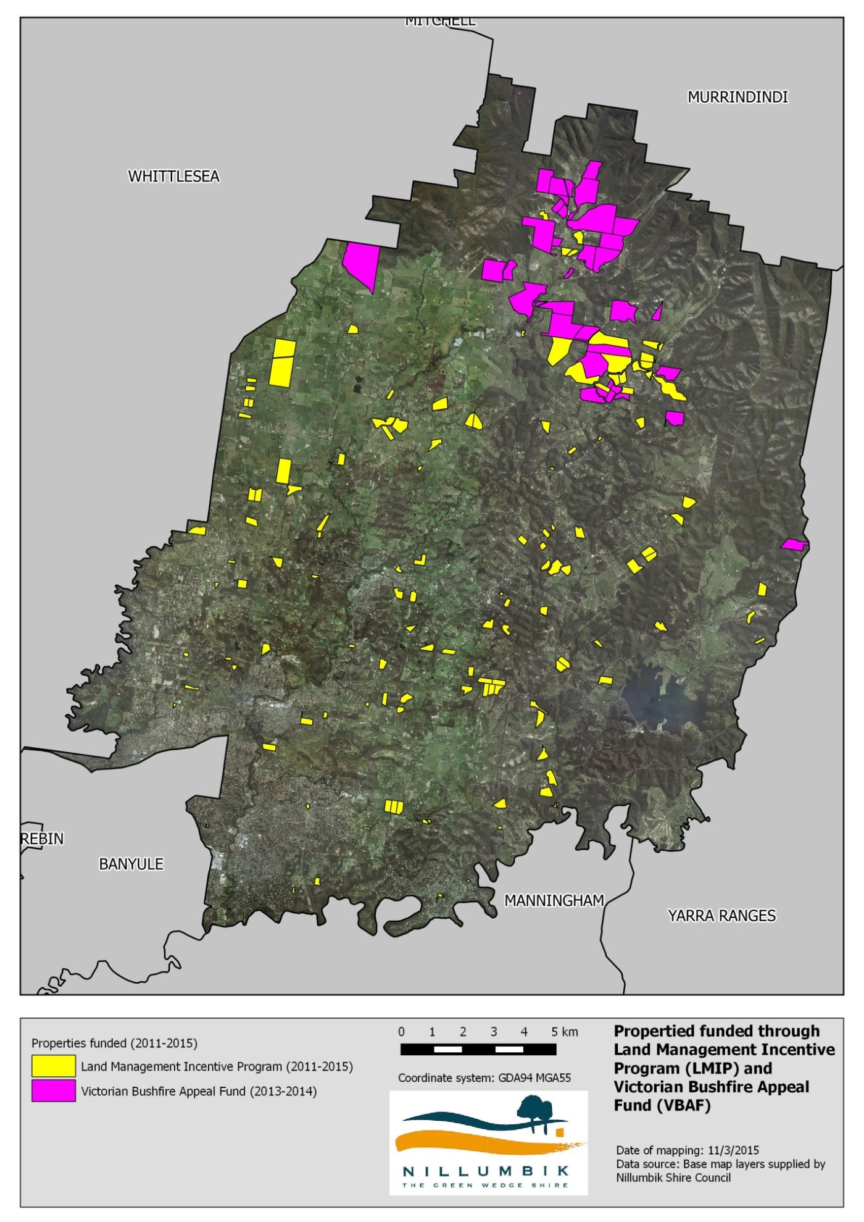

**Figure 8 – The types of Land Management Incentive Program and Victorian Bushfire Appeal Fund works undertaken between 2011-2015**

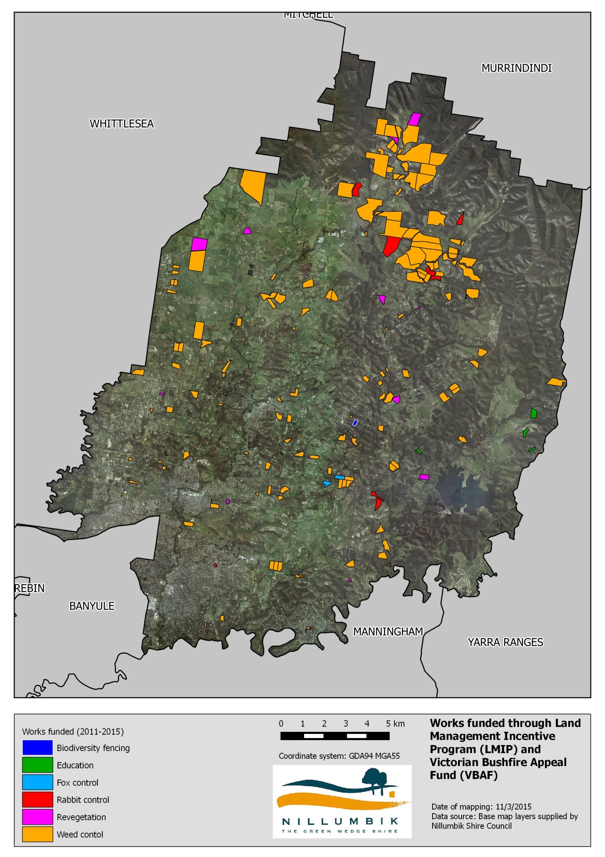

Over this same four year period (2011-15) LMIP has also provided grants to community groups (such as Landcare Groups and Rabbit Action Groups) that can be summarized as follows:

* 16 landscape-scale environmental and noxious weed control programs
* 7 multi-property Rabbit Control Projects
* 1 community-based education event
* development of two landscape-scale Land Management Plans.

**Victorian Bushfire Appeal Fund (VBAF)**

Council jointly managed the VBAF program in partnership with the Nillumbik Landcare Network over a two year period beginning in January 2013. This program was similar to the Land Management Incentive Program (LMIP) in that it provided incentive grants to landholders to implement sustainable land management projects. It differed from LMIP in that recipient properties were required to be within the area that was burnt during the 2009 Black Saturday bushfires. The VBAF program stipulated that all projects had to provide clear benefits beyond the boundary of the property on which the works occur and thus secure a high level community environmental benefit.

The VBAF Program provided assistance to 95 projects that can be summarised as follows:

* 76 noxious and environmental weed control projects
* 14 rabbit control projects
* 2 revegetation control projects
* 1 biodiversity protection fencing project
* 1 grant to assist a local community indigenous plant nursery
* 1 grant to provide labour (15 volunteers for 10 days) for environmental protection works via Conservation Volunteers Australia.

The location and extent of works funded under the VBAF program is shown in Figure 7 and the type of work in Figure 8. The numbers of properties and the breakdown of works for the program are shown in Tables 13 and 14.

**Table 13 – Number of properties involved in the Land Management Incentive Program (LMIP) and Victorian Bushfire Appeal Fund**

|  |  |  |
| --- | --- | --- |
| **Program** | **Year** | **Number of properties** |
| LMIP | 2011-2012 | 43 |
| LMIP | 2012-2013 | 30 |
| LMIP | 2013-2014 | 50 |
| LMIP | 2014-2015 | 34 |
| VBAF | 2013-2014 | 95 |
| **Total** |  | **250** |

**Table 14 – Breakdown of works for the Land Management Incentive Program and Victorian Bushfire Appeal Fund between 2011-2015**

|  |  |  |
| --- | --- | --- |
| **Program** | **Works funded** | **Number of properties** |
| **LMIP** | Biodiversity fencing | 3 |
| **LMIP** | Education | 4 |
| **LMIP** | Fox control | 2 |
| **LMIP** | Rabbit control | 4 |
| **LMIP** | Revegetation | 14 |
| **LMIP** | Weed control | 130 |
| **VBAF** | Biodiversity fencing | 1 |
| **VBAF** | Rabbit control | 14 |
| **VBAF** | Revegetation | 3 |
| **VBAF** | Weed control | 75 |

### Waterway Health

The Shire of Nillumbik is situated in the Yarra catchment and includes frontages to the Yarra River, Diamond Creek, Watsons Creek and the Plenty River. The quality of the catchments and tributaries vary throughout the Shire, depending on the land use and population levels. In Nillumbik the major waterways form important riparian habitat corridors of significant conservation and recreational value. This section deals with those aspects of the waterways that relate most to biodiversity. Other aspects of water are dealt with in the next chapter.

**Index of Stream Condition in Nillumbik Shire**

Melbourne Water has assessed priority streams and wetlands utilising two programs:

* Index of Stream Condition (ISC).
* Index of Wetland Condition (IWC).

These programs have provided an enormously valuable information resource critical for setting long term management objectives, developing priorities for Government investment and evaluating the long term effectiveness of past efforts.

Three statewide ISC assessments have been carried out (1999, 2004, 2010) and the first IWC assessments covered 587 high value wetlands in 2009/10 and 240 wetlands selected to represent the range of Victorian wetland types in 2010/11. For privacy reasons only results for wetlands on public land are available. The next group of assessments for both the ISC and IWC are planned for 2016.

The Index of Stream Condition (ISC) is a composite indicator of river condition covering 23 indicators that integrates five major themes (hydrology, water quality, streamside zone, physical form, and aquatic life). These indicators and themes are shown in Table 15 and the Index of Stream Condition for Nillumbik’s key waterways are provided in Table 16. The assessments now cover 28,000 km of major waterways and their tributaries across the state.

**Table 15 - Index of Stream Condition indicators**

| **Hydrology** | **Streamside Zone** | **Physical Form** | **Water Quality** | **Aquatic life** |
| --- | --- | --- | --- | --- |
| * Low flows * High flows * Zero flows * Seasonality * Variability | * Width * Fragmentation * Longitudinal continuity * Large trees * Structure 1 * Structure 2 * Weeds | * Bank stability * Artificial barriers * Large wood | * Total phosphorous * Turbidity * Salinity (EC) * pH | * AUSRIVAS * SIGNAL * EPT * No. Families |

**Table 16 - Index of Stream Condition for the Yarra Basin (Nillumbik Rivers)**

Index of Stream Condition for the Yarra Basin (Nillumbik Rivers)

Overall, the condition of the major waterways in Nillumbik range from Very Poor to Good. The upper reaches of the Arthurs Creek, Dry Creek and Running Creek are all in good to moderate condition, with the condition becoming moderate further downstream. The variation in condition could be attributed to changes to the impacts of the drought.

## Responding to Biodiversity

Key future actions include:

* Completing the Environmental Significance Overlay (ESO) Review.
* Implementing the Nillumbik Over-the-Counter Offset Program.
* Continuing to support landowners and Landcare groups to protect and enhance biodiversity through the Land Management Incentive program.
* Continuing to support the Nillumbik Landcare Network and assist with seeking external funding for the continuation of the Network projects.
* Continuing to support the Communities for Nature, Nillumbik Conservation Corridors Program and assist with seeking external funding for the continuation of the project.
* Continuing to support the Communities for Nature, Eltham Copper Butterfly project.
* Continuing to advocate to State Government for the continuation of the Urban Fringe Weed Initiative.
* Continuing to develop and implement management plans for Council’s significant reserves and roadsides.
* Completing and implementing the Nillumbik Invasive Species Action Plan.
* Investigation into the impacts of grazing on biodiversity.

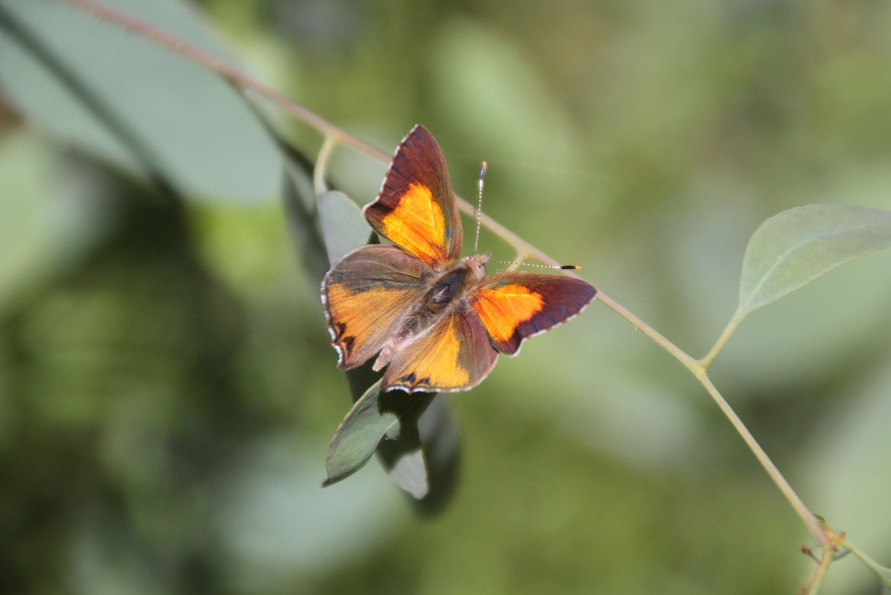

Photo Andrea Canzano

# Water

The periurban nature of the Shire presents some unique opportunities and challenges in terms of new infrastructure and planning associated with Integrated Water Management (IWM). This process promotes the coordinated development and management of all aspects of the water cycle to maximise outcomes without compromising the sustainability of the ecosystem. The predominant sources of alternative water supply for reuse in buildings and for irrigation are likely to be roof runoff and catchment stormwater. Given the distance from major wastewater treatment plant pipelines and the groundwater characteristics, water reuse from these areas is not yet feasible on a large scale. Nevertheless, there may be other site specific opportunities such as reclaim-recycle or grey water systems that should be considered on a site by site basis.

The Water section covers:

* Community Water Conservation.
* Domestic Wastewater Management.

Please note that Council’s water use is dealt with in Section 6 Council Operations.

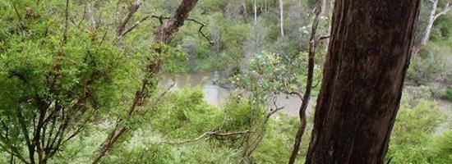

## Pressures on our Water

Key localised pressures include:

* Drought.
* Pollutants (dirt, lint, food, human waste and chemicals).
* Health risks or nuisance caused by odours, vermin and insects.
* Microbial contaminants such as bacteria, viruses and algal blooms which pose a significant public health risk.
* Surface run-off into neighbouring properties and stormwater drains, rivers and streams.
* Wastewater system maintenance.
* Unsewered properties.
* Failure of unmaintained septic tanks systems.

## Condition of our Water

Water is a precious resource that is essential for life. Balancing the supply of fresh water and the demand is an ongoing challenge. It requires water conservation, efficiency measures and recycling.

### Community Water Conservation

Significant reductions have been made in both residential and non-residential water consumption in the Shire when compared to the baseline of 2000/01 with a 31 per cent reduction in residential water use and a 9 per cent reduction in non-residential water use compared to 2013/14. However, although reductions in consumption have been made when compared to the baseline year of 2000/01, it has increased from 2011/12 to 2013/14.

**Table 17 - Residential and non-residential water use patterns** *(Source: Yarra Valley Water)*

|  |  |  |  |  |  |  |
| --- | --- | --- | --- | --- | --- | --- |
| **Water stream** | **Landuse** | **Baseline consumption 00/01 (ML/yr)** | **2011/12 (ML/yr)** | **2012/13 (ML/yr)** | **2013/14 (ML/yr)** | **% change from 00/01 to 13/14** |
| **Mains water** | **Residential** | **5,691** | **3335** | **3818** | **3879** | **-31%** |
| **Non-residential** | **579** | **411** | **497** | **527** | **-9%** |

Note - Corrections have been made by Yarra Valley Water to the residential and commercial water usage figures compared to the data reported in the 2012, State of Environment Report.

The number of properties in the Shire impacts the total water consumption. Figure 9 provides average water consumption per property per suburb for residential properties and Figure 10 provides average water consumption per property per suburb for non-residential properties. For residential properties a 14 per cent increase in water use measured in kL per property has occurred between 2011/12 and 2013/14 and for non-residential properties a 22 per cent increase has occurred over the same time period.

**Figure 9 – Residential water use – average kL per property** *(Source: Yarra Valley Water)*

**Figure 10 - Non-residential water use – average kL per property** *(Source: Yarra Valley Water)*

Note –the data is provided by postcode area. Arthurs Creek is postcode 3099 and also covers Hurstbridge, Cottles Bridge and Nutfield. Non-residential properties are all commercial and industrial customers (including schools and other public institutions). Yarra Valley Water mainly uses the Council planning zones to classify properties. There are some variations where businesses are running within residential zones.

### Domestic Wastewater Management

**Responding to offsite discharge of effluent**

Council’s Environmental Health Officers responded to 52 complaints regarding failing septic systems between 01/01/2012 and 31/12/2014. Council currently has no process in place for monitoring the performance and condition of septic tank systems in the Shire. In most instances Council only becomes aware of defective or failing systems after it receives a complaint about the system or a property owner lodges a planning application to extend or alter a dwelling. The number of complaints responded to by Council officers has steadily increased over the last 8 years. These systems were potentially causing harm to public health and/or the environment.

**Installation and upgrades to septic systems**

Table 18 shows the number of applications to install or alter a septic system in Nillumbik. When an application to alter a septic tank is submitted, landowners need to comply with the current EPA regulations. This often enables an old system to be either replaced or retrofitted in order to meet current legislation.

**Table 18 – Number of applications to install or alter a septic system**

|  | **2012** | **2013** | **2014** | **Total** |
| --- | --- | --- | --- | --- |
| Number of applications to install/alter a septic system | 65 | 63 | 56 | 184 |

**Yarra Valley Water Sewerage Backlog program**

In areas where it is known that there are a number of failing systems and small lot sizes, resulting in considerable threats to public health and the local environment, Council is supporting and lobbying Yarra Valley Water for the installation of sewer. There are approximately 17,000 properties (in the northern and eastern suburbs) on the Yarra Valley Water (YVW) sewer backlog program. YVW is aiming to have all these properties sewered by 2030.

In Nillumbik in 2012/13, the backlog areas of Eltham North and Research were completed and declared sewered areas. This constitutes approximately 155 properties in that area. Data on connection to the sewer is provided in Table 19.

**Table 19 – Sewer backlog in Eltham North/Research (as of March 2015)**

| **Total number of properties** | **Total applied to YVW to connect** | **Total actually connected** | **Total not applied/ not connected** |
| --- | --- | --- | --- |
| 155 | 124 | 80 | 75 |

At the beginning of the Sewerage Backlog Program, Nillumbik Shire Council identified approximately 1,050 properties in North Warrandyte that were of significant risk of failing septic systems. Properties in North Warrandyte are currently scheduled to be serviced by the Sewerage Backlog Program in 2015/2016.

There may be some properties within a backlog area which are of sufficient size and have a suitably performing treatment system to fully contain their wastewater onsite. Provided these properties have an EPA approved treatment system that is in good working order and is being properly maintained, they will not be legally required to connect. However, with a lack of a monitoring and compliance system it will be difficult to ensure that these systems continue to be maintained correctly.

## Responding to Water

Key future actions include:

* Implementing the Integrated Water Management Plan with an emphasis on the development of wetlands to treat stormwater and use it on ovals and for other suitable purposes, thus reducing reliance on potable water and providing wildlife habitat wherever practicable.
* Supporting and promoting the State Government’s water initiatives for residential and non-residential consumers.
* Continue to support Yarra Valley Water’s shower head exchange program.
* Finalising and implementing the revised Domestic Wastewater Management Plan. There will be a particular emphasis on assessing the areas under the greatest threat from failing septic systems and pursuing actions to remedy the situation.
* Continuing to support the implementation of the Sewer Backlog Program and its effective take up in the North Warrandyte area.

Actions relevant to Council operations are provided in Section 6.3.

# Energy and Greenhouse Emissions

The atmosphere surrounding the earth consists of a complex balance of gases that supports life. Human-based activity, such as burning fossil fuels has rapidly increased the percentage of particular gases in our atmosphere resulting in negative impacts to air quality, human health and changes to our climate system.

The Energy section covers:

* Community Energy Use.
* Transport.

Please note that Council’s energy use is dealt with in Section 6 Council Operations.

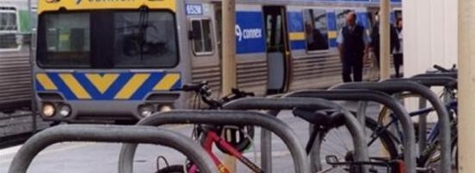

## Pressures on our Energy Use

Key localised pressures include:

* Population increase, leading to increased demand for all energy types.
* Increase in the size of housing and the number of household electrical appliances.
* ‘Peak oil’ and reduced fossil fuel reserves.
* Reliance on non-renewable fossil fuels for energy productions.
* A dependency on vehicle-based transport.

## Condition of our Energy Use and Greenhouse Emissions

Stationary energy consumption (buildings and lighting) and transport are the two largest contributors to the emission of greenhouse gases and impacts on the air quality in Nillumbik.

### Community Energy Use and Greenhouse Emissions

Emissions from stationary energy consumption peaked in Nillumbik in 2010 at 427.0 Tonnes CO2-e. By 2012 emissions had reduced by 6.0% to 401.5 Tonnes CO2-e. Electricity consumption has been the main driver of this reduction in the residential, commercial and industrial sectors. There has been a small increase in gas consumption across all three sectors. The energy and emissions information below is sourced only from metered use through energy providers.

**Figure 11 - Emissions by fuel and by sector 2004-2012 for Nillumbik** *(Source: Northern Alliance for Greenhouse Action)*

**Table 20: Change in emissions from 2010 to 2012 for Nillumbik.** *(Source: Northern Alliance for Greenhouse Action)*

|  |  |  |  |
| --- | --- | --- | --- |
| **Emission Source** | **2010** | **2012** | **Change** |
| **Residential Energy** |  |  |  |
| Daily electricity consumption per household (kWh) | 19.5 | 15.9 | -18.5% |
| Daily electricity consumption per person (kWh) | 6.9 | 5.8 | -15.9% |
| Total annual electricity consumption (kWh) | 165,794 | 157,962 | - 4.7% |
| Daily gas consumption per household (MJ) | 201.0 | 195.0 | -3.0% |
| Total annual gas consumption (MJ) | 1,202,959 | 1,184,827 | -1.5% |
| Total greenhouse gas emissions (tonnes) | 287.0 | 272.5 | -5.0% |
| **Commercial and Industrial Energy** |  |  |  |
| Total annual commercial electricity consumption (kWh) | 42,658 | 40,049 | -6.1% |
| Total annual industrial electricity consumption (kWh) | 55,159 | 49,682 | - 9.9% |
| Total annual electricity consumption (kWh) | 97,817 | 89,731 | - 8.3% |
| Total annual gas consumption (MJ) | 109,944 | 110,150 | 0.2% |
| Total greenhouse gas emissions (tonnes) | 140.1 | 129.0 | -7.9% |
|  |  |  |  |
| **Total Community Emissions from Stationary Energy** | **427.0** | **401.5** | **- 6.0%** |

The two largest energy users in a home are usually heating and water heating. One of the reasons energy consumption has reduced over recent years is the uptake of rooftop solar and hot water generated by renewable energy. There has been significant growth in the number of systems installed throughout the Shire, as shown in Tables 21 to 24.

**Table 21 – Small generation solar installations by township as at December 2014** *(Source: Clean Energy Regulator)*

| Township | Systems Installed | Output Capacity (kW) |
| --- | --- | --- |
| Greensborough | 170 | 444 |
| Diamond Creek | 435 | 1,261 |
| Plenty | 77 | 306 |
| Yarrambat | 74 | 278 |
| Eltham, Eltham North | 784 | 2,230 |
| Wattle Glen | 85 | 229 |
| Kangaroo Ground | 92 | 291 |
| Hurstbridge, Arthurs Creek, Nutfield, Cottles Bridge | 252 | 743 |
| Warrandyte North | 128 | 388 |
| Doreen | 216 | 621 |
| Yan Yean | 2 | 6 |
| Panton Hill | 76 | 263 |
| Smiths Gully | 40 | 138 |
| St Andrews | 93 | 302 |
| Kinglake | 37 | 103 |
| Total | **2,561** | **7,603** |

In 2012 there were 1,108 solar systems installed at a total output capacity of 2338.5 kW.

**Table 22 – Small-scale rooftop solar installations – change from 2011***(Source: Clean Energy Regulator)*

|  | **2011** | **2014** | **Change** |
| --- | --- | --- | --- |
| **Number of systems installed** | 1,109 | 2,561 | 131% |
| **Total generation capacity** | 2,340kW | 7,602kW | 225% |
| **Average size of systems installed** | 2.1kW | 3.0kW |  |
| **Assumed annual generation** | 3,843.45MWh | 12,486.67MWh | 225% |
| **GHG avoided** | 5,188.7tCO2-e | 16,482.4tCO2-e | 218% |

**Table 23 – Solar water heater (SWH) installations by township to end of 2014** *(Source: Clean Energy Regulator)*

| **Township** | **Solar HWS Installed** | **Heat Pump HWS Installed** |
| --- | --- | --- |
| **Greensborough** | 54 | 3 |
| **Diamond Creek** | 149 | 34 |
| **Plenty** | 52 | 12 |
| **Yarrambat** | 53 | 19 |
| **Eltham, Eltham North** | 219 | 57 |
| **Wattle Glen** | 15 | 9 |
| **Kangaroo Ground** | 49 | 51 |
| **Hurstbridge, Arthurs Creek, Nutfield, Cottles Bridge** | 130 | 88 |
| **Warrandyte North** | 36 | 8 |
| **Doreen** | 1057 | 2 |
| **Yan Yean** | 1 | 0 |
| **Panton Hill** | 43 | 28 |
| **Smiths Gully** | 16 | 14 |
| **St Andrews** | 34 | 39 |
| **Kinglake** | 26 | 6 |

**Table 24 – Solar water heater (SWH) installations – change from 2011** *(Source: Clean Energy Regulator)*

|  | **2011** | **2014** | **Change** |
| --- | --- | --- | --- |
| **Number of solar and heat pump HWS installed** | 1,448 | 2,304 | 59% |

### Transport

Table 25 shows an increase in the number of vehicles registered within Nillumbik of 5.6% between 2010 and 2012. The largest growth has been in light trucks, campervans and light commercial vehicles. The number of registrations increased from 0.77 vehicles per person in 2010 to 0.88 vehicles per person in 2012.

**Table 25 – Vehicle use in Nillumbik Shire** *(Source: VicRoads)*

| **Vehicle Type** | **2010** | **2011** | **2012** | **Percentage Increase Since 2010** |
| --- | --- | --- | --- | --- |
| **Light rigid truck** | 231 | 263 | 278 | 20.3% |
| **Heavy rigid truck** | 825 | 845 | 848 | 2.8% |
| **Motorcycle** | 2,401 | 2,542 | 2,628 | 9.5% |
| **Passenger vehicle** | 41,433 | 42,571 | 43,453 | 4.9% |
| **Light commercial vehicle** | 6,700 | 7,117 | 7,379 | 10.1% |
| **Articulated truck** | 85 | 89 | 86 | 1.2% |
| **Non-freight carrying truck** | 30 | 33 | 34 | 13.3% |
| **Bus** | 143 | 149 | 152 | 6.3% |
| **Campervan** | 93 | 100 | 105 | 12.9% |
| **Total Vehicles** | **53,951** | **55,720** | **56,975** | **5.6%** |

The length of on-road bike lanes and priority bus lanes has remained static between 2013 and 2015 at 3.3km and 0.5km respectively.

26km of regional trails and 24km of local trails exist as part of the shared trails network for commuter and recreational use. This is an increase of 13km or 35% since 2013.

Nillumbik has one train line connected to the metropolitan train network that runs from the neighbouring City of Banyule through Eltham, Diamond Creek, Wattle Glen and Hurstbridge. Bus routes managed by Public Transport Victoria consist of seven routes through Eltham, seven routes through Greensborough, one route through Warrandyte North, one route through Diamond Creek and one route through Doreen and Yarrambat. Several of the routes run through more than one Nillumbik township. In response to community requests, Council also runs a Saturday circular bus route between Hurstbridge Station, Panton Hill Store and St Andrews Market.

## Responding to Energy Use

Key future actions include:

* Preparing a new Climate Change Action Plan in 2015.
* Finalising the development of the Regional Climate Change Adaptation Action Plan.
* Continuing to advocate for improved public transport options in the Shire.
* Implementing the Nillumbik Trails Strategy.
* Continuing to support community based programs.
* Continuing to monitor community energy consumption and emissions.

Actions relevant to Council operations are provided in Section 6.3.

# Waste

Municipal waste is collected and treated by the Shire. It covers waste from households, including bulky waste, similar waste from commerce and trade, office buildings, institutions and small businesses, yard and garden, street sweepings, contents of litter containers, and market cleansing.

Hazardous waste is mostly generated by industrial activities and driven by specific patterns of production. It represents a major concern as it can give rise too serious environmental risks if poorly managed: impact the environment leading to toxic contamination of soil, water and waste also results in the production of greenhouse gas emissions from the energy used to originally manufacture the product (embodied energy), from its breakdown in landfills, transportation and methane emissions from landfill.

The Waste section covers:

* Residential kerbside waste collection.
* Street and reserve litter bin collection.
* Waste education programs to encourage recycling and waste reduction within the community.
* Recycling and Recovery Centre (RRC) and Re-use Shop
* Residential hard waste collection.
* Green waste drop off days.
* Landfill management.

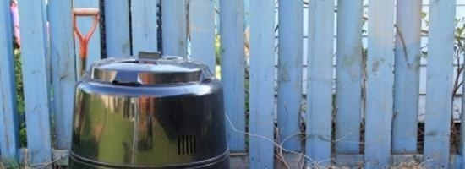

## Pressures on Waste

Key localised pressures include:

* Waste generation.
* Increased packaging.
* Illegal dumping and littering.
* Ground water and land contamination.
* Greenhouse gas emissions.
* Incidental fossil fuel consumption from transportation and disposal.
* e-waste.
* Odour.
* Noise.

## Condition of our Waste

The municipal waste management environment has undergone considerable change at the local, regional, State and Commonwealth level since 2002. In the metropolitan area with the move to larger, regional landfills Local Government has moved towards being a transporter of waste and has moved away from being a receiver of waste. As part of this process Nillumbik’s Plenty Landfill closed in 2006.

Currently rubbish is disposed of at Hanson Landfill at Wollert. Hanson Landfill is a renewable energy landfill which captures approximately 11.5 million cubic metres of methane (capturing 85% of total methane gas generated) from decomposing waste which is used to produce 35 million kilowatt hours of electricity per annum.

Council takes recyclable materials to SKM Recyclers in Coolaroo. SKM Recyclers services 12 local government Councils and can process 500 tonnes of recyclable materials each weekday.

The green waste is transported to a composting facility in Bulla owned by Veolia. Council has a 15 year contract with this facility to accept its green waste. The compost from this facility is used in gardens and broad acre farming. Nillumbik is one of 11 Councils providing green waste to the facility.

The Council-owned Kangaroo Ground Landfill site closed in 1999 and is being prepared for rehabilitation. The Council owned Plenty Landfill closed in 2006 and is also being prepared for rehabilitation. Rehabilitation of the Plenty Landfill will commence in 2015-16.

The GRO three bin kerbside collection system was introduced in 2003. It was promoted as an initiative to meet the targets of the then, State Government’s Towards Zero Waste Strategy, which was to divert 65% of municipal solid waste by 2014-2015. The 2014 waste audit showed the GRO system has the potential to divert 74% of the total waste stream from landfill. The average diversion rate over the last five years, assuming all green bin material can be processed is 63.4%.

**Table 26 - Annual waste tonnages 2010-11 to 2013-14**

|  |  |  |  |  |
| --- | --- | --- | --- | --- |
| **Waste** | **2010-11** | **2011-12** | **2012-13** | **2013-14** |
| Garbage (Tonnes) | 6,684 | 6,516 | 6,107 | 6,244 |
| Green Organics (Tonnes) | 8,043 | 7,373 | 7,699 | 6,179 |
| Recycling (Tonnes) | 7,706 | 7,610 | 7,405 | 7,694 |
| **Total (Tonnes)** | **22,433** | **21,499** | **21,211** | **20,117** |

Table 26 shows an overall decrease in waste received from the kerbside. This could be attributed to the bin inspections and education programs particularly concerning the issue of home composting. Recycling tonnage collected through the GRO system moves up and down from year to year, though it has reduced for some components due to consumer movements away from glass to plastic and away from print media towards electronic media. Contamination of recycling bins remains a significant issue requiring further education and bin inspections.

Population increase in the Shire since the last reporting period needs to be taken into account when considering tonnage of waste generated. Table 27 shows the relatively static figures, despite an increase in number of households, reflect more efficient waste diversion.

**Table 27: Waste diversion static figures**

| **Year** | **Households** | **Population** |
| --- | --- | --- |
| 2001 | 18,499 | No figure available |
| 2006 | 19,125 | 61,515 |
| 2011 | 19,806 | 62,716 |

Profile.id March 2015

Contamination in the green bin has decreased, with the highest level recorded in 2006 of 10.6 per cent, but only three per cent recorded last year. This improvement is likely a result of the waste education programs and Shire-wide green bin inspection program.

### Bin Inspection Programs

Bin inspection programs have been conducted in 2012 and 2014 to educate residents about contamination in the recycling and green waste bins. This provides information to residents who contaminate their bins, by placing a sticker on the bin lid. Alternatively, residents are congratulated with a ‘well done’ sticker if they have a contamination free bin. Between April and August 2014, two bin inspection methods were utilised, Shire-wide internal inspections and contractor run inspections.

Bin inspections for the entire Shire are conducted using the cameras in the truck to view contents of bins being emptied. Contamination letters and surveys are then sent to households and bins are reinspected in the following weeks. Households that continue to contaminate their green bins are directly contacted by Waste Management staff to offer further education. Some results from 2014 inspections include:

* 2449 contamination letters and surveys sent over the two inspection rounds.
* When inspecting bin contents going into the truck using camera, 29 per cent improvement rate was recorded (12 per cent contaminated bins at start of June down to 8.5 per cent in mid-July).

An external contractor, EnviroCom conducted initial inspections and reinspections of up to 200 green and 200 yellow bins in 9 locations, resulting in a 40 per cent improvement rate (from 26 per cent contaminated bins to 15 per cent). The bins that continued to contaminate have gone on to the Shire-wide inspection program that is helping to further reducing contamination. Results of this process will be included in a future report.

### Community engagement

Council has adopted the following strategies to create awareness and encourage participation in reducing waste going to landfill.

* *My Pledge*: This program enables residents to make an online commitment to contamination-free green waste and in return receive a bin sticker promoting that commitment.
* *Green bin survey*: Residents can complete an online survey on how they use their green bin. They are then informed of any contaminant that should not be placed in their green waste bin.
* *Online education*: Council provides information online on acceptable products for the different waste streams appropriate for kerbside collection bins or the Recycling and Recovery Centre.
* *Workshops:* Council provides residents with free education workshops on topics such as home composting, recycling and re-usable nappy workshops.
* *Free waste drop off days*: Council provides a free hard rubbish collection to residents once a year. In addition a free garden green drop off day is available twice a year.
* *Reuse Shop*: Located at the Resource and Recovery Centre the Reuse Shop provides a convenient location to encourage residents to recycle household goods, bicycles, gardening equipment, crockery and toys that are still in good condition. It is run by the Green Wedge Christian Community Church.
* *Public Place Recycling - Clean Up Our Game***:** Most of the waste generated at a footy game is recyclable. This presented an opportunity for Whittlesea, Darebin and Nillumbik Councils to partner with the Northern Football League to develop the “Clean Up Our Game – Recycle” public place recycling project. Funded by a government grant through Sustainability Victoria, the project provides an opportunity for spectators attending local football matches to recycle and contribute to a positive change by raising awareness about recycling and reducing litter.

Supporters can now use the yellow lidded recycling bins at the football grounds to recycle their glass and plastic drink bottles, cans, cardboard food containers, cardboard coffee cups, newspapers and magazines.

## Responding to Waste Issues

Key future actions include:

* + Continuing to work with the community to reduce contamination in the green and recycling waste streams and to divert recyclables from the garbage stream.
  + Continuing annual auditing to ensure that Council has consistent and comparable data to support decision making about future service provision.
  + Reviewing current kerbside service level standards in 2015-16 to ensure that Council’s waste management messaging to the community is consistent and accessible and that service levels are meeting customer needs.
  + Reviewing the kerbside service delivery model.

# Community Engagement

Community engagement and participation is a key ingredient to successfully addressing local environmental issues. Community participation gives a human face to environmental issues, empowers people to become active agents of sustainable and equitable development, and promotes an understanding that communities are pivotal to changing attitudes towards environmental issues.

The Community Engagement section covers:

* Community engagement.
* Community participation.

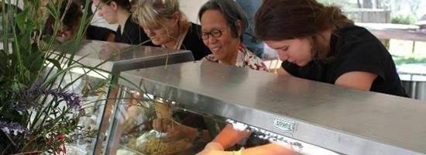

## Pressures on our Community

Key localised pressures include:

* Lack of community awareness and engagement about local environmental issues such as waterway health, rare and endangered species, invasive weeds, feral animals and habitat fragmentation.
* Barriers to volunteer participation, such as:
  + time constraints
  + lack of resources to support volunteers
  + training requirements
  + insurance issues
  + lack of awareness about local environmental volunteer groups.

## Condition of our Community

The Environmental Education Strategy 2012 provides a coordinated approach to the delivery of environmental education programs by different sections of Council. There is an emphasis, where appropriate, on lifelong learning and achieving behaviour change through environmental education rather than just providing knowledge alone. Direct Council programs include those provided for preschools and schools at Edendale and through courses at Living & Learning Nillumbik. A broad range of environmental events and workshops are delivered across the Shire, often in cooperation with community organisations including Landcare, Friends and Local Food Connect Groups.

### Landcare in Nillumbik

Nillumbik’s Landcare Groups are community-based, autonomous groups involved in land restoration across Nillumbik Shire. They bring landowners together to learn, identify, address and undertake works related to local land management issues. Members often have a wealth of knowledge about their local catchment and can assist landowners in seeking land management information, technical advice and funding opportunities. The Nillumbik Landcare Network is comprised of 10 Landcare groups within the Shire of Nillumbik.

A number of case studies are provided below to demonstrate the benefits of Landcare groups.

**Boneseed Eradication on Round-the–Bend Conservation Cooperative, Bend of Islands**

As is the case for any Landcare group the range of work to be done in managing a bush property often exceeds the amount of time and labour available to individual members.

Early on in the 1960’s when a 320 acre property was acquired, it was decided to target Boneseed on a regular work-party process. This did not exclude working on other weeds but it had a regular focus, mainly because it was widespread and easy to identify by untrained volunteers.

Now some 40 years later, the consistency of the approach in having a well-attended annual walk through the bush, covering the whole property, has been rewarded to the extent that Boneseed has been reduced to minimum background levels. Boneseed days have become ‘woody weed days’ and now the woody weed density has been reduced to the extent that effective control can be achieved with control works now held only every second year. This has allowed the Landcare efforts to now have a greater focus on grassy weed control.

**Strathewen Landcare Group Angled Onion Control**

| Strathewen Landcare Group Angled Onion Control | Strathewen Landcare Group Angled Onion Control |
| --- | --- |
| *Angled Onion roadside infestation* | *Angled Onion control 3 years on.* |

Strathewen Landcare Group has taken an active role in managing roadsides. The photos above demonstrate that ongoing commitment to roadside weeds can have a positive impact with the infestation of Angled Onion reducing.

### Nillumbik Friends Groups

A Friends Group is a group of volunteers with an interest in a particular park, reserve or species of native plant or animal. Members are involved in activities such as planting, weed control, mulching, plant and animal monitoring and water quality monitoring.

These groups do over 2,000 hours of volunteer work in Council bushland reserves each year. They play a vital role in protecting threatened natural environments, as well as making Nillumbik, a more beautiful place to live. There are 22 active Friends Group in Nillumbik, which is an increase of three Friends Groups since the last report.

### Environmental Activities and Events

Council provides a range of environmental activities and events and there is strong attendance by the community as shown in the following table.

**Table 28 - Attendance at environmental activities and events**

| **Program** | **2011/12**  **(number)** | **2012/13**  **(number)** | **2013/14**  **(number)** |
| --- | --- | --- | --- |
| **Environmental Activities Program** | 625 | 600 | 700 |
| **Practically Green Festival** | 6,000 | 5,000 | 5,000 |
| **Home Harvest Feast** | 275 | 300 | 350 |
| **Open Farm Day** | - | - | 1,200 |
| **Eltham Copper Butterfly Festival** | - | - | 2,700 |
| **Edendale school education program (students)** | 5,234 | 6,305 | 6,753 |
| **Land Management Incentive Program** | 43 | 30 | 50 |
| **Sustainable Agricultural Rebate** |  | 76 | 65 |
| **Victorian Bushfire Appeal Fund** | - | - | 95 |
| **Nillumbik Conservation Corridors Project** |  | 200 | 200 |
| **Total** | **12,134** | **12,511** | **17,113** |

Numbers in the school education program have increased considerably over the past six years, with a particularly big jump between 2010-11 and 2011-12.

Schools come to Edendale from all over metropolitan Melbourne and brochures are now sent out as far as Mornington Peninsula Shire, and Casey and Hobson’s Bay Councils. The vast majority of schools attending Edendale are primary schools, but several whole year-levels from secondary schools come each year.

The program is also getting an increasing number of small secondary school groups who are doing environmental science as an elective, or are part of a school’s “green team”. Preschool numbers have increased each year (from around 900 children in 2011-12 to around 1600 in 2013-14) and there is significant engagement with Nillumbik preschools through both excursions and incursions.

Individual participation in Council’s environmental education programs has increased by 70 per cent in the last four years.

There are approximately 50 local community groups involved in on-ground works, strategy and policy development and engagement in their communities. These include:

* Friends Groups
* Landcare Groups
* Nillumbik Landcare Group
* Waterwatch
* Home Harvest Working Group
* Warrandyte Climate Action Now (WCAN)
* Eltham Copper Butterfly Recover Committee
* Agricultural Advisory Committee
* Environment Advisory Committee
* Local Food Connect

### Environmental Publications

58 editions of the Nillumbik Environment Network (NEN) e-newsletter and Fringe Focus e-newsletters were delivered (46,218 in total) between June 2012 to February 2015.

The Live Local Plant Local and the Common Weeds of Nillumbik publications were reprinted and still remain very popular publications. Practically Green at Home: a guide to sustainable building, renovating and living is a new publication released in 2014 and is aimed at assisting households to reduce their impact on the environment. Around 4,000 copies have been distributed to date.

## Responding to Community

Key future actions include:

* Continuing to implement the Environmental Education Strategy.
* Continuing to hold the Eltham Copper Butterfly Festival.
* Working collaboratively with Melbourne Water on a Platypus project (new).
* Continuing to hold the Home Harvest Feast.
* Continuing to hold the Practically Green Festival and Awards.
* Continuing to support and collaborate with community groups to deliver projects.

# Council Operations

Nillumbik Shire plays a significant role in environmental management. Through proactively pursuing sustainable development and implementing actions, Council will protect and improve the local environment.

The Council Operations section covers:

* Water management.
* Energy management.
* Fleet.
* Other corporate activities.

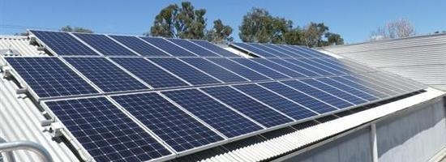

## Pressures on our Council operations

Key localised pressures include:

* More frequent flash flooding of the stormwater drainage systems.
* Increasing costs of water, gas and energy.
* Lower than average rainfall levels and higher than average temperatures.
* Increased electronic waste.
* Council fleet and plant vehicle use.
* Increasing cost of fuel.
* Increasing service provision, such as longer opening hours, increased site use and the inclusion of more electrical equipment.

## Condition of Council operations

Council aims to be a leader in resource efficiency and to demonstrate environmental, financial and social responsibility. This applies not only to everyday resource use but also includes integrating sustainability into all Council projects.

### Council’s Water Consumption

In Table 29, Council’s water consumption figures are presented for the different types of Council’s buildings and facilities combined into what are called amenity groups.

**Table 29 - Council’s water consumption for 2012/13 and 2013/14 for 137 Council owned sites with metered water**

| **Amenity Group** | **2012/13 Consumption**  **kL** | **2013/14 Consumption**  **kL** | **% Change from 2012/13-2013/14** |
| --- | --- | --- | --- |
| **Aquatic Complex** | 5,965 | 12,445 | + 108% |
| **Childcare** | 1,431 | 2,367 | + 65% |
| **Civic Centre** | 1,598 | 1,105 | -30% |
| **Community Centre** | 1,139 | 1,301 | + 14% |
| **Dwelling** | 562 | 373 | - 34% |
| **Environment Centre** | 1,625 | 1,611 | -0.8% |
| **Halls** | 1,732 | 2,115 | + 22% |
| **Historical** | 32 | 29 | - 9% |
| **Learning** | 348 | 504 | + 45% |
| **Library** | 68 | 205 | + 201% |
| **Maternal Health** | 963 | 893 | - 7% |
| **Operations Centre** | 868 | 993 | + 14% |
| **Sports Pavilion** | 10,058 | 15,341 | + 53% |
| **Playhouse** | 95 | 72 | - 24% |
| **Preschool** | 3,219 | 1,826 | - 43% |
| **Public Amenities** | 535 | 812 | + 52% |
| **Reserves and Ovals** | 52,694 | 55,994 | +6% |
| **Sporting Complex** | 18,292 | 29,476 | + 61% |
| **Tower** | 232 | 169 | - 27% |
| **Water Supply (standpipe)** | 3,739 | 5,119 | + 37% |
| **Total** | **105,195kL** | **152,572kL** | **+45%** |

When the State of Environment report was undertaken in 2012 water consumption data was only available for 116 out of 137 sites with metered water accounts. Table 30 provides a comparison to 2011/12 based on those 116 sites.

**Table 30: Council’s water consumption compared to the previous State of Environment Report**

|  |  |  |  |  |
| --- | --- | --- | --- | --- |
| **Water source** | **2011/12 Consumption (ML)** | **2012/13 Consumption (ML)** | **2013/14 Consumption (ML)** | **% Change from 2011/12-2013/14** |
| **Mains water** | 67.47 | 92.77 | 124.94 | + 85% |
| **Rainwater**  **(storage capacity)** | 9.9 | 9.9 | 9.9 | 0% |
| **Licensed extractions** | 90 | 90 | 90 | 0% |
| **Other\*** | 25.4 | 25.4 | 25.4 | 0% |
| **Total** | **192.7** | **218.07** | **250.24** |  |

*\* Other refers to water sourced from a private dam for road grading purposes (approximately 100kL per day between November-March and 40kL per day between April and October)*

**Figure 12: Council’s top ten water users for 2012/13 and 2013/14**

Figure 12 reveals that a significant proportion of Council’s water consumption is used for sport ovals irrigation. Following the construction of the Hurstbridge Wetland water consumption at Ben Frilay Oval should decrease as the stormwater harvested and treated will be used to irrigate the oval. This data also highlights that a significant amount of potable water (6,115kL in 2013/14) is being used at Marngrook Oval although water harvested at Coventry Wetlands is available for irrigation of this oval.

Eltham Leisure Centre is suffering from the effects of ageing plant and infrastructure which has been subject to frequent leaks, believed to be the source of the increase in water use. It is anticipated that the upcoming aquatic redevelopment of the centre will help address these issues and provide reductions in energy and water consumption.

The significant increase in water consumption at the Diamond Creek Outdoor Pool is currently being investigated.

### Council’s Electricity Consumption

In Table 31, Council’s electricity consumption figures are presented for the different types of Council buildings and facilities combined into amenity groups.

**Table 31 - Council’s electricity consumption for 2012/13 and 2013/14 for 155 Council owned sites**

| Amenity Group | 2012/13 Consumption  (kWh) | 2013/14 Consumption  (kWh) | % Change from 2012/13-2013/14 |
| --- | --- | --- | --- |
| **Aquatic Complex** | 32,117 | 28,804 | -10% |
| **Car Park** | 4,005 | 2,149 | -46% |
| **Childcare** | 78,103 | 74,474 | -5% |
| **Civic Centre** | 670,719 | 648,027 | -3% |
| **Community Centre** | 136,681 | 132,554 | -3% |
| **Dwelling** | 25,213 | 32,332 | +28%**\*** |
| **Environment Centre** | 34,096 | 27,464 | -19% |
| **Golf Complex** | 52,540 | 55,042 | +4.5% |
| **Halls** | 119,853 | 121,321 | +1% |
| **Historical** | 1,974 | 6,680 | +238% |
| **Learning** | 40,402 | 42,663 | +6% |
| **Library** | 538,119 | 466,643 | -13% |
| **Lighting (traffic and security)** | 26,366 | 23,507 | -11% |
| **Maternal Health** | 22,068 | 19,211 | -13% |
| **Operations Centre** | 168,037 | 163,615 | -3% |
| **Sports Pavilion** | 530,758 | 540,639 | +2% |
| **Playhouse** | 15,117 | 11,636 | -23% |
| **Preschool** | 115,464 | 121,612 | +5% |
| **Public Amenities** | 18,644 | 16,309 | -13% |
| **Reserves and Ovals** | 29,175 | 39,664 | +36% |
| **Rotundas** | 3,197 | 6,356 | +98% |
| **Sporting Complex** | 2,017,986 | 1,850,047 | -8% |
| **Streetlighting** | 1,593,754 | 1,598,353 | +0.2% |
| **Tower** | 4,368 | 4,042 | -7% |
| **Total Consumption (kWh)** | **6,278,757** | **6,009,817** | **-4%** |
| Total Emissions (tCO2-e) | 7,346 | 7,091 | -3% |

**\***Data incomplete for two dwellings for 2012/13 and unavailable due to change in provider.

Note – CO2 emissions calculated using the *National Greenhouse Accounts Factors,* Australian Government 2013 and 2014.

Considerable effort has been made to retrofit Council buildings with more efficient technologies to assist with reducing Council’s greenhouse gas emissions. Since 2013, 14 buildings have had efficient lighting installed, 8 buildings have had solar electricity systems installed and 15 solar or heat pump hot water systems have been installed. Double glazing, draught proofing, low-e window film and efficient heating/cooling has been installed throughout various buildings. Energy consumption at these facilities has shown significant improvement.

New buildings such as the Hurstbridge Community Hub and St Andrews Community Centre have been constructed using high quality passive solar design, sustainable materials and energy and water efficient appliances.

One of the larger increases in energy consumption reflected in Table 31 is at Reserves and Ovals. This is due to sportsground lighting replacement at a number of sites which has improved lighting to meet required sporting code standards. Rotundas include outdoor shelters, and primarily those at Eltham Lower Park. The increase here could be attributed to increased use of the facilities including electric barbecues at the park following the launch of the Eltham Lower Park play space.

The data shows a significant increase in usage at Historical sites. This increase is actually a reflection of billing issues experienced in 2012/13 with a high number of estimated reads followed by an actual read resulting in a negative usage being reported for the year. The roll out of smart meters means these types of billing errors should occur less.

When the State of Environment Report was undertaken in 2012, electricity usage data was not available for all sites. Data was available for 90 out of 155 sites with metered electricity accounts. Table 32 provides a comparison to 2011/12 based on those 90 sites.

**Table 32: Council’s electricity consumption trends**

|  | 2007/08 | 2008/09 | 2009/10 | 2010/11 | 2011/12 | 2012/13 | 2013/14 |
| --- | --- | --- | --- | --- | --- | --- | --- |
| kWh | 2874357 | 3102921 | 3104742 | 3185341 | 3261083 | 3367116 | 3075524 |
| Tonnes CO2e | 3,478 | 3,755 | 3,757 | 3,854 | 3,946 | 3,939 | 3,629 |

Table 32 and Figure 13 show that Council’s electricity consumption (for the 90 comparable sites) rose steadily until 2012/13 and has been on a downward trend since. However the trends in these figures should not be applied to Council’s electricity trends as a whole. When comparing the total for 2013/14 in Table 32 of 3,075,524kWh to the total for all Council sites for 2013/14 in Table 31 of 6,009,817kWh, it reveals that those 90 comparable sites only account for 51 per cent of Council’s electricity consumption.

**Figure 13 - Council’s electricity consumption trends**

**Figure 14 - Council’s top five electricity users for 2012/13 and 2013/14**

Figure 14 reveals Council’s top five electricity users for 2012/13 and 2013/14. The highest user is streetlighting for the Eltham area. This electricity use has stayed consistent from 2012/13 and 2013/14 as the number of lights has not changed and efficiencies resulting from the street lighting upgrade completed in December 2010 have already been achieved. Across the other four sites – Eltham Leisure Centre, Council Offices, Diamond Valley Sports and Fitness Centre and Eltham Library – a decrease in electricity use has occurred from 2012/13 to 2013/14.

### Council’s Gas Consumption

In Table 33, Council’s gas consumption figures are presented for the different types of Council buildings and facilities combined into amenity groups.

**Table 33: Council’s gas consumption (MJ) for 2012/3 and 2013/14 for 51 Council owned sites**

| Amenity Group | 2012/13 Consumption | 2013/14 Consumption | % Change from 2012/13-2013/14 |
| --- | --- | --- | --- |
| **Aquatic Complex** | 1,826,422 | 1,817,215 | -0.5% |
| **Childcare** | 151,084 | 114,547 | -24% |
| **Civic Centre** | 1,836,388 | 1,626,157 | -12% |
| **Community Centre** | 215,105 | 145,487 | -32% |
| **Dwelling** | Not collected | 9,275 |  |
| **Environment Centre** | 206,949 | 176,492 | -15% |
| **Halls** | 190,188 | 143,709 | -22% |
| **Learning** | 75,513 | 67,333 | -11% |
| **Maternal Health** | 27,798 | 28,383 | +2% |
| **Sports Pavilion** | 280,823 | 200,418 | -30% |
| **Playhouse** | 35,420 | 32,510 | -8% |
| **Preschool** | 238,385 | 253,155 | +6% |
| **Sporting Complex** | 11,529,785 | 11,127,685 | -3% |
| **Total Consumption (MJ)** | **16,613,860** | **15,742,401** | **-5%** |
| Total Emissions (tCO2-e) | 853 | 808 | -5% |

Gas consumption at the Council Offices has dropped 12 per cent between 2012/13 and 2013/14. During this time solar hot water was installed, timers were applied to hot water recirculating rings and a low-e film was installed to reduce heat loss through office windows. It should also be noted that warmer than average temperatures were experienced in both years.

During 2013/14, 15 solar or heat pump hot water systems were installed at Council facilities. These sites included childcare centres, the civic centre and pavilions and, where they have been installed, a notable decrease in gas consumption has occurred. There is now a trend to move away from gas appliances across all Council sites, installing highly efficient electrical appliances coupled with rooftop solar power. This reduces Council’s reliance on fossil fuels and thus reduces greenhouse gas emissions. New buildings such as the Hurstbridge Community Hub have been constructed using high quality passive solar design, sustainable materials and energy and water efficient appliances.

**Figure 15: Solar Hot Water Installations**

Figure 15 shows the decrease in gas consumption that has been experienced at the Council sites where solar hot water systems were installed that are connected to mains gas.

When the State of Environment Report was undertaken in 2012 gas usage data was not available for all sites. Data was available for 17 out of 51 sites with metered gas accounts. Due to some issues with the data provided for the Eltham Leisure Centre for the previous State of Environment Report, it has been removed for comparison purposes. Table 34 provides a comparison to 2011/12 based on 16 sites.

**Table 34: Council’s gas consumption trends**

|  | 2007/08 | 2008/09 | 2009/10 | 2010/11 | 2011/12 | 2012/13 | 2013/14 |
| --- | --- | --- | --- | --- | --- | --- | --- |
| MJ | 1692192 | 1485441 | 1483685 | 1458456 | 2299274 | 2247798 | 1959994 |
| Tonnes CO2e | 88 | 77 | 77 | 75 | 118 | 115 | 100 |

**Figure 16 - Council’s gas consumption trends**

Table 34 and Figure 16 show that Council’s gas consumption (for the 16 comparable sites) experienced a sharp increase for 2011/12 (mainly as a result of the installation of large boilers as part of the Civic Centre refurbishment) has been on downward trend since then. This downward trend, although not as pronounced, is reflected in the figures for 2012/13 and 2013/14 for the total 51 sites. Figure 17 shows gas use at Council’s top five users for 2012/13 and 2013/14.

**Figure 17 - Council’s top five gas users for 2012/13 and 2013/14**

The target stated in the Climate Change Action Plan 2010-15 for a 20% reduction in building energy consumption by 2015 compared to 2006 levels was not achieved. However, there has been a 4% reduction in Council electricity consumption and 5% reduction in Council gas consumption over the year to June 2014. This has resulted in a 3.7 % reduction in Council greenhouse gas emissions over that year.

**Council’s solar photovoltaic systems program**

Since the last report in 2010, a further eight solar electricity systems have been installed on Council-owned buildings.

Table 35 shows the solar systems installed on Council owned buildings, how much energy is being generated and the emissions avoided through consumption of renewable energy.

**Table 35: Council’s solar photovoltaic systems**

| **Facility** | **System Size (kW)** | **Anticipated Annual Generation (kWh)** | **Total Generation 2014 (kWh)** | **Tonnes of Avoided CO2 2014** | **No. of Cars Off the Road 2014** |
| --- | --- | --- | --- | --- | --- |
| Panton Hill Football & Cricket Clubrooms | 4.37 | 6,832 | 5,717 | 7.7 | 1.8 |
| Panton Hill Playhouse | 5.13 | 5,994 | 5,326 | 7.2 | 1.7 |
| Panton Hill Living & Learning Centre | 2.28 | 2,694 | 1,765 | 2.4 | 0.6 |
| Operations Centre | 7.98 | 10,110 | 9,806 | 13.2 | 3.1 |
| Diamond Creek Community Centre | 12.16 | 16,936 | 14,294 | 19.3 | 4.5 |
| Eltham Performing Arts Centre | 7.98 | 10,925 | 6,577 | 8.9 | 2.1 |
| River Bend | 3.08 | 4,096 | 2,494 | 3.4 | 0.8 |
| Birrarung | 1.98 | 2,604 | 1,462 | 2.0 | 0.5 |
| Eltham Living & Learning Centre | 3.04 | 3,650 | 3,779 | 5.1 | 1.2 |
| Edendale | 1.35 | 1,971 | 1,543 | 2.1 | 0.5 |
| Diamond Valley Library | 7.98 | 10,147 | 10,328 | 13.9 | 3.3 |
| Allwood House | 3.42 | 4,504 | 3,957 | 5.3 | 1.3 |
| Strathewen Pavilion | 3.68 | 6,036 | 6,036 | 8.1 | 1.9 |
| Diamond Creek Occasional Care | 4.50 | 7,391 | 276 | 0.4 | 0.1 |
| Eltham Childcare Cooperative | 4.50 | 7,391 | 279 | 0.4 | 0.1 |
| Eltham Playhouse | 3.50 | 5,749 | 206 | 0.3 | 0.1 |
| Eltham Preschool | 3.00 | 4,928 | 314 | 0.4 | 0.1 |
| Eltham Woods Childcare Cooperative | 4.50 | 7,391 | 508 | 0.7 | 0.2 |
| Eltham Woods Preschool | 4.50 | 7,391 | 357 | 0.5 | 0.1 |
| Yarrambat Preschool | 10.00 | 16,425 | 899 | 1.2 | 0.3 |
| Hurstbridge Sports Stadium | 12.00 | 19,710 | - | - | 0.0 |
| **Total** | **110.93** | **162,876** | **75,922** | **102.5** | **24.0** |

Council, service providers and clubs avoided around $19,000 of electricity costs in 2013/14. This figure is expected to double as the systems begin to generate over a full year. Council has also saved approximately $1,400 by not having to purchase carbon offsets.

### Council’s Carbon Offsets

When the Nillumbik Climate Change Action Plan (CCAP) 2010-2015 was adopted, Council committed to purchasing 100% accredited offsets for building emissions over the life of the CCAP. Council purchased GreenPowerTM between 2008-2011 to offset emissions. In 2012, Council commenced the purchased of offsets using a mix of GreenPowerTM , GoldPowerTM and through the Voluntary Carbon Standard (VCS).

Table 36 shows the quality and type of carbon offsets Council has purchased between 2012-2014. The purchase of offsets only includes emissions from electricity and gas use in Council buildings, it does not offset emissions from fleet, travel or water use.

**Table 36: Council’s purchased carbon offsets between 2012- 2014**

|  |  |  |  |  |  |  |  |  |
| --- | --- | --- | --- | --- | --- | --- | --- | --- |
| **2012** |  |  | **2013** |  |  | **2014** |  |  |
| **Type of Offset** | **Quantity** | | **Type of Offset** | **Quantity** | | **Type of Offset** | **Quantity** | |
| GreenPower, Victoria | 1,585 | MWh | GreenPower, Victoria | 1,004 | MWh | GreenPower, Victoria | 1,508 | MWh |
| Wind Farm Project, Turkey | 1,068 | tCO2-e | Wind Farm Project, Turkey | 1,068 | tCO2-e | Small Hydro Electriciy Project, Turkey | 994 | tCO2-e |
| Wind Farm Project, China | 393 | tCO2-e | Native Forest Protection, Tasmania | 784 | tCO2-e | Wind Farm Project, Turkey | 392 | tCO2-e |
| Biomass Project, China | 676 | tCO2-e | Wind Farm Project, India | 676 | tCO2-e | Small Hydro Electric Project, China | 994 | tCO2-e |
|  |  |  | Biomass Project, China | 393 | tCO2-e | Wind Farm Project, India | 392 | tCO2-e |

### Council’s Fleet Emissions

**Table 37: Council fleet fuel consumption and emissions**

| **Diesel 2013/14** |  |  | **Change from 2012/13** |
| --- | --- | --- | --- |
| Total Litres Diesel 2013/14 | 572,571.00 |  | 0.6% |
| Total Kilolitres Diesel | 572.57 |  |  |
| Energy Content Factor (GJ) | 22,101.24 |  |  |
| Emissions of carbon dioxide | 1,529,405.85 |  |  |
| Emissions of methane | 1,105.06 |  |  |
| Emissions of nitrous oxide | 11,050.62 |  |  |
| **Total GHG emissions** | **1,541.56** | **tCO2e** |  |
| **Unleaded 2013/14** |  |  |  |
| Total Litres Unleaded 2013/14 | 114,266.00 |  | 30.2% |
| Total Kilolitres Unleaded | 114.27 |  |  |
| Energy Content Factor (GJ) | 3,907.90 |  |  |
| Emissions of carbon dioxide | 260,656.74 |  |  |
| Emissions of methane | 78.16 |  |  |
| Emissions of nitrous oxide | 781.58 |  |  |
| **Total GHG emissions** | **261.52** | **tCO2e** |  |
| **LPG 2013/14** |  |  |  |
| Total Litres LPG 2013/14 | 35,514.00 |  | 24.3% |
| Total Kilolitres LPG | 35.51 |  |  |
| Energy Content Factor (GJ) | 930.47 |  |  |
| Emissions of carbon dioxide | 55,455.82 |  |  |
| Emissions of methane | 279.14 |  |  |
| Emissions of nitrous oxide | 279.14 |  |  |
| **Total GHG emissions** | **56.01** | **tCO2e** |  |
| **Total Emissions** | **1,859.09** | **tCO2e** | **4.5%** |

There have been a number of changes to Council’s fleet since 2012 including replacement of the waste vehicle fleet and the purchase of an additional sweeper. The biggest change is in the use of unleaded fuel.

### Production of indigenous plants

Edendale Indigenous Plant Nursery produces over 100,000 indigenous plants each year. The plants, grown from locally collected seeds and plant cuttings are available for purchase by the community and are for revegetation in reserves and parkland around the Nillumbik Shire.

All plants are grown on site, in a purpose-built propagation shed and hot houses, by a team of dedicated staff and volunteers.

**Table 38: Number of indigenous plants purchased from Edendale**

| **Year** | **Number purchased/planted** | **Estimate area (ha)** |
| --- | --- | --- |
| **2010/11** | 55,495 | 1.3 |
| **2011/12** | 61,329 | 1.5 |
| **2012/13** | 70,051 | 1.8 |
| **2013/14** | 67,362 | 1.7 |
| **Total** | **254,237** | **6.3** |

At 4 plants per square metre, it is estimated that between 2010 and 2014 an area equivalent to 6.3 ha was revegetated.

### Council’s Integrated Water Management

Table 38, summarises existing Council Water Sensitive Urban Design (WSUD) projects and associated stormwater flow reduction and pollutant load reductions. Collectively the WSUD projects reduce stormwater flow volumes and pollutant loads discharged to local waterways. Since the last State of Environment Report, one new stormwater treatment harvesting system has been constructed in Hurstbridge. This system will save an estimated 7ML of potable water per year in sportsground irrigation in addition to the waterway benefits.

**Table 39: Summary of existing WSUD projects**

| **System/Asset Name** | **Component** | **Area (m2)** | **Installation Date** |
| --- | --- | --- | --- |
| Yarrambat Lake | Storage Pond / Lakes | 28575.7 | 1984 |
| Vegetated Swale | 1800 |
| Sedimentation Pond | 34.3 |
| Fergusons Paddock Wetlands | Wetland | 9430 | 1/01/1991 |
| Ephemeral Wetland | 1571.8 |
| Swale | 122 |
| Murrays Wetland | Wetland | 3190.7 | 1996 |
| Wetland | 1320.5 |
| Wetland | 222.7 |
| Wetland | 669.4 |
| Wetland | 142.8 |
| Lenister Farm | Wetland | 755.5 | 10/01/1997 |
| Wetland | 1409.7 | 10/01/1997 |
| Treetops Estate Wetlands | Wetland | 469.2 | 16/09/1997 |
| Wetland | 715 | 16/09/1997 |
| Henry Arthur Drive Estate Drainage | Bioretention Swale | 2480 | 17/03/2003 |
| Raingardens | 11 |
| Edendale Raingarden | Raingarden | TBC | 2004 |
| Swale | TBC | 2014 |
| Raingarden | TBC | 2014 |
| Barak Bushland/Falkiner Street Wetland | Sedimentation Pond | 275.5 | 1/08/2004 |
| Wetland | 2368 |
| Billabong | 3379.8 | Existing |
| Challenger Street Wetland | Sedimentation Pond | 506 | 13/08/2005 |
| Wetland | 3611.6 |
| Ephemeral Wetland | 9168.2 | 27/09/2011 |
| Billabong | 1372.2 | 13/08/2005 |
| Dam | 2116.2 |
| Ephemeral Wetland | 3455.7 | 28/02/2011 |
| Vegetated Swale | 833 | 13/08/2005 |
| Dianella Court Reserve Swales | Swale | 307 | 20/03/2006 |
| Eltham Leisure Centre | Bioretention Swale | 85 | October/2006 |

| **System/Asset Name** | **Component** | **Area (m2)** | **Installation Date** |
| --- | --- | --- | --- |
| Yarrambat Drainage Scheme/Youngs Road | Wetland | 64.3 | October/2006 |
| Wetland | 153.3 |
| Wetland | 87.5 |
| Sedimentation Pond | 185.3 |
| Dam | 362.6 |
| Dam | 819.3 |
| Swale | 300 |
| Dianella Court Wetland/Luscombe Dr Storage Pond | Wetland | 1013.6 | 15/06/2007 |
| Gross Pollutant Trap | N/A |
| Coventry Wetland Development | Sedimentation Pond | 248.8 | 19/11/2007 |
| Wetland | 1266.9 |
| Storage Pond / Lakes | 4103.6 |
| Pump, Sump & Generator | N/A |
| Eltham Library Raingarden | Raingarden | TBC |  |
| Rotin Court, Plenty | Bioretention Swale | 260 | Jun/2008 |
| Rotin Court Sedimentation Pond | Sedimentation Pod | 113 | Jun/2008 |
| Eltham Circulatory Road | Raingarden | 192.5 | 23/07/2010 |
| Hill Mews, Eltham | Swale | TBC | 9/08/2010 |

| **System/Asset Name** | **Component** | **Area (m2)** | **Installation Date** |
| --- | --- | --- | --- |
| Alistair Knox Wetland | Wetland | 1025.5 | 27/09/2011 |
| Storage Pond / Lakes | 762.3 |
| Gross Pollutant Trap | N/A |
| 33-51 Kurrak Road, Plenty | Raingarden | 40 | 15/11/2011 |
| Swale | 458 |
| Swale | 100 |
| Diamond Valley Library Raingarden | Raingarden | TBC | 2012 |
| Eltham Lower Park Raingardens | Raingarden | 171.3 | 10/09/2012 |
| Hurstbridge Wetland (new) | Gross Pollutant Trap | N/A | Aug/2014 |
| Wetland | 3000 |
| Storage Pond/Lake | 500 |
| Pump | N/A |
| Swale | 140 |
| Shire Office Raingarden (new) | Raingarden | 40 | Nov/2014 |
| Civic Drive Precinct Raingarden (new) | Raingarden | 200 | Dec/2014 |
| Grange Avenue Swales | Bioretention Swale | 387 |  |
| Eltham North Carpark at Soccer Ground | Bioretention Swale | 110 |  |

| Shire office raingarden construction | Hurstbridge wetland construction |
| --- | --- |
| Shire Office Raingarden under construction (January 2015) | Hurstbridge Wetland post construction (July 2014) |

## Responding to Council operations

Key future actions include:

* Continue membership of the Northern Alliance for Greenhouse Action and work in collaboration with member Councils to coordinate emissions reduction and adaptation activities.
* Completing the feasibility study for the Eltham Integrated Water Management Corridor.
* Completing the Civic Drive Precinct Integrated Water Management Project.
* Continuing to install solar photovoltaic systems on Council buildings as prioritised.
* Continuing with the implementation of Council building retrofit works to improve energy and water efficiency.
* Continuing to implement the Utility Billing Management System and monitor consumption across all facilities.
* Working with facility users to understand how to reduce utility costs.
* Continuing to run the Ecoteam as a means of implementing organisational change and coordinating environmentally friendly practices across the organisation.

# Appendix

**Table 40 - Number of FFG Act and EPBC Act listed, Endangered, Vulnerable, Rare and Poorly Known Flora Species in Nillumbik**

| **Vic Adv List** | **EPBC** | **FFG** | **Scientific Name** | **Common Name** |
| --- | --- | --- | --- | --- |
| en |  |  | *Prasophyllum pyriforme s.s.* | Silurian Leek-orchid |
| en |  |  | *Pterostylis sp. aff. striata (Silurian)* | Silurian Striped Greenhood |
| k |  |  | *Acacia leprosa var. graveolens* | Common Cinnamon-wattle |
| k |  |  | *Bolboschoenus fluviatilis* | Tall Club-sedge |
| k |  |  | *Caladenia australis* | Southern Spider-orchid |
| k |  |  | *Caladenia prolata* | Fertile Finger-orchid |
| k |  |  | *Calochilus herbaceus* | Leafless Beard-orchid |
| k |  |  | *Calochilus therophilus* | Slender Beard-orchid |
| k |  |  | *Carex chlorantha* | Green-top Sedge |
| k |  |  | *Desmodium varians* | Slender Tick-trefoil |
| k |  |  | *Geranium aff. sp. 3* | Rosella Crane's-bill |
| k |  |  | *Hypsela tridens* | Hypsela |
| k |  |  | *Kunzea leptospermoides* | Yarra Burgan |
| k |  |  | *Montia fontana subsp. fontana* | Water Blinks |
| k |  |  | *Olearia ramulosa var. tomentosa* | Twiggy Daisy-bush |
| k |  |  | *Pterostylis aciculiformis* | Slender Ruddyhood |
| k |  |  | *Sclerolaena muricata var. muricata* | Black Roly-poly |
| vu |  |  | *Lasiopetalum ferrugineum* | Rusty Velvet-bush |
| r |  |  | *Acacia leprosa var. uninervia* | Large-leaf Cinnamon-wattle |
| r |  |  | *Acacia stictophylla* | Dandenong Wattle |
| r |  |  | *Austrostipa rudis subsp. australis* | Veined Spear-grass |
| r |  |  | *Billardiera scandens s.s.* | Velvet Apple-berry |
| r |  |  | *Calochilus imberbis* | Naked Beard-orchid |
| r |  |  | *Corybas fimbriatus* | Fringed Helmet-orchid |
| r |  |  | *Cymbonotus lawsonianus* | Bear's-ear |
| r |  |  | *Diuris X palachila* | Broad-lip Diuris |
| r |  |  | *Encalypta vulgaris* | Common Extinguisher-moss |
| r |  |  | *Eucalyptus fulgens* | Green Scentbark |
| r |  |  | *Euchiton umbricola* | Cliff Cudweed |
| r |  |  | *Fissidens strictus* | Water Pocket-moss |
| r |  |  | *Gentianella polysperes* | Early Forest-gentian |
| r |  |  | *Geranium sp. 3* | Pale-flower Crane's-bill |
| r |  |  | *Grevillea repens* | Creeping Grevillea |
| r |  |  | *Levenhookia sonderi* | Slender Stylewort |
| r |  |  | *Pimelea pauciflora* | Poison Rice-flower |
| r |  |  | *Pomaderris oblongifolia* | Snowy River Pomaderris |
| r |  |  | *Pteris comans* | Netted brake |
| r |  |  | *Pterostylis smaragdyna* | Emerald-lip Greenhood |
| r |  |  | *Pterostylis sp. aff. parviflora (Southern Victoria)* | Red-tip Greenhood |
| r |  |  | *Pterostylis sp. aff. plumosa (Woodland)* | Woodland Plume-orchid |
| r |  |  | *Pterostylis X ingens* | Sharp Greenhood |
| r |  |  | *Senecio campylocarpus* | Floodplain Fireweed |
| r |  |  | *Thelymitra X irregularis* | Crested Sun-orchid |
| r |  |  | *Thryptomene calycina* | Grampians Thryptomene |
| vu |  |  | *Caladenia oenochila* | Wine-lipped Spider-orchid |
| vu |  |  | *Cardamine papillata* | Forest Bitter-cress |
| vu |  |  | *Coronidium gunnianum* | Pale Swamp Everlasting |
| vu |  |  | *Dianella sp. aff. longifolia (Benambra)* | Arching Flax-lily |
| vu |  |  | *Geranium solanderi var. solanderi s.s.* | Austral Crane's-bill |
| en | EN | L | *Caladenia amoena* | Charming Spider-orchid |
| en | VU | L | *Caladenia concolor* | Crimson Spider-orchid |
| en | EN | L | *Caladenia robinsonii* | Frankston Spider-orchid |
| en | EN | L | *Caladenia rosella* | Little Pink Spider-orchid |
| en | EN | L | *Dianella amoena* | Matted Flax-lily |
| en | CR | L | *Pomaderris vacciniifolia* | Round-leaf Pomaderris |
| k |  |  | *Cardamine tenuifolia* | Slender Bitter-cress |
| k |  |  | *Marsilea mutica* | Smooth Nardoo |
| r |  |  | *Caladenia venusta* | Large White Spider-orchid |
| r |  |  | *Eucalyptus yarraensis* | Yarra Gum |
| r |  |  | *Grevillea rosmarinifolia subsp. rosmarinifolia* | Rosemary Grevillea |
| r |  |  | *Pultenaea weindorferi* | Swamp Bush-pea |
| vu |  |  | *Eucalyptus leucoxylon subsp. connata* | Melbourne Yellow-gum |
| vu | VU | L | *Glycine latrobeana* | Clover Glycine |
|  | VU |  | *Amphibromus fluitans* | River Swamp Wallaby-grass |

**Table 41 - FFG listed, Critically Endangered, Endangered, Vulnerable, Near Threatened and Data Deficient Fauna (vertebrate and invertebrate) species in Nillumbik**

| **VIC Advisory List** | **FFG** | **EPBC** | **Scientific Name** | **Common Name** |
| --- | --- | --- | --- | --- |
| vu | L |  | *Accipiter novaehollandiae novaehollandiae* | Grey Goshawk |
| en | L |  | *Acrodipsas brisbanensis* | Large Ant Blue |
| nt |  |  | *Alcedo azurea* | Azure Kingfisher |
| vu |  |  | *Anas rhynchotis* | Australasian Shoveler |
| cr | L | EN | *Anthochaera phrygia* | Regent Honeyeater |
| en | L |  | *Ardea intermedia* | Intermediate Egret |
| vu | L |  | *Ardea modesta* | Eastern Great Egret |
| vu |  |  | *Aythya australis* | Hardhead |
| vu |  |  | *Biziura lobata* | Musk Duck |
| en | L | EN | *Botaurus poiciloptilus* | Australasian Bittern |
| en | L |  | *Burhinus grallarius* | Bush Stone-curlew |
| vu | L |  | *Calamanthus pyrrhopygius* | Chestnut-rumped Heathwren |
| nt |  |  | *Cercartetus nanus* | Eastern Pygmy-possum |
| en | L |  | *Chelodina expansa* | Broad-shelled Turtle |
| dd |  |  | *Chelodina longicollis* | Common Long-necked Turtle |
| nt |  |  | *Chrysococcyx osculans* | Black-eared Cuckoo |
| vu | L |  | *Chthonicola sagittatus* | Speckled Warbler |
| nt |  |  | *Cinclosoma punctatum* | Spotted Quail-thrush |
| nt |  |  | *Climacteris picumnus victoriae* | Brown Treecreeper (south-eastern ssp.) |
| en | L | EN | *Dasyurus maculatus maculatus* | Spot-tailed Quoll |
| rx | L |  | *Dasyurus viverrinus* | Eastern Quoll |
| en | L |  | *Egretta garzetta nigripes* | Little Egret |
| vu |  |  | *Falco subniger* | Black Falcon |
| nt |  |  | *Gallinago hardwickii* | Latham's Snipe |
| vu | L |  | *Grantiella picta* | Painted Honeyeater |
| vu | L |  | *Haliaeetus leucogaster* | White-bellied Sea-Eagle |
| vu |  |  | *Hirundapus caudacutus* | White-throated Needletail |
| nt | L |  | *Hydroprogne caspia* | Caspian Tern |
| en | L |  | *Ixobrychus minutus dubius* | Little Bittern |
| en | L | EN | *Lathamus discolor* | Swift Parrot |
| vu | L |  | *Lewinia pectoralis pectoralis* | Lewin's Rail |
| en | L | VU | *Litoria raniformis* | Growling Grass Frog |
| vu | L |  | *Lophocroa leadbeateri* | Major Mitchell's Cockatoo |
| vu | L |  | *Lophoictinia isura* | Square-tailed Kite |
| vu | L | VU | *Maccullochella peelii* | Murray Cod |
| nt |  |  | *Macquaria ambigua* | Golden Perch |
| en | L | EN | *Macquaria australasica* | Macquarie Perch |
| nt | L |  | *Melanodryas cucullata cucullata* | Hooded Robin |
|  | L |  | *Miniopterus schreibersii GROUP* | Common Bent-wing Bat |
| vu | L |  | *Miniopterus schreibersii oceanensis* | Common Bent-wing Bat (eastern ssp.) |
| nt |  |  | *Myotis macropus* | Southern Myotis |
| nt | L |  | *Neophema pulchella* | Turquoise Parrot |
| vu | L |  | *Neophema splendida* | Scarlet-chested Parrot |
| en | L |  | *Ninox connivens connivens* | Barking Owl |
| vu | L |  | *Ninox strenua* | Powerful Owl |
| nt |  |  | *Nycticorax caledonicus hillii* | Nankeen Night Heron |
| en | L |  | *Oxyura australis* | Blue-billed Duck |
| en | L |  | *Paralucia pyrodiscus lucida* | Eltham Copper |
| cr | L | VU | *Pedionomus torquatus* | Plains-wanderer |
| vu |  |  | *Petauroides volans* | Greater Glider |
| nt |  |  | *Phalacrocorax varius* | Pied Cormorant |
| vu | L |  | *Phascogale tapoatafa* | Brush-tailed Phascogale |
| nt |  |  | *Platalea regia* | Royal Spoonbill |
| nt |  |  | *Plegadis falcinellus* | Glossy Ibis |
| vu |  |  | *Pogona barbata* | Bearded Dragon |
| vu | L | VU | *Polytelis anthopeplus monarchoides* | Regent Parrot |
| vu | L | VU | *Prototroctes maraena* | Australian Grayling |
| en | L |  | *Pseudophryne bibronii* | Brown Toadlet |
| vu |  |  | *Pseudophryne semimarmorata* | Southern Toadlet |
| vu | L | VU | *Pteropus poliocephalus* | Grey-headed Flying-fox |
| vu | L |  | *Rhinolophus megaphyllus megaphyllus* | Eastern Horseshoe Bat |
| nt | L |  | *Sminthopsis leucopus* | White-footed Dunnart |
| vu |  |  | *Sminthopsis murina murina* | Common Dunnart |
| nt | L |  | *Stagonopleura guttata* | Diamond Firetail |
| en | L |  | *Tandanus tandanus* | Freshwater Catfish |
| dd |  |  | *Thaumatoperla robusta* |  |
| nt |  |  | *Turnix velox* | Little Button-quail |
| en | L |  | *Tyto novaehollandiae novaehollandiae* | Masked Owl |
| vu | L |  | *Tyto tenebricosa tenebricosa* | Sooty Owl |
| en |  |  | *Varanus varius* | Lace Monitor |

# Glossary

**Biodiversity**- the variety of all lifeforms, the different plants, animals and microorganisms, the genes they contain, and the ecosystems of which they form a part.

**Conservation covenant-** is a permanent, legally-binding agreement placed on a property's title to ensure native plants and wildlife on the property are protected forever. The agreement is voluntary, negotiated between Trust for Nature and each individual landowner.

**Definition of Conservation Status Codes**

**Conservation status under the Environment Protection and Biodiversity Conservation Act**

| X | Extinct | A taxon is extinct when there is no reasonable doubt that the last individual of the taxon has died. |
| --- | --- | --- |
| CR | Critically Endangered | A taxon is critically endangered when it is facing an extremely high risk of extinction in the wild in the immediate future. |
| EN | Endangered | A taxon is endangered when it is not critically endangered but is facing a very high risk of extinction in the wild in the near future. |
| VU | Vulnerable | A taxon is vulnerable when it is not critically endangered or endangered but is facing a high risk of extinction in the wild in the medium-term future. |
| **Conservation status under the Flora and Fauna Guarantee Act** | | |
| L | Listed | Listed as threatened |
| N | Nominated | Nominated for listing as threatened but has not yet completed the listing process. In some cases, the taxon may have received a preliminary or final recommendation indicating that it is eligible or ineligible for listing. |
| I | Invalid or ineligible | Nominated but rejected for listing as threatened; taxon invalid or ineligible |
| D | Delisted | Delisted as threatened under the FFG Act |
| **Conservation Status of Threatened Flora in Victoria (DSE 2005)** | | |
| x | Presumed Extinct | Not recorded from Victoria during the past 50 years despite field searches specifically for the plant, or, alternatively, intensive field searches (since 1950) at all previously known sites failed to record the plant. |
| e | Endangered | At risk of disappearing from the wild state if present landuse and other causal factors continue to operate. |
| v | Vulnerable | Not presently endangered but likely to become so soon due to continued depletion; occurring mainly on sites likely to experience changes in landuse which would threaten the survival of the plant in the wild; or taxa whose total population is so small that the likelihood of recovery from disturbance, including localized natural events such as drought, fire or landslip, is doubtful. |
| r | Rare | Rare but not considered otherwise threatened – there are relatively few known populations or the taxon is restricted to a relatively small area. |
| k | Poorly known | Poorly known and suspected, but not definitely known, to belong to one of the above categories (x,e,v or r) within Victoria. At present, accurate distribution information is inadequate. |

**DELWP** – The State Government’s Department of Environment, Land, Water and Planning.

***Environment Protection and Biodiversity Conservation Act 1999*** (the EPBC Act)- is the Australian Government’s central piece of environmental legislation. It provides a legal framework to protect and manage nationally and internationally important flora, fauna, ecological communities and heritage places.

**Ecological Vegetation Class (ECV)** – a native vegetation type classified on the basis of a combination of its florist, life form, environmental and ecological characteristics.

***Flora and Fauna Guarantee Act 1998 (FFG Act)*** - is the key piece of Victorian legislation for the conservation of threatened species and communities and for the management of potentially threatening processes.

**Fossil fuels -** a natural fuel such as coal or gas, formed in the geological past from the remains of living organisms.

**General biodiversity equivalence unit** – score or units used to quantify the relative overall contribution of a site to Victoria’s biodiversity.

**General offset** – an offset that is required when a proposal to remove native vegetation is not deemed, by application of the specific-general offset test, to have a significant impact on habitat for nay rare or threatened species.

**GoldPowerTM**-is a product created by the offset trading company Climate Friendly and represents offset projects certified to *Gold Standard*, the highest standard of accreditation world-wide. GoldPowerTM renewable energy projects are sourced from developing countries that are not signatories to the Kyoto Agreement and provide offsets additional to those under the Protocol. There are also often extraordinary social and economic benefits to the communities in which these projects are housed. This is the most highly regarded accreditation within the industry.

**GreenPowerTM**- is a federal government accreditation scheme to promote power generated from renewable energy generators installed in Australia after 1997. The intention of the scheme is to drive new investment that funds the installation of more renewable energy generation systems. Whilst this product directly offsets emission intensive coal-fired power, GreenPowerTM offsets are legislated and do contribute towards Australia’s Kyoto Protocol target, so it is not “additional”.

**GRO** – Nillumbik Shire Council’s kerbside waste collection program. GRO refers to:

G: green and organic waste (green lid) - collected weekly

R: recycle (yellow lid) - collected fortnightly

O: other or residual waste (red lid) - collected fortnightly

**Heat pump** - is a device that provides heat energy from a source of heat to a destination called a "heat sink". Heat pumps are designed to move thermal energy opposite to the direction of spontaneous heat flow by absorbing heat from a cold space and releasing it to a warmer one.

**Northern Alliance for Greenhouse Action (NAGA)** - formed in 2002 as a network that shares information, coordinates emission reduction and adaptation activities and cooperates on the research and development of innovative projects. NAGA's goal is to substantially contribute to the transition to a low-carbon future by delivering effective programs and leveraging local government, community and business action.

**Native vegetation** – defined in the Planning Scheme as plants that are indigenous to Victoria, including trees, shrubs, herbs and grasses.

**Native vegetation credit** – gains in the contribution that native vegetation makes to Victoria’s biodiversity that are registered on the native vegetation credit register. Native vegetation credits are offered for sale to parties who are required to offset the removal of native vegetation.

**Offset** – protection and management (including revegetation) of native vegetation at a site to generate a gain in the contribution that native vegetation makes to Victoria’s biodiversity. An offset is used to compensate for the loss to Victoria’s biodiversity from the removal of native vegetation.

**Peak oil** - is the point in time when the maximum rate of extraction of petroleum is reached, after which the rate of production is expected to enter terminal decline.

**Rare or threatened species** – a species that is listed in:

* DELWP’s Advisory List of Rare or Threatened Plants in Victoria as ‘endangered’, ‘vulnerable’ or ‘rare’, but does not include the ‘poorly known’ category.
* DELWP’s Advisory List of Rare or Threatened Vertebrate Fauna in Victoria as ‘critically endangered’, ‘endangered’, or ‘vulnerable’ but does not include ‘near threatened’ or ‘data deficient’ categories.
* DELWP’s Advisory List of Threatened Invertebrate Fauna in Victoria as ‘critically endangered’, ‘endangered’ or ‘vulnerable’, but does not include ‘near threatened’ or ‘data deficient’ categories.

**Section** **173 Agreement** is a legal agreement made between Council and another party or parties, under Section 173 of the Planning and Environment Act (1987). A landowner is normally the other party to the Agreement, while in some cases a third party, such as a Referral Authority may also be involved.

**Site Loss** – loss in the condition, or condition and extent, of native vegetation when native vegetation is fully or partially removed.

**Specific biodiversity equivalence units** – with reference to a specific species, a score or units used to quantify the relative contribution of a site to Victoria’s biodiversity.

**Specific offset** – an offset that is targeted to a particular species (or multiple species) impacted by the removal of native vegetation.

**Voluntary Carbon Offsets** are accredited through the Voluntary Carbon Standard (VCS). VCS renewable energy projects are sourced within Australia and from developing countries that are not signatories to the Kyoto Agreement and provide offsets additional to those under the Protocol. There are also often extraordinary social and economic benefits to the communities in which these projects are housed. The accreditation process is not as rigorous as that required for Gold Standard, however, the standard is still highly regarded within the industry.