Climate Change Action Plan

2016-2020

Glossary
Active transport | Modes of transport that require physical effort, including walking, cycling and, skating.
CASBE | Council Alliance for the Sustainable Built Environment (CASBE) – open to all Victorian councils to participate in to improve the sustainability outcomes of commercial and residential buildings.
Decarbonising | Removing or reducing the proportion of greenhouse gases in an energy supply.
Distributed energy | Gas and electricity sourced from the state or national networks.
Embodied energy | The amount of energy consumed during the manufacturing and transport of goods.
Emissions | Greenhouse gases produced through the burning of fuels.
Greenhouse gases | Include the main contributors of carbon dioxide, methane, nitrous oxide and small amounts of other gases such as carbon monoxide, chlorofluorocarbons and hydrochlorofluorocarbons.
GreenPower | The GreenPower Program is a government managed scheme that enables Australian households and businesses to displace their electricity usage with certified renewable energy, which is added to the grid on their behalf.
MWRRG | Metropolitan Waste Resource and Recovery Group.
NAGA | Northern Alliance for Greenhouse Action (NAGA) is an alliance of northern metropolitan Melbourne councils and Moreland Energy Foundation. Council members include City of Banyule, City of Darebin, City of Hume, City of Manningham, City of Melbourne, City of Moreland, City of Whittlesea, City of Yarra and the Shire of Nillumbik.
Non-energy emissions | Emissions that are released as a by-product of manufacturing, mining and agricultural processes and changes to the way land is used.
Renewable energy | Energy generated from a source that can be fully replenished within a human lifetime.
Sequester | Refers to technologies that will capture and hold greenhouse gases in earth or water to prevent their release into the atmosphere.
Stationary energy | Includes energy generation activities, electricity, gas and other fuels consumed in businesses and households, excluding transport.
Tonnes CO2-e | This refers to all greenhouse gases converted to the equivalent of tonnes of carbon dioxide. It is used as an abbreviation in writing about greenhouse gases.
Low greenhouse gas growth | Under this scenario, it is expected that there will be a weak growth in emissions until 2040, and then a decline. It assumes that there is a rapid shift to less fossil-fuel intensive industries.
High greenhouse gas growth | Under this scenario emission concentrations more than triple, relative to pre-industrial levels, by 2100. It assumes a continuation of strong economic growth based on continued dependence on fossil fuels.

Table of Contents
Glossary i
Executive summary 1
Council’s vision 2
Council’s commitment 2
Context 5
The latest information on climate change 6
Forecast local climate changes 6
Pathways to effective change 8
Mitigation of climate change 9
Nillumbik’s emissions 12
Total community emissions 12
Council’s operational emissions 12
Stationary energy emissions 13
Renewable energy installations 14
Climate change mitigation targets 15
Targets – Council 16
Targets – Community 16
Adaptation to climate change 16
Climate change adaptation targets 17
Targets – Council 17
Targets – Community 17
Monitoring and reporting 18
Action plan 18
Strategic actions 20
Corporate actions 23
Residential actions 26
Business actions 30
Energy supply 31
Transport 33
Residual emissions 36

Executive summary
The Shire of Nillumbik recognises that climate change is one of the most serious challenges facing the world today and into the future. Council understands the importance of preserving the Green Wedge, contributing to global efforts to reduce greenhouse gas emissions across all sectors, conserving natural resources and to promoting a healthy, safe and resilient community.
This Climate Change Action Plan builds on work commenced through the Climate Change Action Plan 2010-2015. In recognition that the climate has already begun to change, there is an additional focus in this plan on actions that will assist Council and the community to adapt to the forecast changes for our part of the country.
This plan aims to:
- Identify the forecast changes to our local climate.
- Identify how these changes might impact upon Council operations and the Nillumbik community.
- Develop strategies and actions to reduce the severity of those impacts on our community, including those most vulnerable to extreme weather events and their consequences.
- Prioritise actions that will lead to achieving Council and community emissions targets.
The Plan contains goals and targets related to both mitigation and adaptation.
The overarching mitigation goal of this plan is to reduce greenhouse gas emissions produced from Council operations by 17 per cent and from community activities by six per cent from 2012 levels by 2020. This will be achieved through a combination of targets for energy savings and renewable energy generation, community education and facilitation.
The overarching adaptation goal of this plan is to ensure that Council and the community have identified risks and vulnerabilities related to climate change and have a considered pathway to implement appropriate measures to reduce the potential impacts.
The vision, objectives and targets in this plan were derived through interdepartmental discussion and review as well as community feedback.

Council’s vision
Council operations are carbon neutral through a combination of energy efficient buildings, infrastructure and vehicles, the use of renewable energy and carbon offsets. Actions to address climate change impacts are embedded through Council policies, strategies and plans.
The Nillumbik community has a low reliance on fossil fuels and is actively engaged in lowering greenhouse gas emissions, preserving our natural environment and finding ways to become more resilient in the face of a changing climate.

Council’s commitment
The Shire of Nillumbik recognises that climate change is one of the most serious challenges facing the world today and into the future. Council understands the importance of preserving the Green Wedge, contributing to global efforts to reduce greenhouse gas emissions, conserving natural resources, and to promoting a healthy and safe community. The Nillumbik Environment Charter outlines Council’s commitment to tackle a number of environmental issues that affect populations globally and locally, including climate change.
Council’s response to climate change takes an approach that recognises the ongoing need to reduce both corporate and community emissions (climate change mitigation) as well as preparing our community to face the impacts of a changed climate (climate change adaptation). In doing so, Council will show strong leadership and provide a governance structure that ensures our approach is responsive, effective, equitable and transparent.
Figure 1 shows the framework for Council’s response to climate change. There are three main components; mitigation, adaptation and leadership, with governance overarching all three. Figure 1 illustrates how the three main components cross over and interact. Cross overs can occur where actions address both mitigation and adaptation issues. The leadership shown by Council and community members overlaps with mitigation and adaption actions and is an essential part of inspiring the Nillumbik community to take action that contributes to international emission reduction targets and adaptation to a changed climate. Governance is required over all aspects of climate change action to ensure effective actions do not lead to unintended negative consequences, provide value for money, inter-generational equity and flexibility as changes arise.

Figure 1: The framework for Council’s response to climate change
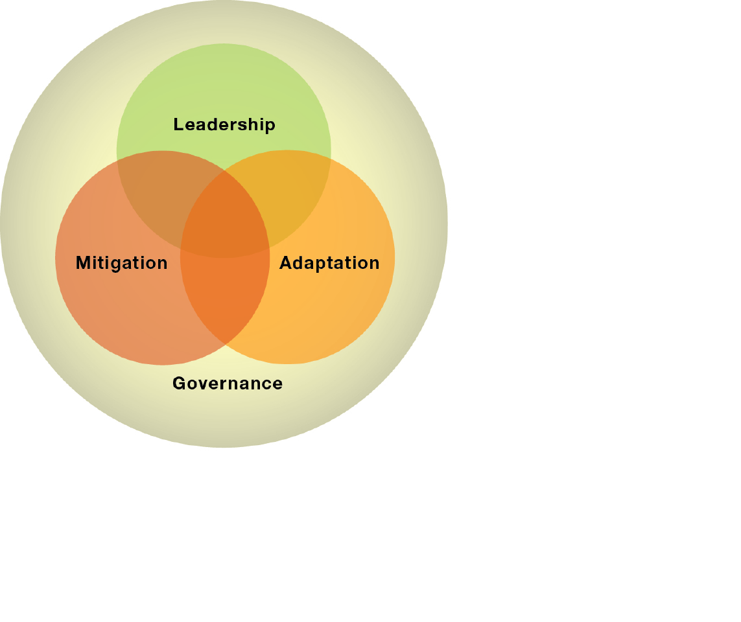
Plan aims
This plan aims to:
- identify the forecast changes to our local climate
- identify how these changes might impact upon Council operations and the Nillumbik community
- develop strategies and actions to reduce the severity of those impacts on the delivery of Council services and our community, including those most vulnerable to extreme weather events and their consequences
- prioritise actions that will lead to achieving Council and community emissions targets
In doing so, Council will aim to balance:
- economic security
- community wellbeing (including mental and physical health and safety)
- social inclusion and intergenerational equity
- environmental protection
Council recognises that the following challenges must be addressed through this plan:
- the accommodation of increased population while minimising the impact on the natural environment
- an ageing population
- increasing expectations of community facilities (size, quality, automation, temperature control)
- increasing utilisation of facilities
- cost pressures of energy and water supplies and waste disposal
- engaging our community to undertake change
- limited public transport
- urban growth corridors to the west of the Shire
- consideration of embodied energy and the supply chain
- aged building stock of Council and the community
- the lifestyle of our residents in terms of land use and social activity
- finite Council resources

Context
The Shire of Nillumbik is located less than 25 kilometres north-east of Melbourne, and has the Yarra River as its southern boundary. It extends 29 kilometres to Kinglake National Park in the north and approximately 20 kilometres from the Plenty River and Yan Yean Road in the west to Christmas Hills and the Yarra escarpment in the east.
The Shire covers an area of 432 square kilometres and has an estimated population of 62,872 who live in close-knit communities which range from typical urban settings to remote and tranquil bush properties.
There are over 300 hectares of nature and recreation reserves and 5,400 hectares of the Kinglake National Park in the north of the Shire.
Nillumbik hosts just over 6,300 businesses employing around 15,000 people. Most of these businesses are categorised as small. Health care, education and retail are the three largest business sectors, but there are also a number of food producers and manufacturers.
The Nillumbik Green Wedge covers 91 per cent of the total Shire area. Green Wedge areas were set up over 30 years ago to preserve land for farming, conserve biodiversity and habitat for wildlife and to provide opportunities for people to “escape” from the city. The Green Wedge areas now have an added role in the context of climate change with the relatively dense tree population in Nillumbik acting as a carbon sink, absorbing carbon dioxide produced through our daily activities.
While Australia, with a population of 24 million, generates around 1.5 per cent of global emissions (about the same as France, population 66 million, United Kingdom, population 64 million, and Italy, population 62 million), on a per capita basis Australia generates more emissions than any other Organization for Economic Cooperation and Development (OECD) country at double the OECD average and more than four times the world average.

This is not sustainable in the long term in respect to both the quantity of resources consumed and the greenhouse gases emitted.
Successful reduction in greenhouse gas emissions to a level that will prevent unmanageable climate impacts will require a whole-of-community response, including:
- energy and resource efficiency across all sectors
- clean renewable energy technologies
- addressing high levels of consumerism and waste
- acknowledging impacts upon the whole environment and incorporating rehabilitation costs into decision making processes
- reducing the environmental impact of unavoidable emissions

The latest information on climate change
The Intergovernmental Panel on Climate Change (IPCC) is a scientific body established to provide an objective source of information about climate change. The IPCC’s role is to assess worldwide technical and scientific literature and to synthesize the information produced into a clear scientific view of what the world knows about climate change. The IPCC does not perform scientific research or monitor data and is policy neutral.
Since its inception in 1988, the IPCC has produced five reports, the latest of which is IPCC’s Fifth Assessment Report, 2014.
This report identified the following observed changes to the global climate:
- An increase in global average land and sea surface temperature of 0.9 degrees Celsius from 1880 to 2012. Almost the entire globe has experienced surface warming.
- Changes in extreme weather events have been observed since 1950. The number of cold days and nights has decreased while the number of hot days and nights has increased. The frequency of heatwaves has increased in Europe, Asia and Australia and rainfall patterns are changing across the globe.
- The average temperature of the upper 75 metres of oceans has increased by 0.4 degrees Celsius between 1971 and 2010.
- Ice sheets in the northern hemisphere and glaciers have lost substantially more ice in recent years while the Antarctic ice sheet had larger increases in size between 2002 and 2011 than previously seen.
- Global mean sea level rose by 0.19m from 1901 to 2010.
- Atmospheric concentrations of carbon dioxide (CO₂), methane (CH₄) and nitrous oxide (N₂O) have increased by 40 per cent, 150 per cent and 20 per cent respectively from pre-industrialised time in the late 18th century to 2011.

Forecast local climate changes
Future changes to the climate will depend upon the rate at which society emits greenhouse gases: the higher the emission levels, the greater the effect on the climate.
By 2070 Melbourne can expect that:
- With low greenhouse gas emissions growth: 1.3 degrees Celsius warmer with six per cent less rainfall, or
- With high greenhouse gas emissions growth: 2.6 degrees Celsius warmer with 11 per cent less rainfall.
Table 1: This table compares the current Nillumbik weather patterns to those predicted by 2070 under the two different scenarios. It shows the average number of days of each event each year or the percentage change each year:
Event | Current | 2070 with low growth emissions | 2070 with high growth emissions
Frosts | 3 | 1 | 0
>30 degrees | 30 | 39 | 49
>35 degrees | 9 | 14 | 20
>40 degrees | 1 | 3 | 5
Rainy Days |  | -10% | -19%
Extreme Daily Rainfall |  | +3% | +6%
The expected weather impacts on the Shire of Nillumbik include:
- increased number of hot days and nights
- increased frequency and duration of heatwaves
- increased intensity and duration of droughts
- less rainfall, particularly in winter and spring
- increased number of heavy precipitation events
- increased frequency of windy days and higher wind speeds
The consequences of these changes for the community and the environment include:
- significant reductions in water runoff into rivers, creeks and streams (up to 50 per cent less under a high emissions growth scenario)
- increases in water temperature and changes in stream flows
- more extreme weather events such as storms, floods and heatwaves
- longer fire seasons and a higher risk of bushfire
- lower crop and stock production
- increased number of heat related deaths and illnesses
- increased number of stress related illnesses
- short term power blackouts during peak demand on hot summer afternoons
- long term power blackouts due to infrastructure failure
- increased frequency of damage to infrastructure and private property from fire, flood and wind
- lower quality of playing surfaces at sportsgrounds
- more disruptions to public transport and road travel
- greater loss of biodiversity and tree canopy
- introduction of invasive species due to fire, drought and migration
- outbreaks of contagious diseases common to warm climates
- economic costs from lost infrastructure and assets, reduced number of workdays, lost production and rising energy and water costs.
The impacts of climate change on community infrastructure, health and wellbeing are recognised in the Australian Academy of Science report Climate change challenges to health. Risks and opportunities.
“The direct and indirect physical and mental impacts of climate change on health and wellbeing are considerable. Extreme weather events can cause injury and death while infrastructure losses, mental stress and trauma can have long-term effects. Future changes in weather and climate will also have indirect effects through their adverse impacts on agriculture and aquaculture while changes in temperature and rainfall regimes could alter the distribution and transmission of vector-, food- and water-borne diseases. More frequent extreme weather events will also place a greater and growing demand on public health and emergency services.”

Pathways to effective change
The 1994 Convention on Climate Change sets a framework for intergovernmental action to tackle the effects of climate change. There is international agreement to limit global warming to two degrees to prevent the most serious consequences for human health, food and water supplies, biodiversity and extreme weather events.
ClimateWorks Australia and the Australian National University have been leading research into how Australia could play its role in this global challenge. Their report Pathways to Deep Decarbonisation in 2050: How Australia Can Prosper in a Low Carbon World proposes three possible pathways to achieve zero net emissions in Australia by 2050 while allowing for ongoing annual economic growth of 2.4 per cent.
The pathways include:
- Energy efficiency – across all sectors of the community.
- A low carbon electricity supply – including increases in renewable energy generation or the inclusion of a portion of nuclear energy generation.
- Electrification and fuel switching – including transport, industry and buildings.
- Dealing with non-energy emissions through process improvement and carbon forestry.
“This is the critical decade for action. We are now in 2014 and approaching the halfway point in the decade. Despite the promising developments in low carbon technologies and energy efficiency measures, Australians have not yet reached a consensus on the need to decarbonize our economy and on the development of policies that will turn investments towards a decarbonized future. This challenge must be met if we are to minimize the risk of worsening extreme weather events for our children and grandchildren. It’s time to get on with the job.”
Climate Council of Australia Ltd, Angry Summer 2013/2014, 2014.
The actions in this plan will ensure Council and the Nillumbik community make contributions to Australia achieving zero net emissions by 2050.

Mitigation of climate change
There are many actions that Council and the community can undertake to reduce emissions and the consequent severity of climate change. Council follows the principles of the carbon management hierarchy to ensure efficient and effective outcomes. Table 2 lists each principle in priority order. It is generally cheaper to implement actions toward the top of the table than those towards the bottom, although in recent years the cost of rooftop solar has seen shorter payback periods than some types of energy efficiency measures.
Table 2: Carbon Management Hierarchy
Principle | Explanation | Council’s actions to date
Measure | Measuring the current level of emissions from all sources enables a clear picture to inform stakeholders of what action might be required. It also allows for monitoring of progress towards targets. | Council gathers information on energy and water consumption for all Council-owned assets, including Council managed and leased buildings, sports grounds, streetlighting and reserves.  Council gathers information on residential, industrial and commercial energy consumption and emissions within Nillumbik on an annual basis.
Set goals | Setting goals that will lead to achieving the vision and inform strategies and actions. | Through the Climate Change Action Plan goals are set every five years to reduce energy consumption, switch to cleaner sources of energy and to offset residual emissions. The Ecologically Sustainable Development (ESD) Policy contains goals for energy efficiency building standards for Council’s new developments and significant alterations.
Avoid | Strategies to avoid the generation of emissions. | New facilities are built to high energy efficiency standards in accordance with the ESD Policy.  Sensors for lighting and air conditioning are retrofitted and set points for air conditioning changed.  Residential and Council waste is diverted from landfill through the three-bin system which includes recycling and composting.  The Procurement Policy directs officers to make purchasing decisions that consider the environmental impact of goods and services.
Reduce | Strategies to reduce the generation of emissions. | Energy efficient appliances, insulation, draught proofing, shade structures, windows, tap aerators and low flow showerheads are retrofitted.  Fleet vehicles are replaced with more fuel efficient, lower emission vehicles.  Staff use public transport where feasible.  Council-owned streetlights were replaced with energy efficient lamps in 2010.  The landfill waste site uses methane capture to generate electricity.
Switch | Strategies to use energy from cleaner, renewable sources. | Rooftop solar systems are installed on Council-owned buildings (206.5 kilowatts to June 2015).  GreenPower is purchased for Council electricity consumption.
Sequester | Strategies to capture carbon dioxide below ground, sea or in trees. | There is insufficient land in Nillumbik available for planting to sequester significant quantities of greenhouse gases. Some sequestration projects are supported through the purchase of carbon offsets.
Offset | Gas, vehicle fuels and grid supplied electricity are offset as a final action. | Purchase of accredited offsets for Council electricity, gas and fuel consumption.
Council encourages the community to take action based on the carbon management hierarchy in their own homes, businesses and community groups. Council provides a number of opportunities to help the community to achieve this, including:
- Providing a comprehensive environmental activities program including workshops, talks and demonstrations on a variety of ways to reduce our impact on the environment (Autumn Action, Winter Escapes and Spring Outdoors).
- Information about climate change, energy and energy efficiency, sustainable building, composting, growing food and better environmental choices on the website and through free publications.
- Providing examples of sustainable building, technologies and behaviours through Edendale Community Environment Farm.
- Communicating information about local energy consumption to our residents, including average consumption by postcode, setting targets for efficient consumption and how to reduce energy use (Go5 Pilot Project).
- Providing home energy auditing kits through Nillumbik libraries.
- Offering free sustainability information to applicants throughout the planning and building phases of their building projects (Sustainable Design Assessment in the Planning Process).
- Offering bulk purchasing programs for products that help reduce emissions (Delivering Clean Energy Solutions).
- Hosting an annual sustainability festival to showcase the latest products and services available to assist households to become more sustainable (Practically Green Sustainability Festival).
- Coordinating awards for outstanding examples of sustainability throughout the community (Practically Green Sustainability Awards).
- Hosting an annual program to encourage households to grow their own food that culminates in a feast for growers, their families and friends (Home Harvest).

Nillumbik’s emissions

Total community emissions
The majority of greenhouse gas emissions generated in Nillumbik come from stationary energy consumption (59 per cent) and transport (38 per cent). Industry, agriculture and changes to land use contribute only small quantities to the total. Council operations generate approximately 1.5 per cent, with the community generating the remaining 98.5 per cent of the total emissions for the Shire.
Figure 2: Overall emissions for the Shire of Nillumbik by source.

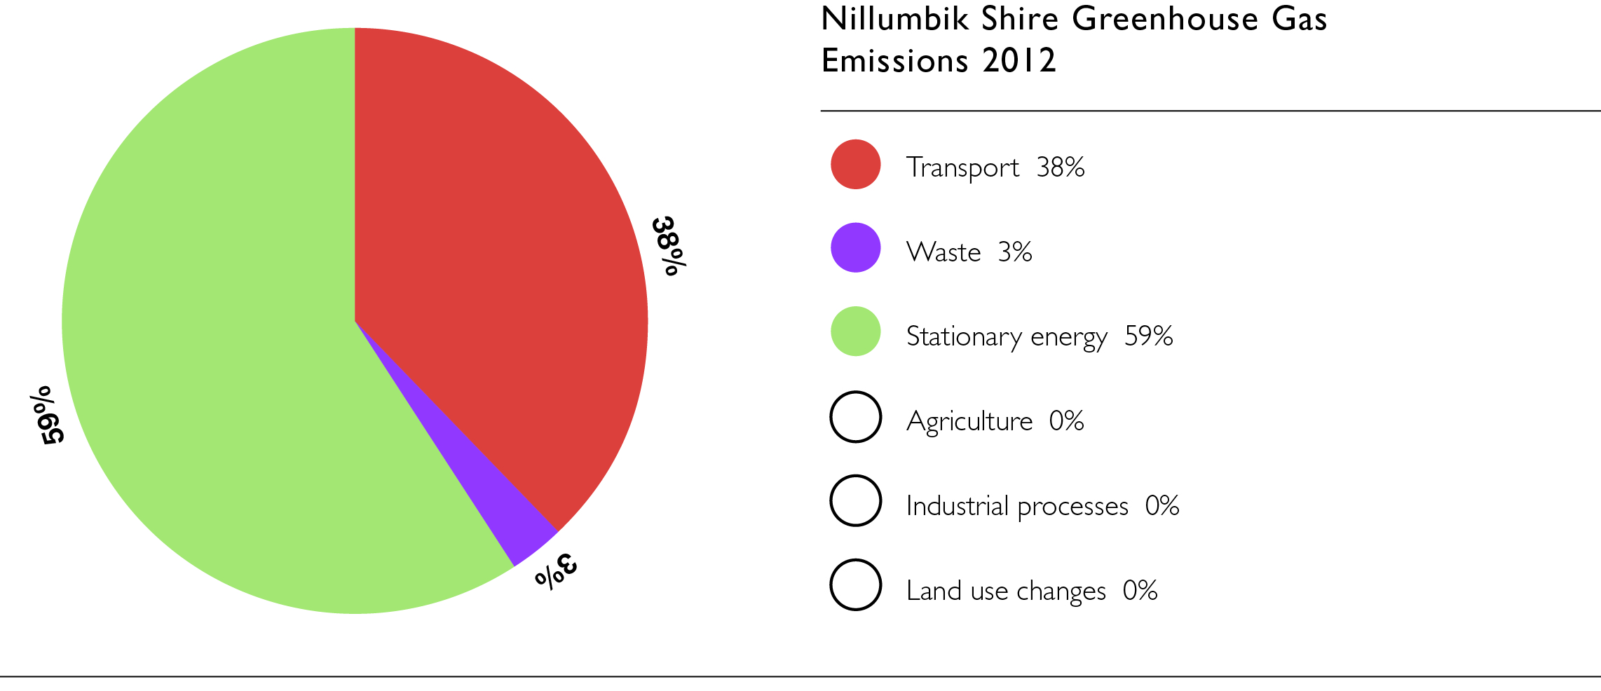

Council’s operational emissions
Of Council’s total emissions, stationary energy (62 per cent), transport (19 per cent) and streetlighting (18 per cent) are the three largest contributors.

Figure 3: Council’s operational emissions by source

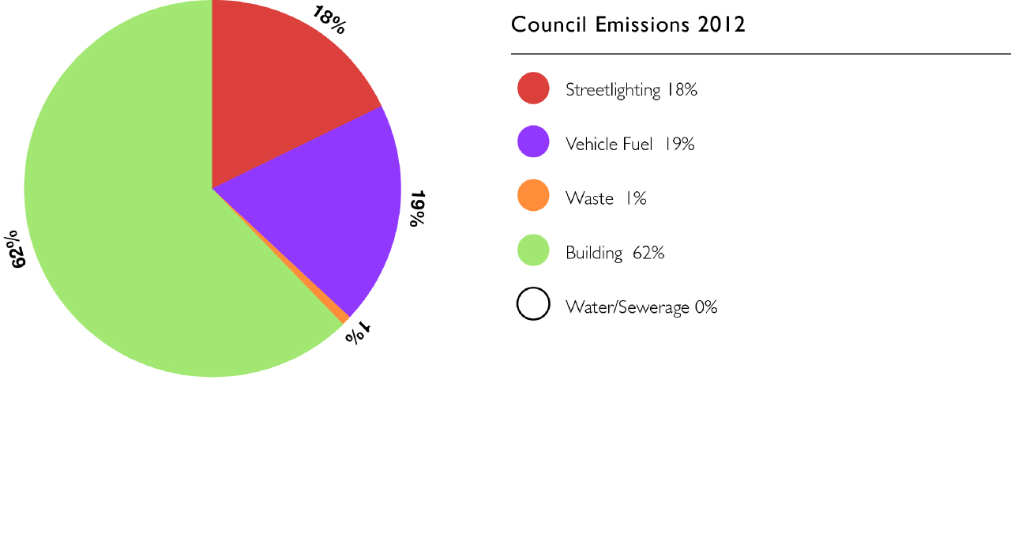

Stationary energy emissions
Stationary energy consumption in Nillumbik refers primarily to electricity and gas consumed in businesses and households.
Figure 4: The percentage of emissions generated by households and business by fuel type and a comparison of the consumption patterns between 2006 and 2012.
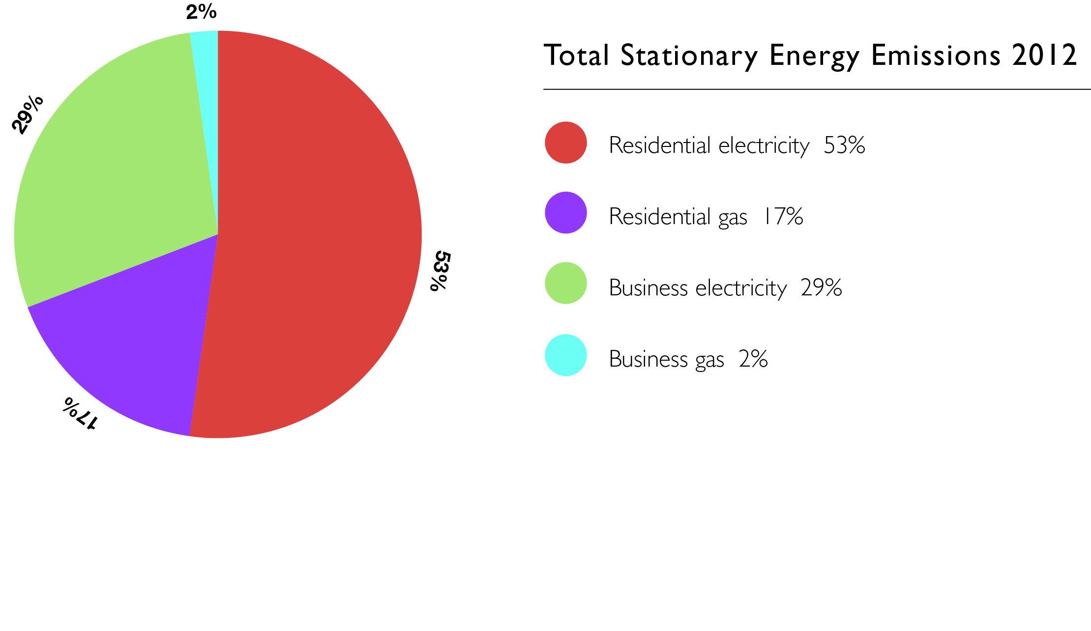
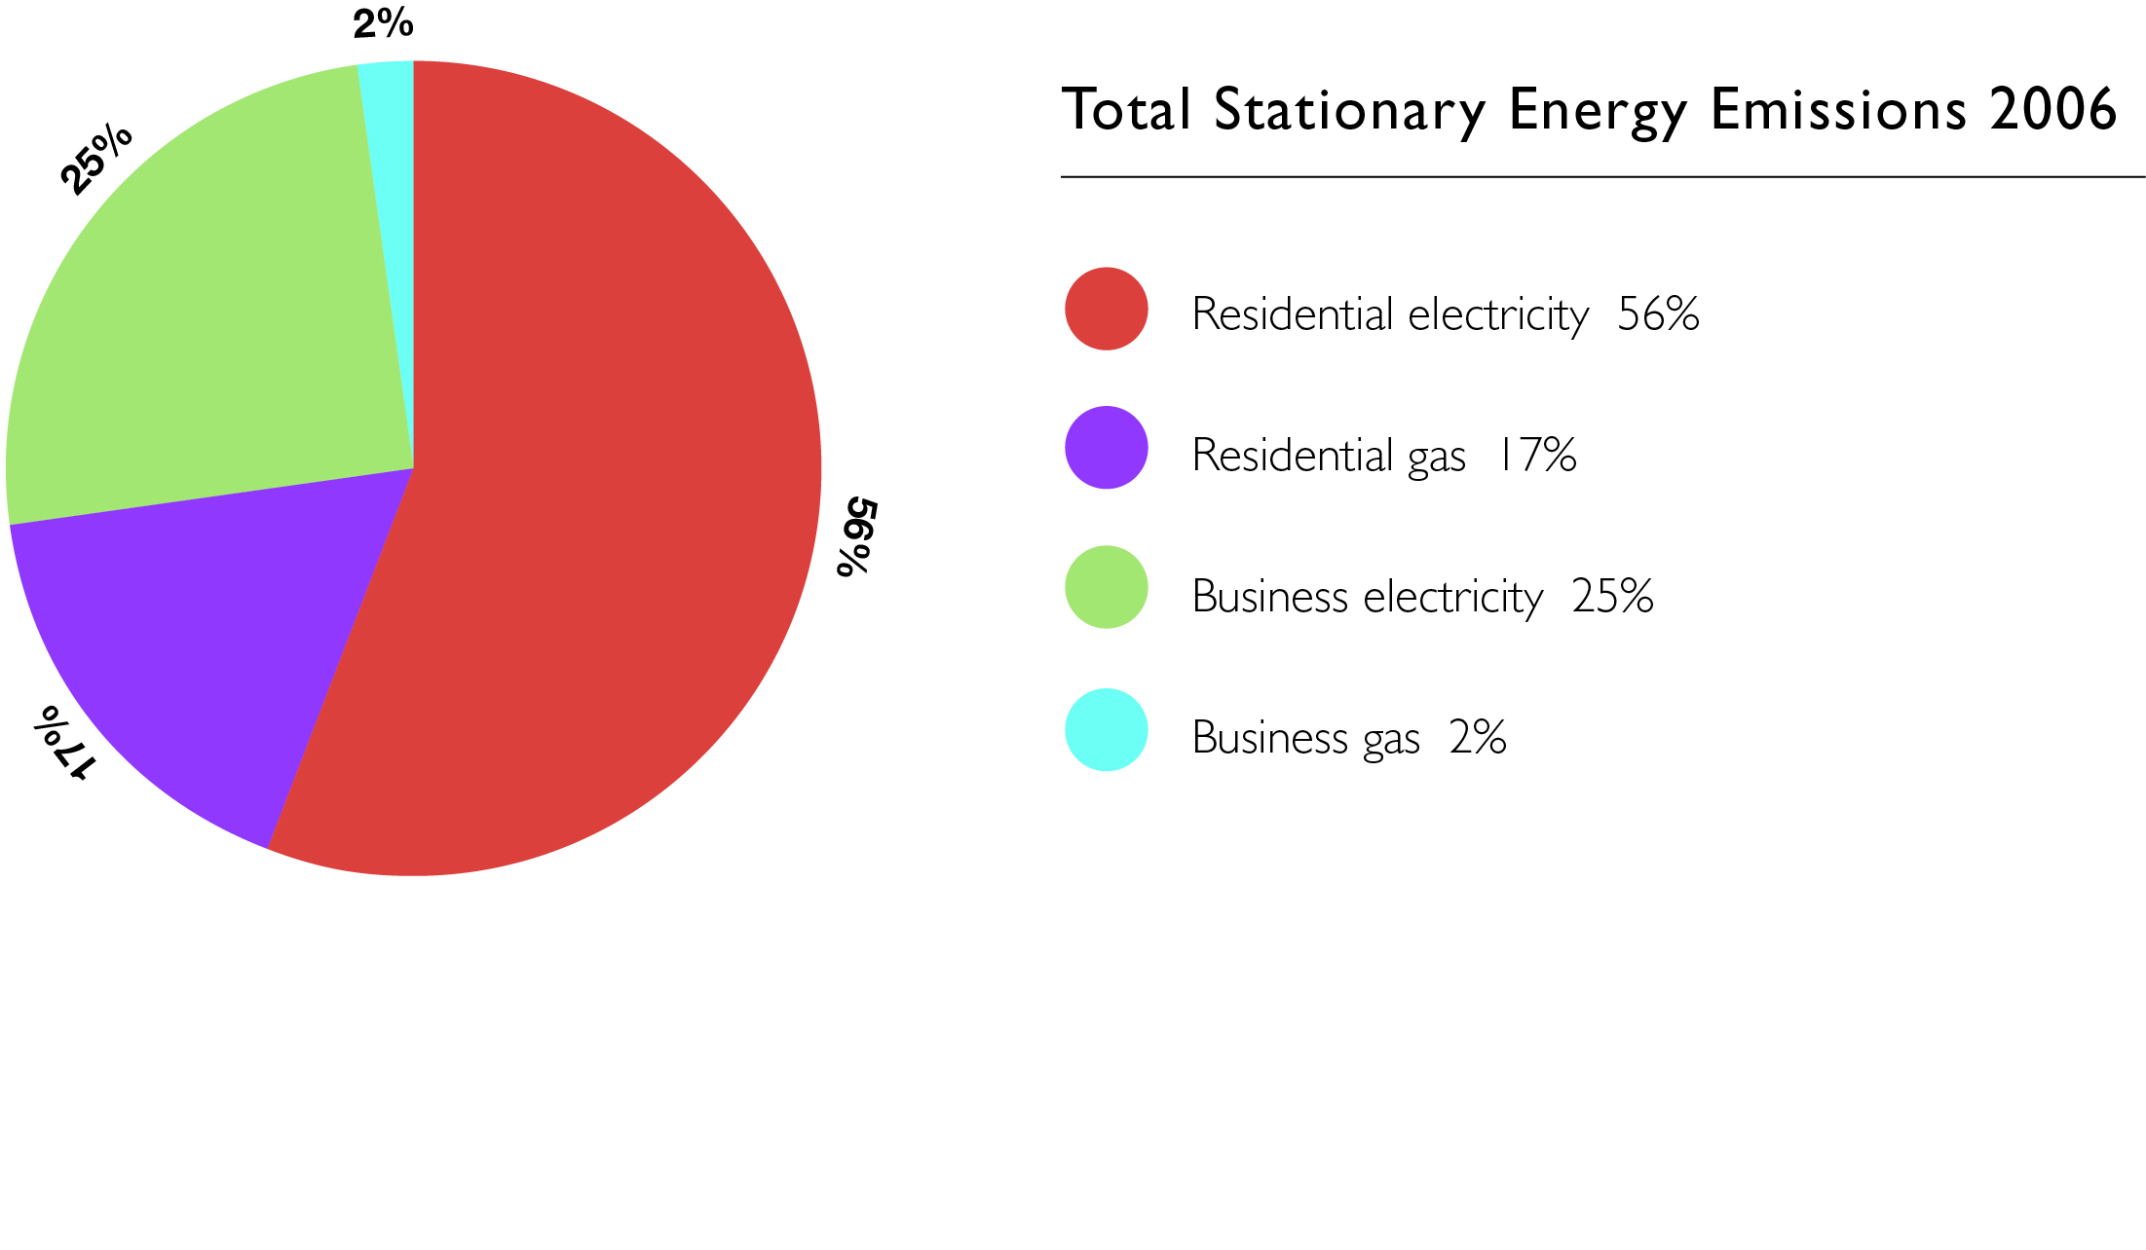The distribution of consumption has remained relatively stable between 2006 and 2012, with only a three percent increase in business electricity emissions offset by a three per cent decrease in residential electricity emissions. Total emissions from stationary energy consumption increased from 381kilotonnes (kt) CO₂-e in 2006 to 393kt CO₂-e in 2012, or 3.1 per cent.

Renewable energy installations
Rapid improvements in technology and pricing have resulted in a significant increase in renewable energy systems worldwide.
The graph below shows a total of 4,464 solar electricity systems were installed on Nillumbik rooftops to 2012. This compares to a total of nine systems in 2006.

Figure 5: The total number of solar electricity systems installed in Nillumbik to 2012 by postcode.
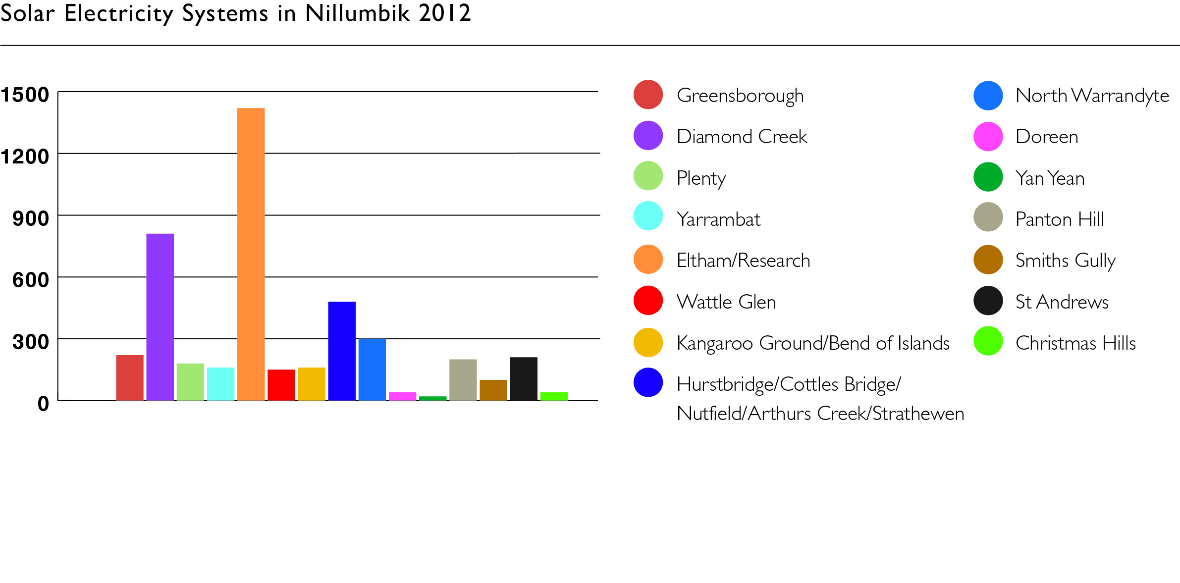
The graph below shows a total of 1,149 solar and heat pump hot water systems installed throughout Nillumbik to 2012. This compares to a total of 193 systems in 2006.
Figure 6: The total number of solar and heat pump hot water systems installed in Nillumbik to 2012 by postcode.
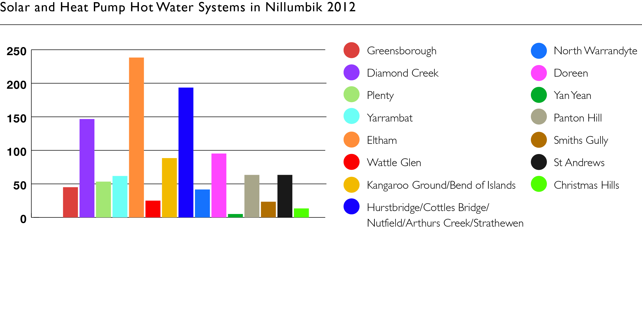

Climate change mitigation targets
The overarching goal of this plan is to reduce greenhouse gas emissions produced by Council by 17 per cent and community activities by six per cent from 2012 levels by 2020 in order to mitigate climate change. Council recognises that making significant changes to the carbon intensity of the energy supply, building energy efficiency standards and vehicle emissions standards is limited at the local level. Mitigation targets have therefore been set with achievable changes by Nillumbik households and businesses in mind that will result in lower emissions.

Targets – Council
- To produce 30 per cent of Council’s building energy requirements through on-site renewable energy sources by 2020.
- To reduce gas consumption at Council-owned buildings by 21 per cent of 2012/13 levels by 2020*.
- To reduce grid supplied electricity consumption at Council-owned buildings by 20 per cent of 2012/13 levels by 2020*.
- To develop a target for reduced Council fleet emissions by 2017.
- To offset 100 per cent of Council’s emissions from centralised energy and fleet fuel consumption for the life of the Plan.

Targets – Community
- To assist 100 households and 20 businesses to install solar electricity by 2020.
- To assist 20 businesses to implement energy efficiency measures by 2020.
- To assist Nillumbik households to reduce electricity consumption to an average of six kilowatt hours per person per day by 2020.
- To assist Nillumbik households to reduce gas consumption by 10 per cent of 2012 levels by 2020.
*These targets include buildings in existence in 2012. All new Council buildings are built to high energy efficiency standards in accordance with the Ecologically Sustainable Development (Building, Design and Works) Policy 2011.

Adaptation to climate change
There is no doubt our climate is changing already and that our community must prepare to live with these changes in the best way possible.
In 2014, Council signed a Memorandum of Understanding with the Victorian Government that outlines agreed responsibilities for adaptation strategies for both parties.
In early 2015, a Regional Climate Change Adaptation Plan was developed for the northern region of Melbourne. The Plan identifies a number of risks, vulnerabilities and actions for Council and forms the core of Council’s individual and regional adaptation work.
Over the last few years Council has also been developing adaptation actions through a number of plans, strategies and policies, including:
- Health and Wellbeing Plan 2013-2017
- Emergency Management Plan 2014-2017
- Fire Management Plan 2013-2016
- Heatwave Plan, Pandemic Plan and Flood and Storm Plan (sub plans of the Emergency Management Plan are reviewed annually)
- Resilient Nillumbik (strategy currently under development)
- Integrated Water Management Plan 2013
- Domestic Wastewater Management Plan 2015-2018
- Ecologically Sustainable Development (Building, Design and Works) Policy 2011
- Water Tank Policy 2011.
This Climate Change Action Plan seeks to formalise an adaptation planning framework that will embed adaptation actions throughout Council’s work.
It is evident that most households and businesses have not yet begun to take action that would help them to adapt to a changed climate. Council is in a good position to assist the community to identify the impacts and risks associated with climate change and to facilitate action to mitigate those impacts and risks.

Climate change adaptation targets
The overarching adaptation goal of this plan is to ensure that Council and the community have identified risks and vulnerabilities related to climate change and have a considered pathway to implement appropriate measures that will reduce the potential impacts.

Targets – Council
- All plans, strategies and policies are reviewed to incorporate applicable adaptation actions by 2020.
- All vulnerable assets are identified and a plan to mitigate risk is in place by 2020.

Targets – Community
- The impacts of climate change on Nillumbik households are widely understood and some preparedness is underway, for example, are using an adaptation toolkit to assess risk and take action.
- The impacts of climate change on Nillumbik businesses are widely understood and some preparedness is underway, for example, are using an adaptation toolkit to assess risk and take action.
- Council and the community are working together on implementing specific actions that will allow sectors of the community to adapt to a changed climate.

Monitoring and reporting
The Climate Change Action Plan will be reviewed every five years to assess progress towards priority actions, that goals are relevant and that existing actions will assist in achieving the targets.
Progress towards achieving targets will be reviewed every second year through the State of the Environment Report and will be made available to the community on the Nillumbik Shire Council website.
Key actions within the Climate Change Action Plan will form part of Council’s business planning process and progress will be reported annually, monitored by analysis of annual emissions and the progress towards embedding climate change adaptation within Council and community.

Action plan
The Action Plan provides a structure for climate change mitigation and adaptation activities consistent with achieving the targets. It includes actions to be undertaken directly within Council operations as well as services and actions that support community responses.
The Action Plan has been divided into seven goal areas:
- Strategic - Developing a framework to ensure climate change action is embedded into Council operations and progress is measured and reported. Actions related to work on a regional scale and advocacy for wider reaching programs are also included in this section.
- Corporate – Improving the energy and water efficiency of Council-owned assets to reduce greenhouse gas emissions and enhance operational resilience to climate change impacts.
- Residential – Providing assistance and education to households to improve the energy and water efficiency of Nillumbik homes in order to reduce greenhouse gas emissions and enhance the health and wellbeing of residents in a changed climate.
- Business – Providing assistance and education to businesses to improve energy, water and resource efficiency of their operations and to enhance operational resilience to climate change impacts.
- Energy Supply – Decarbonising the energy supply through advocacy to Federal and State Governments and providing assistance for households, businesses and community groups to transition to clean renewable energy sources.
- Transport – Improving transport links to facilitate active transport use by Nillumbik residents and improving local business and consumer networks to reduce transport emissions.
- Residual Emissions – Offsetting Council’s unavoidable operational emissions and encouraging the community to offset emissions in a cost-effective and environmentally beneficial way.
Legend – Internal Council teams
AP | Assets and Property
CASBE | Council Alliance for the Sustainable Built Environment
CF | Community Facilities
Comms | Communications
Council | Whole of Council
CP | Community Participation
E | Edendale Community Environment Farm
ECG | Environment Coordination Group
ED | Economic Development
EM | Emergency Management
EP | Environmental Planning
ET | Ecoteam
EW | Environmental Works
FCS | Family and Children’s Services
Fin | Finance
FM | Fleet Management
GMT | General Management Team
ID | Infrastructure Development
IM | Infrastructure Maintenance
IT | Information Technology
LL | Living and Learning Nillumbik
LSI | Leisure and Social Infrastructure
MWRRG | Metropolitan Waste Resource and Recovery Group
NAGA | Northern Alliance for Greenhouse Action
OD | Organisational Development
PBS | Planning and Building Services
SP | Strategic Planning
WM | Waste Management

Strategic actions
Council is committed to managing the environment in a sustainable way and to ensuring the Nillumbik community is safe and healthy in the face of a changing climate. These strategic actions will ensure that Council has a framework in place to coordinate internal action that will help to achieve its stated goals, to harness the power of working with the community, agencies, alliances and all levels of government to implement incremental change and to measure and monitor progress.
In this, Council’s fourth Climate Change Action Plan, there is an added focus on adaptation actions that will help assess the emerging risks and vulnerable sectors of our community. This will assist Council to achieve more flexible operations and service delivery that responds to the changing environment.
Strategic - General
Number | Action | Timing | Responsibility | Secondary Responsibility
1 | Continue to actively support the Northern Alliance for Greenhouse Action (NAGA) to effect large scale regional emission reductions and adaptation strategies. | Ongoing from 2016 | EP
2 | Continue to work with other regional greenhouse alliances, local government alliances and industry bodies to effect large scale emission reductions and adaptation strategies. | Ongoing from 2016 | EP
3 | Share Council actions on climate change mitigation and adaptation with the community through the biennial State of the Environment Report. | 2017 and 2019 | EP | Council
4 | Continue to allocate budget to the Resource Conservation Fund to facilitate ongoing emission reductions and meet the adaptation requirements of Council assets. | Ongoing from 2016 | Council
5 | Progress towards all actions will be provided by responsible managers to GMT annually for review. | Ongoing from 2016 | EP, All | GMT
6 | Investigate the feasibility of including ESD into the Municipal Strategic Statement and developing local planning policy to improve the environmental sustainability of building stock in Nillumbik. | 2017 | SP | EP
7 | Monitor results from the ESD Policy implementation in Victorian councils. | Ongoing from 2016 | EP | PBS
8 | Continue to extend structure planning to all neighbourhood centres to ensure sustainable urban design outcomes are achieved across the Shire. | Ongoing from 2016 | SP
9 | Ensure lease and licence agreements incorporate requirements to work with Council to reduce energy and water consumption and waste volumes, and encourage community participation in climate change mitigation and adaptation programs. | Ongoing from 2016 | AP | EP, LSI,  CF, FCS
There is no doubt our climate is changing already and that our community must prepare to live with these changes in the best way possible.

Strategic - Mitigation
Number | Action | Timing | Responsibility | Secondary Responsibility
1 | Continue to investigate, trial and adopt new energy efficiency and renewable energy technologies and practices where suitable. | Ongoing from 2016 | EP, NAGA | Council
2 | Continue involvement with Victorian Government partnerships that promote emissions reduction, information sharing and capacity building programs. | Ongoing from 2016 | EP, NAGA
3 | Advocate to the Victorian and Australian Governments on issues affecting climate change mitigation, including:  * substantial mitigation actions should not take a back seat to adaptation actions  * renewable energy generation and equitable feed-in tariffs  * equitable energy supply costs  * assistance for vulnerable sectors of the community to improve the energy efficiency of their homes  * assistance for disadvantaged local governments to improve the energy efficiency of their buildings  * improved sustainable building standards through planning legislation and National Construction Code  * improved energy efficiency of public lighting  * improved public transport options across the region. | Ongoing from 2016 | NAGA | EP
4 | Advocate to the Victorian Government for specialist waste recovery streams, including, but not limited to:  * construction and demolition  * solar panel components  * bottles. | Ongoing from 2016 | MWRRG | IM
5 | Develop a Council fleet fuel reporting system to enable robust reporting and analysis of emissions and offset requirements. | 2017 | EP | Fin, IM
6 | Continue to monitor Council energy and water consumption through the Utility Billing Management System to enable robust reporting and analysis of emissions and offset requirements. | Ongoing from 2016 | EP | Fin, Bill Payers
7 | Continue to monitor community energy consumption to enable robust reporting and analysis of emissions and to inform the Environmental Activities Program. | Ongoing from 2016 | EP | NAGA
8 | Investigate opportunities to divest funds supporting the fossil fuel industry. | Ongoing from 2016 | Fin | Council

Strategic - Adaptation
Number | Action | Timing | Responsibility | Secondary Responsibility
1 | Continue involvement with Victorian Government partnerships that promote adaptation programs, including Council's obligations under any memorandum of understanding. | Ongoing from 2016 | EP, NAGA
2 | Advocate to the Victorian and Australian Governments on issues affecting climate change adaptation, including:  * assistance for vulnerable sectors of the community to improve the thermal performance of their homes  * assistance for disadvantaged local governments to implement adaptation actions | Ongoing from 2016 | NAGA | EP
3 | Support actions identified in the Regional Climate Change Action Plan. | Ongoing from 2016 | EP | Council
4 | Form cross-functional working groups to integrate climate change adaptation into all policy, strategy and plan reviews. | Ongoing from 2016 | Council | ECG, EP
5 | Facilitate discussion around issues with conflicting risks to determine Council's policy position. | Ongoing from 2016 | ECG | Council
6 | Review the Ecologically Sustainable Development Policy (Building, Design and Works) every two years to determine whether or not it meets the needs for a changed climate. | Biennially from 2017 | EP
7 | Review the Disaster Recovery Plan every two years to ensure it includes risks from a changed climate. | Biennially from 2016 | EM, IT
8 | Review the Business Continuity Plan every two years to ensure it includes risks from a changed climate. | Biennially from 2016 | Fin

Corporate actions
Council operations contribute around 1.5 per cent of total emissions within the Shire of Nillumbik. Council holds a unique ability to demonstrate leadership in climate change mitigation and adaptation activities as well as having a responsibility to manage Shire assets to maximise their use and minimise the cost to ratepayers.
Council will continue to work with the occupants of Council-owned facilities to improve the efficiency of the site and change behaviours to maximise emissions reductions.
Mitigation actions will continue to be taken to reduce emissions from building operations, public and street lighting, fleet, waste and procurement to achieve the stated targets. New facilities will be built to the high sustainability standards contained in the Ecologically Sustainable Development (Building, Design and Works) Policy to avoid unnecessary increases in emissions.
While some actions taken to mitigate climate change will also assist with adaptation, efforts will initially focus on developing a toolkit that will ensure adaptation is embedded across all Council operations over the life of this plan.
Corporate - Strategic
Number | Action | Timing | Responsibility | Secondary Responsibility
1 | Review the Information Technology and Communications Strategy to include new energy efficient technologies and processes. | 2019 | IT
2 | Include sustainability related continuous professional development (CPD) as a requirement of all regular contractors in future panel tenders. | Ongoing from 2016 | Fin | EP, AP
3 | Develop a list of Council policies, strategies and plans and their review dates to ensure mitigation and adaptation actions are included. | 2016 | EP
“Sustainable development is the pathway to the future we want for all. It offers a framework to generate economic growth, achieve social justice, exercise environmental stewardship and strengthen governance.”
Ban Ki-Moon, United Nations Secretary General, 5 September 2013.
Corporate - Mitigation
Number | Action | Timing | Responsibility | Secondary Responsibility
1 | Continue Council's ecoteam activities to reduce staff emissions generated by energy consumption, travel and waste. | Ongoing from 2016 | ET | Council
2 | Develop information about how Council staff can reduce their impact on the climate to be included in the induction process. | 2017 | ET | OD
3 | Continue to work with the Municipal Association of Victoria (MAV) to improve the energy consumption of information and communication equipment. | Ongoing from 2016 | IT
4 | Continue to encourage sustainable purchasing of products and services through the Procurement Policy and ESD Policy and ensure that requirements are regularly communicated to all staff. | Ongoing from 2016 | EP, Fin | Council
5 | Ensure Council contractors are informed about objectives and targets within the Climate Change Action Plan and the ESD Policy through information sessions. | Triennially from 2016 | EP, Fin
6 | Review the implementation of Structure Plans to encourage greater construction around activity centres including commercial, residential and transport infrastructure. | 2017 | SP
7 | Continue to reduce the amount of bitumen/concrete product used on existing and proposed infrastructure by:  * reducing road width appropriate to use  * timing construction and resurfacing to ensure the efficacy of the works. | Ongoing from 2016 | ID | IM
8 | In partnership with other Councils in the region investigate ways to turn some Council streetlighting off late at night. | 2018 | NAGA | EP, ID
9 | Investigate where lights can be removed or timers can be placed on security lighting to reduce energy consumption. | Ongoing from 2016 | ID
10 | Review the Public Lighting Policy to remove the need to install grid connected lighting where mains power is available. Replace with options dependent upon a lifecycle cost assessment. | 2016 | ID
11 | Review Fleet Policy annually to include:  * the most fuel efficient, fit-for-purpose vehicles available  * pool car and parking options to minimise work travel. | Annually from 2017 | IM | OD
12 | Investigate and pursue emerging technologies for fuels and vehicles. | Ongoing from 2016 | FM
13 | Continue to support work from home options in the Enterprise Agreement and provide electronic conferencing options to reduce unnecessary travel. | Ongoing from 2016 | OD

Corporate - Adaptation
Number | Action | Timing | Responsibility | Secondary Responsibility
1 | Continue Council's ecoteam activities and incorporate adaptation activities on water and health. | Ongoing from 2016 | ET | Council
2 | Develop a climate change adaptation information package for officers to use when developing Council policies, strategies and plans. | 2016 | EP
3 | Promote the Regional Climate Change Adaptation Plan 2015 to all officers. | Ongoing from 2016 | EP
4 | Develop a reporting tool to track adaptation action progress for reporting purposes. | 2016 | EP | Council
5 | Perform vulnerability assessments on all Council assets and services to identify risks and appropriate adaptation improvements required. | 2016 - 2020 | EP | AP, CF, ID

Residential actions
Residential stationary energy is the highest single contributor to greenhouse gas emissions in Nillumbik. Historical household electricity and gas consumption data dating back to 2002 has been collected from the distribution companies. This information shows that Nillumbik residents are some of the highest energy consumers in Victoria, especially for electricity. Nillumbik homes are larger than the Victorian average and are occupied by more residents than the Victorian average, however, the consumption per person per day is also high. Nillumbik residents are wealthier than average and a large proportion of the housing stock was built prior to the introduction of energy efficiency standards, so often lacks the benefits of passive solar design, insulation, double glazing and a well-sealed building envelope.

Figure 7: The amount of electricity consumed per person per day measured in kilowatt hours within Nillumbik postcode areas compared with the northern (NAGA) region of metropolitan Melbourne.
“We cannot avoid all climate change but significant, urgent and sustained emission reductions will limit the impacts to more manageable levels.” Australian Academy of Science, Response to the “Setting Australia’s Post-2020 Target for Greenhouse Gas Emissions Issues Paper”, May 2015, p2.
Most household energy is consumed for heating, hot water and running electrical appliances. Sustainability Victoria’s 2013 survey indicates how a typical household uses energy.

Figure 8: The breakdown of energy use in a typical Victorian home.
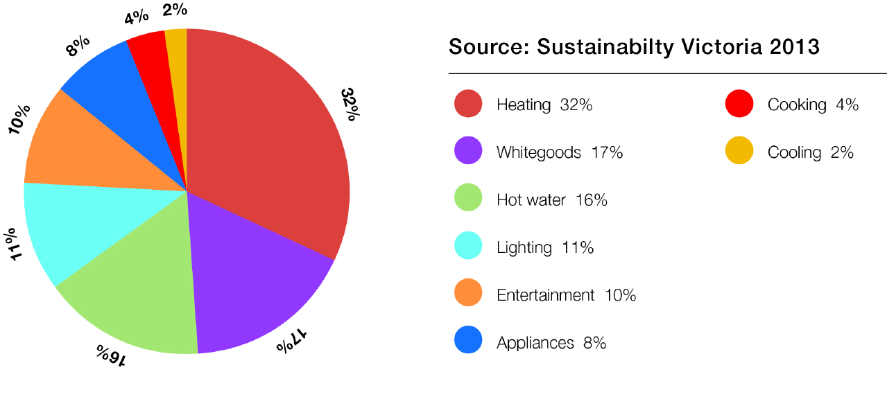
Nillumbik Shire Council has identified the importance of assisting households to reduce their greenhouse gas emissions. There are some unusual challenges for Nillumbik residents with buildings styles including flat roof structures, traditional mud brick construction, limited access to mains gas in the rural areas and a treed environment, all of which make energy efficiency upgrades a little more challenging than the typical suburban house. Council has identified a number of actions to assist households to implement mitigation and adaptation changes and to embed sustainable behaviours in Nillumbik children.
Residential - Strategic
Number | Action | Timing | Responsibility | Secondary Responsibility
1 | Seek opportunities to access government funding to improve interpretation and education programs at Edendale. | Ongoing from 2016 | E
2 | Continue to advocate to the Victorian Government for the incremental adoption of compulsory building standards for new homes and renovations that enhance energy and water efficiency. | Ongoing from 2016 | CASBE, NAGA | EP
Residential - Mitigation
Number | Action | Timing | Responsibility | Secondary Responsibility
1 | Provide displays and take-home materials for the community via hardcopy, web and other social media on how to reduce greenhouse gas emissions. | Ongoing from 2016 | EP, E | LL
2 | Support local climate action groups by assisting to coordinate and promote key events. | Ongoing from 2016 | EP
3 | Continue to offer the community opportunities to learn about climate change and how to implement changes in their lives through workshops and talks, expos and tours, festivals and awards. | Ongoing from 2016 | EP, E
4 | Continue to develop and deliver the environmental education program in accordance with the Environmental Education Strategy, the Edendale Environmental Education Strategy and the Edendale Interpretive Plan, including:  * energy  * biodiversity  * local food  * water  * waste. | Ongoing from 2016 | EP, E
5 | Investigate opportunities to promote bulk purchasing of sustainable technologies throughout the community. | Ongoing from 2016 | EP
6 | Continue GRO 3-bin kerbside domestic waste and recycling to divert organics from landfill, including:  * quarterly reporting on performance of landfill waste, green waste and recycling  * use of recycled materials in the manufacture of bins. | Ongoing from 2016 | WM
7 | Continue to work with the Metropolitan Waste Resource and Recovery Group (MWRRG) and Victorian Government to implement best practice waste management and education programs. | Ongoing from 2016 | WM
8 | Continue to specify diversion targets in future hard waste management contracts. | Ongoing from 2016 | WM
Residential - Adaptation
Number | Action | Timing | Responsibility | Secondary Responsibility
1 | Provide take-home materials for the community via hardcopy, web and other social media on preparing for climate change impacts. | Ongoing from 2016 | EP, E | EW, LL
2 | Continue to offer the community opportunities to learn about climate change adaptation and how to implement changes in their lives through workshops and talks, expos and tours, festivals and awards. | Ongoing from 2016 | EP, E | EW, LL
3 | Develop and adaptation toolkit for households. | 2016 | EP

Business actions
The Shire of Nillumbik has 6,380 businesses employing around 15,089 people. Around 96 per cent are small or micro businesses. Nillumbik has no heavy industry although there are a few small manufacturing plants. Nillumbik businesses contribute around 31 per cent of total stationary energy emissions, mainly from electricity consumption.
Nillumbik Shire Council has identified the importance of assisting businesses to reduce their greenhouse gas emissions and prepare for the impacts of climate change. Assisting businesses to access information about new technologies and financing options, build business cases for change and planning for extreme weather events is the focus of actions in this plan.
“Climate change is as much an opportunity as it is a threat. It is our chance to usher in a new age of green economics and truly sustainable development. New economies can and must grow with reduced carbon intensity even as they create new jobs and alleviate poverty.”
Ban Ki-Moon, United Nations Secretary General, 12 December 2007.
Business - Mitigation
Number | Action | Timing | Responsibility | Secondary Responsibility
1 | Seek opportunities to promote Victorian Government and agency programs to improve energy, water and resource efficiency. Link to established and emerging finance mechanisms offered by state and local government and private financiers. | Ongoing from 2016 | EP, ED
2 | Investigate opportunities for funding of commercial recycling pilots and promote existing programs to business. | Ongoing from 2016 | IM | EP
3 | Continue to offer and support programs that promote the growth of and linkages between local businesses that produce food, including:  * Agricultural Advisory Committee  * land management services  * food mapping and marketing  * farmers' markets  * Open Farm Day  * Landholder Expo. | Ongoing from 2016 | EP, ED
4 | Investigate opportunities to promote sustainability as a point of difference to business networks. | 2020 | ED
5 | Develop a toolkit to assist home based businesses to improve the sustainability of the house and business processes to reduce energy consumption. | 2017 | EP, ED
6 | Continue to advocate to the Australian Government for earlier connection to the National Broadband Network for all areas of the Shire to improve small business and working from home options. | Ongoing from 2016 | ED, Council | EP
Business - Adaptation
Number | Action | Timing | Responsibility | Secondary Responsibility
1 | Develop an adaptation toolkit for small to medium enterprises and launch through business networks. | 2016 | NAGA, EP | ED

Energy supply
Around 90 per cent of Victoria’s electricity demand in 2014 was met with power generated from brown coal. The remaining 10 per cent was met by renewable energy sources such as wind, solar, hydro and bioenergy. The percentage of Victorian renewable energy is lower than the national average of 13.47 per cent and that of South Australia at 40 per cent.
Brown coal contains around 70 per cent water which, when burned to produce electricity, creates high-intensity greenhouse gases (93.11kgCO₂-e/GJ) compared with black coal (88.43kgCO₂-e/GJ), gas (51.33kgCO₂-e/GJ) wind (0.0kgCO₂-e/GJ).
Electricity generation in our current power plants has another problem. The process of burning coal and converting the mechanical energy to electrical energy, plus the vast distance the electricity must be transported via transmission and distribution lines to where it is used means that around 73 per cent of the energy contained in coal is lost.
So why not switch to gas? Using gas does produce lower emissions than brown coal. However, it is still a fossil fuel which does create some emissions and is a finite resource. Council recognises that there are still some applications for which gas is the most efficient source of energy, such as heating pool water in an aquatic centre. As such, gas is considered a transition fuel – one that will be required to effect immediate reductions in emissions, but is not sustainable in the long term. Actions such as enhancing the thermal efficiency of a building and replacing ageing equipment with more efficient versions will help to reduce the amount of gas consumed until new technology enables a switch to renewable energy for these functions.
Electricity generated from the sun, wind and water creates no emissions and the resources are replenished continuously.
In Nillumbik, Council and the community have limited opportunity to enhance the efficiency of our electricity grid other than through advocacy to government and industry, so this plan focuses on switching our energy supply to less emissions-intensive sources.
To the end of 2012, 4,464 solar electricity systems had been installed on Nillumbik rooftops, compared with nine systems in 2006. Similarly there has been a rapid uptake in solar and heat pump hot water systems within the Shire with 1,149 units installed compared with 193 in 2006.
Energy supply - Mitigation
Number | Action | Timing | Responsibility | Secondary Responsibility
1 | Encourage the community to take up clean, renewable energy, including storage options, through:  * providing technical information  * facilitating bulk purchasing opportunities. | Ongoing from 2016 | EP
2 | Investigate opportunities to support community-based distributed clean energy solutions. | Ongoing from 2017 | EP | NAGA
3 | Investigate opportunities at Council facilities to replace inefficient gas appliances with more efficient gas technologies where renewable energy is not feasible. | Ongoing from 2016 | EP, AP
4 | Continue to advocate to Australian Government to:  * increase the Renewable Energy Target (RET)  * increase support to the renewable energy industry and remove subsidies to the fossil fuel industry  * introduce policy and programs that will achieve incremental reductions in greenhouse gas emissions in the stationary energy sector. | Ongoing from 2016 | NAGA | EP
5 | Continue to advocate to the Victorian Government for the moratorium on coal seam gas exploration and extraction in Victoria be made permanent. | Ongoing from 2016 | NAGA | EP
6 | Continue to support Australia's transition from fossil fuels to renewable energy by purchasing GreenPower according to the Nillumbik Carbon Management Strategy, or a similar accredited product, for grid-supplied electricity at all Council-owned buildings. | Ongoing from 2016 | EP

Energy supply - Adaptation
Number | Action | Timing | Responsibility | Secondary Responsibility
1 | Encourage the community to take up new on-site electricity storage solutions and hybrid photovoltaic systems as they become available to reduce the impact of power outages. | Ongoing from 2017 | EP
2 | Advocate to Australian and Victorian Governments to instigate a program to place all electricity grid power lines underground to mitigate damage to infrastructure from extreme weather events and bushfire. | Ongoing from 2016 | NAGA | EP

Transport
Transport is the fastest growing source of greenhouse gas emissions in Australia, increasing by 50 per cent between 1990 and 2012. While the number of cars per capita in Australia peaked in 2012, it continues to increase in Nillumbik going from 0.78 in 2006 to 0.90 per person in 2012. This is perhaps reflective of the lack of public transport options available in many parts of the Shire as well as taxation incentives that promote the purchase of leased vehicles, particularly light commercial types.
Transport emissions across Australia account for around 16 per cent of total emissions. It is much higher as a percentage of total emissions in Nillumbik at around 38 per cent, as Nillumbik has no heavy industry or energy generation facilities. While vehicles have become more fuel efficient, the number of vehicles on the road has increased to outstrip the efficiency gains.
Figure 9: The composition of all transport emissions in Australia in 2012.
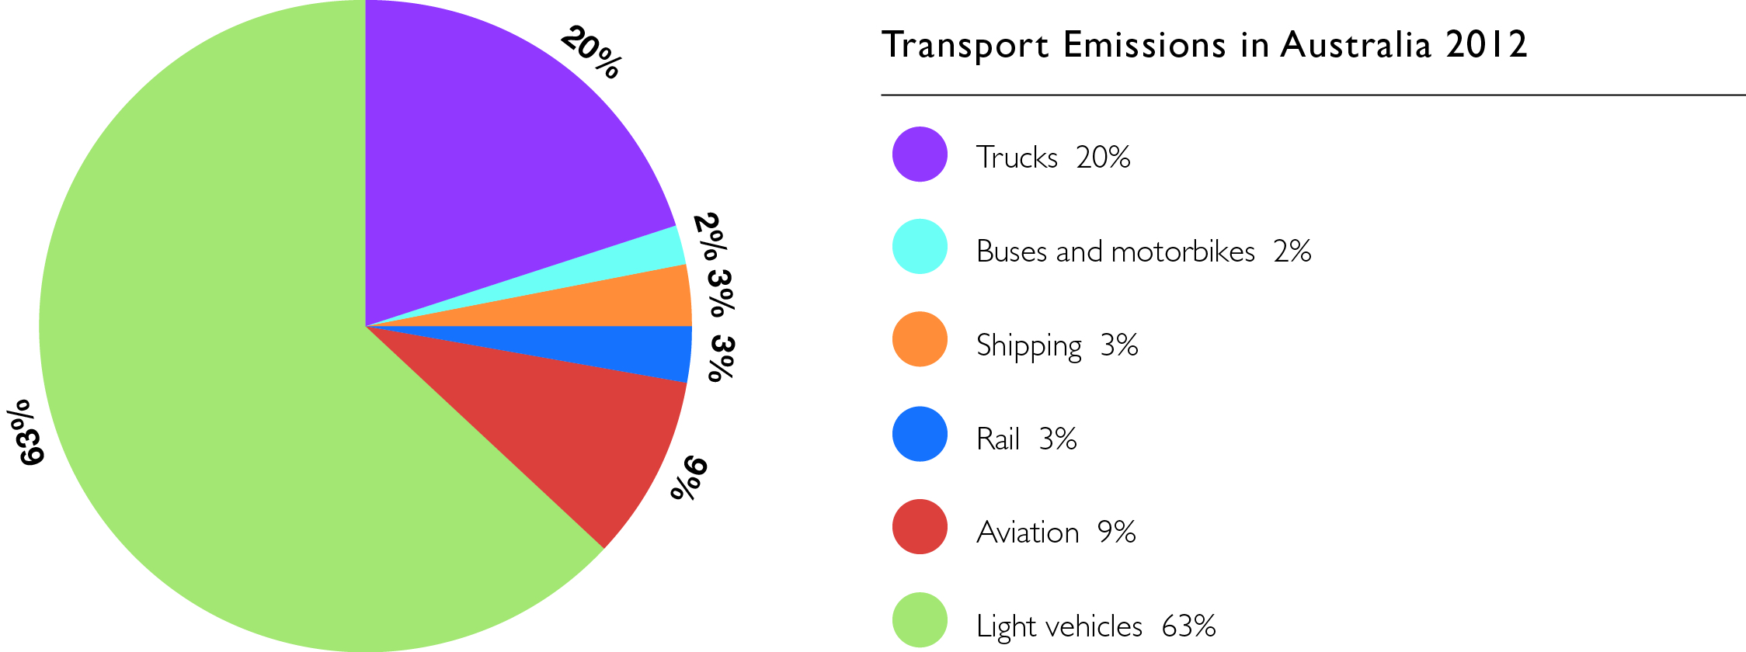

In Nillumbik, Council and the community have little or no opportunity to enhance the efficiency standards of vehicles available in Australia other than through advocacy to government and industry, so this plan focuses on encouraging the use of public transport, walking and cycling trails and switching to more fuel efficient vehicles.
Supporting residents to grow their own food or source it locally as well as supporting home-based businesses will help to reduce travel miles for shopping and work tasks. Continuing upgrades to Nillumbik’s road network through the road sealing and drainage programs will improve travel times, encourage active transport methods, such as cycling, reduce vehicle maintenance and infrastructure repair costs as well as providing for more robust road transport system during extreme weather events.
Council will continue to encourage active transport options, advocate for better public transport and actively seek opportunities to promote emission-free transport within Nillumbik.
Council will continue to offer staff opportunities to work from home, choose public transport for work-related travel, use electronic meeting technologies and provide a range of fuel efficient vehicles in the fleet.
“Continued emissions of greenhouse gases will cause further warming and changes in all components of the climate system. Limiting climate change will require substantial and sustained reductions of greenhouse gas emissions.”
IPCC Fifth Assessment Report, 2013.

Transport - Mitigation
Number | Action | Timing | Responsibility | Secondary Responsibility
1 | Identify new opportunities to promote Nillumbik businesses through an "experience local" campaign. | 2017 | ED
2 | Continue to support urban and peri-urban agriculture programs such as Local Food Connect, community gardens and Home Harvest. | Ongoing from 2016 | EP
3 | Continue to support farmers' markets to provide locally grown and organic produce for consumers. | Ongoing from 2016 | ED
4 | Continue to provide opportunities for home-based and local employment through economic development plans and strategies. | Ongoing from 2016 | ED
5 | Continue to provide opportunities for the community to grow their own food through workshops, on-site displays and activities. | Ongoing from 2016 | E | EP
6 | Encourage and support 10 Nillumbik schools to provide active transport programs. | Ongoing from 2016 | CP
7 | Continue to implement the Footpath Strategy, including auditing and upgrading footpaths with a focus on the areas around schools and activity centres. | Ongoing from 2016 | ID | LSI, CP
8 | Continue involvement with Victorian Government partnerships that promote active transport programs, information sharing and capacity building programs and seek external funding to implement programs through a Sustainable Transport Officer. | Ongoing from 2016 | CP
9 | Lobby the Victorian Government through Public Transport Victoria to improve public transport integration in Nillumbik using the Nillumbik Integrated Transport Statement to determine priorities. | Ongoing from 2016 | ID
10 | Continue to seek Victorian Government funding for sustainable transport infrastructure, including safer and more accessible bus stops. | Ongoing from 2016 | ID
11 | Continue to implement actions in the Nillumbik Integrated Transport Statement to support sustainable travel behaviour. | Ongoing from 2016 | ID
12 | Advocate to VicRoads to improve the bicycle network through expansion of paths, improving links between paths and destinations and separation from vehicles. | Ongoing from 2016 | ID | LSI
13 | Continue working with Bicycle Network Victoria, Public Transport Victoria and Victorian Government to improve bicycle facilities, such as trails, docking stations and lockers. | Ongoing from 2016 | LSI | ID
14 | Continue to expand off-road bicycle paths. | Ongoing from 2016 | LSI | ID
15 | Seek funding and industry partnership for the installation of vehicle charging stations within Nillumbik. | Ongoing from 2017 | EP | ID
16 | Advocate to the Australian Government for reduced taxes on electric vehicle sales to increase uptake. | Ongoing from 2016 | NAGA | EP
Transport - Adaptation
Number | Action | Timing | Responsibility | Secondary Responsibility
1 | Review the Emergency Management Plan to include public transport infrastructure failure within Nillumbik. | 2017 | EM
2 | Continue to upgrade drainage and road surfaces to accommodate extreme weather events. | Ongoing from 2016 | ID
3 | Work with external agencies to identify flood prone roads and find alternative routes to reach vulnerable populations in the event of road closures. | 2018 | EM | ID
4 | Review design criteria for new transport infrastructure such as bridges to incorporate projected climate impacts. | Ongoing from 2016 | ID

Residual emissions
Through the adoption of a carbon management hierarchy, Council recognises that there will be emissions from some sources that are unavoidable. These include such things as gas used in Council-owned buildings for air and water heating and cooking, vehicle fuels and electricity supplied from the national grid where local renewable energy is not available. It is Council’s desire to avoid and minimise these emissions as first steps to mitigate climate change and reduce the ongoing cost of purchase. Residual emissions will be offset by purchasing products according to the National Carbon Offset Standard (NCOS). These products fund third party projects that either:
- avoid or reduce emissions through building large scale renewable energy projects or projects that capture and destroy greenhouse gases; or
- sequester (remove) emissions from the air through storage in vegetation or soil.
To be eligible under NCOS a project must meet the following criteria:
- The project must provide abatement additional to that which would have occurred anyway, such as a requirement of a legislated scheme.
- The project must provide permanent abatement of greenhouse gases.
- The emission reductions must be measurable.
- The emission reductions must be verifiable by an independent party.
- Information about the project, methodologies used in calculations and monitoring of progress must be transparent and accessible to consumers.
Purchases are usually made by buying quantities of avoided or reduced greenhouse gases measured in tonnes (using the term CO₂-e to signify a volume of equivalent carbon dioxide). Each project has a register of certificates equivalent to the total expected abatement over the lifetime of the project. Once purchased, a certificate is retired from the register so that it cannot be used again.
Residual emissions - Strategic
Number | Action | Timing | Responsibility | Secondary Responsibility
1 | Maintain high quality indigenous vegetation in Council reserves, including parks, roadsides and streetscapes, consistent with the Tree Policy to:  * act as a carbon sink for greenhouse gas emissions  * provide habitat for indigenous fauna  * provide a tree canopy to protect against the heat island effect. | Ongoing from 2016 | EW, IM
2 | Seek external funding in partnership with a tertiary institution and NAGA to quantify the greenhouse gas abatement attributable to reserves and private land within Nillumbik. | 2019 | EP, NAGA
Residual emissions - Mitigation
Number | Action | Timing | Responsibility | Secondary Responsibility
1 | Continue to purchase accredited carbon offsets consistent with the Nillumbik Carbon Management Strategy, for residual grid-supplied electricity at all Council-owned buildings and streetlights. | Ongoing from 2016 | EP
2 | Review options for purchasing appropriate accredited carbon offsets for fleet fuel consumption. | 2016 | EP | FM
3 | Review the Nillumbik Carbon Management Strategy to ensure best value for the Shire. | Biennially from 2016 | EP
4 | Continue to encourage the community to support the retention of vegetation in the Shire and encourage the protection and expansion of high quality vegetation on privately-owned property where not compromising bushfire safety. | Ongoing from 2016 | PBS, SP | EP, EW, E
5 | Encourage the Nillumbik community to offset residual energy consumption from households, business, travel and waste. | Ongoing from 2016 | EP
Residual emissions - Adaptation
Number | Action | Timing | Responsibility | Secondary Responsibility
1 | Monitor emerging programs that encourage a dual carbon and native vegetation offset benefit. | Ongoing from 2016 | EP

ABS ERP 2014, profile.id, community profile.
Intergovernmental Panel on Climate Change, 2015.
Climate Change Victoria Department of Environment and Primary Industries, 2014.
Ibid.
Climate change challenges to health. Risks and opportunities, Australian Academy of Science, 2015.
ClimateWorks Australia is an independent, research-based, not-for-profit organisation committed to catalysing reductions in greenhouse gas emissions in Australia.
Australia is a member of the United Nations Sustainable Development Solutions Network along with 14 other industrialised countries, all of which have conducted research on how to achieve zero net emissions by 2050 in their individual economies.
ClimateWorks Australia and the Australian National University, Climate Works, September 2014.
A consortium consisting of Arup, State Government, state agencies, Northern Alliance for Greenhouse Action and its nine member councils, Moreland Energy Foundation and other not-for-profit organisations.
Including the City of Banyule, City of Darebin, City of Hume, City of Melbourne, City of Manningham, City of Moreland, City of Whittlesea, City of Yarra and the Shire of Nillumbik.
Economyid, 2014.
Climate Change Authority, 2015
Department of Transport, 2015.

