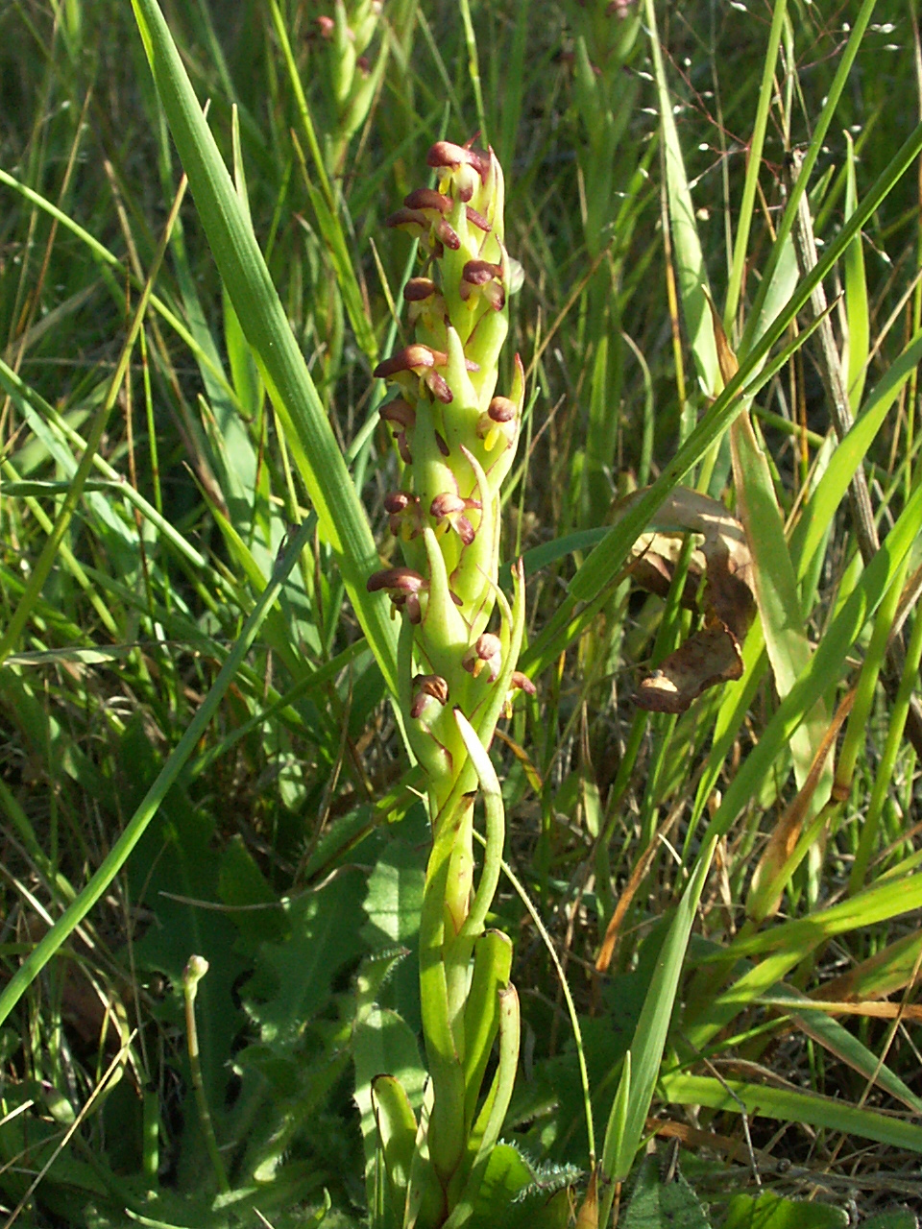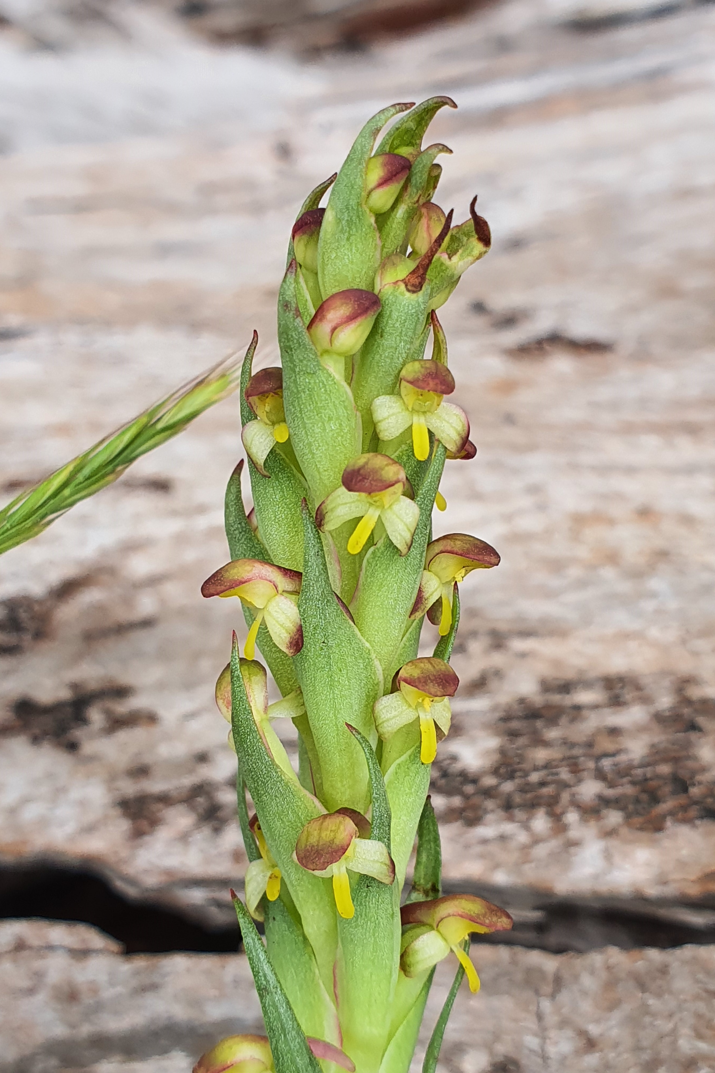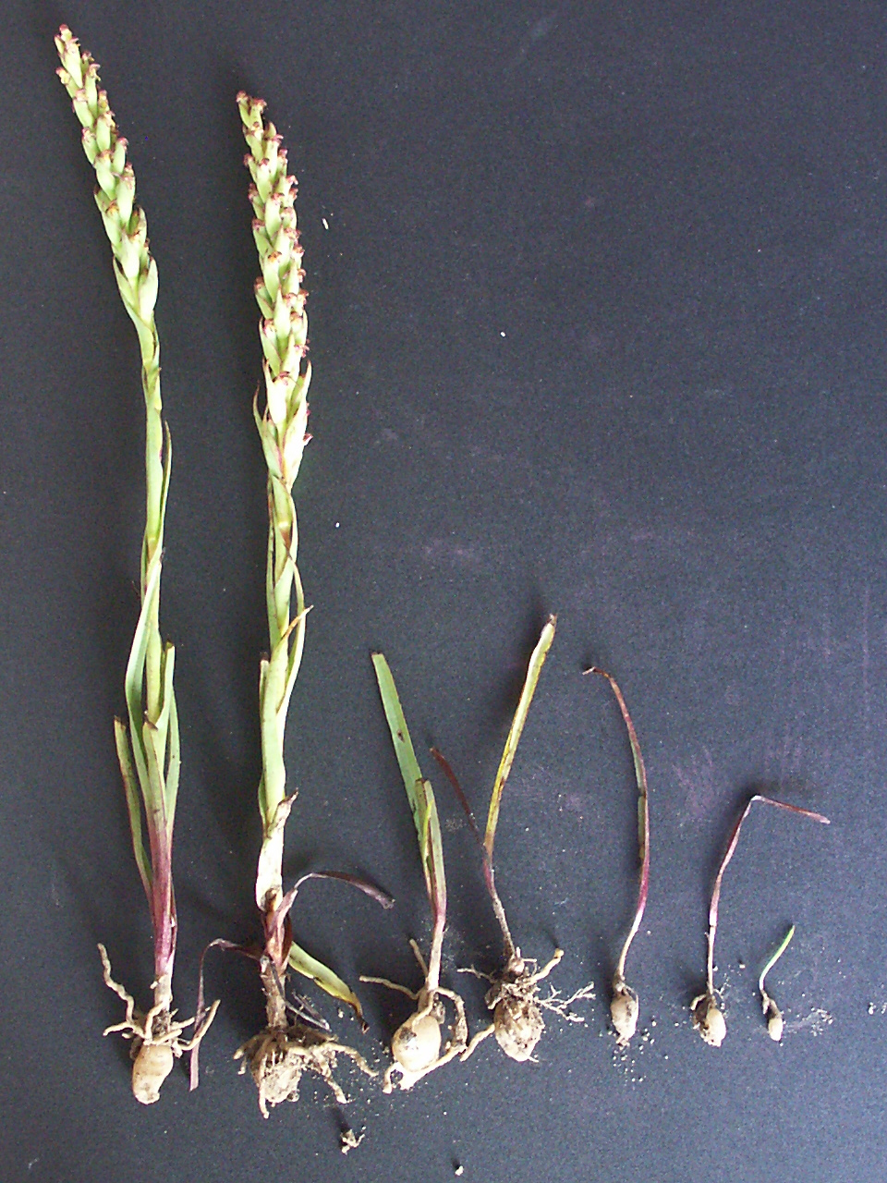
South African Weed Orchid (Disa bracteata)
Credit: Garry French
South African Weed Orchid (Disa bracteata)
An emerging threat to Nillumbik’s native wildflower populations.
This highly invasive environmental weed produces millions of dust-like seeds allowing it to spread easily and form dense colonies.
If you find South African Weed Orchids in Nillumbik contact Nillumbik Shire Council on 9433 3111 for further advice.

Nillumbik is unique in its range and assemblages of native orchids and other wildflowers. South African Weed Orchid poses a new threat to these sensitive environments. If we allow this plant to invade unchecked the consequences could be devastating.
South African Weed Orchid is the only invasive non-native orchid in Victoria. First found in the 1940s, South African Orchid has established populations across the state. Most plants are found in moderately disturbed areas. However, it does invade bushland, where it can compete with and exclude smaller native plants such as lilies, grasses and orchids.
Fortunately, in early stages of South African Weed Orchid’s invasion, it is a threat we can eliminate.
In Nillumbik, South African Weed Orchid has been recorded in a number of locations. Due to the potential risk of this weed to native wildflowers, all known sites are carefully monitored and emerging plants removed.
This is a weed we can’t risk ignoring.
A joint effort to locate and eradicate
Nillumbik Shire Council is calling for residents to help locate all infestations of South African Weed Orchid in the Shire. If found early infestations are much easier to eradicate.
With the joint effort of community and agency staff we have the opportunity to eradicate this new nasty.
If you suspect you’ve found an infestation
- Do not disturb – there is a high risk of spread.
- Contact Nillumbik Shire Council, 9433 3111.
- Council will support you with identification and control options.

Identification
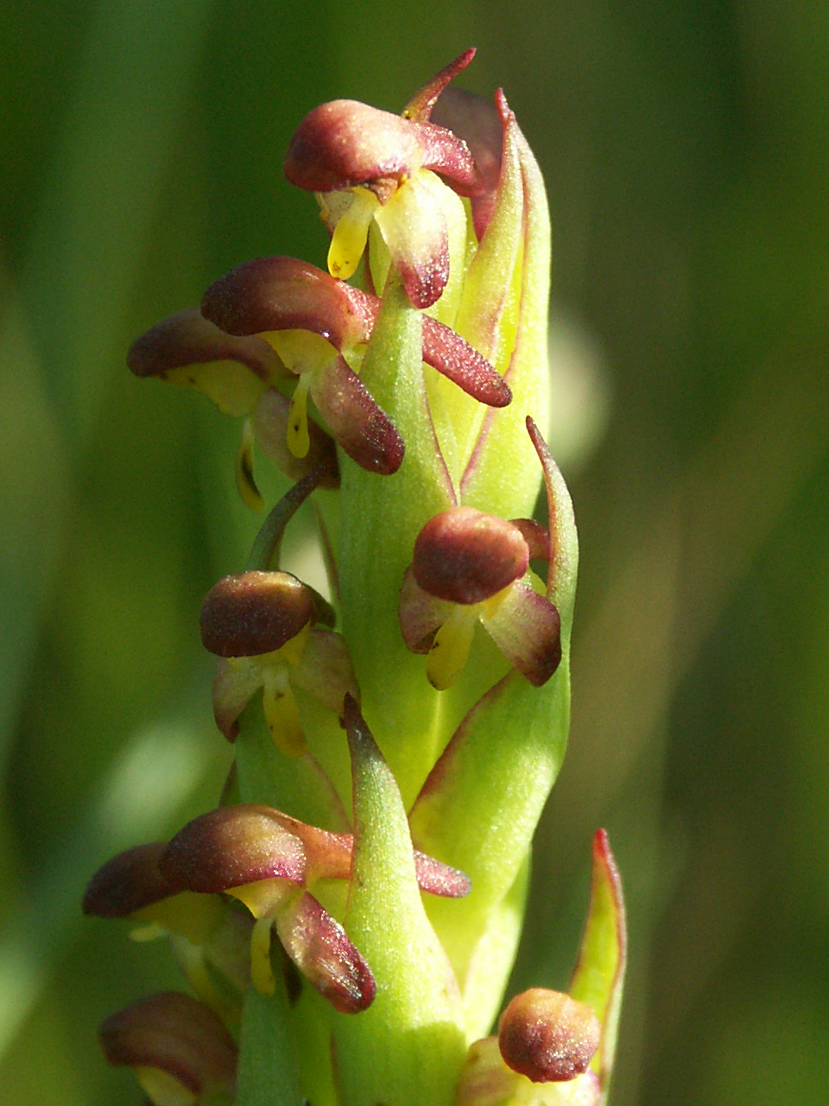A robust, erect, fleshy perennial orchid 30–50cm high with annual above-ground growth from tubers. One plant grows up to 60 tiny flowers in a dense spike that resembles a brownish asparagus spear. It is easiest to identify when flowering.
South African Weed Orchid (Disa bracteata)
Credit: Garry French
Leaves: A rosette of 6–10 narrow, channeled leaves appears early spring. Leaves initially form a clump at the base, and then numerous green grass-like leaves with purplish under-surfaces develop on the lower stem as it lengthens. Leaves numerous with parallel veins, decreasing in size progressively up the stem: lower leaves 5–15cm long. Modified leaves also embrace each flower.
Flowers: Flowers mainly late Sep–Nov in the plant’s second or third year. 20–60 flowers are born on a single thick cylindrical spike (5–20cm long). Flowers small (to 5mm long) with hooded red-brown upper parts and yellow-green thin, downward pointing lower parts. Labellum (larger bottom petal) yellow, protruding forward like a tongue. Each flower is surrounded by a conspicuous tapering modified leaf.
Fruits: Brown capsule containing minute dust-like seeds. Seed set and dispersal occurs at the end of November.
If you think you have found an infestation of South African Weed Orchid call Nillumbik Shire Council for advice and support on 03 9433 3111
Similar native species: Similar to Onion-orchids (Microtis spp.) and Leek-orchids (spp.). However, these orchids only have a single leaf emerging at the base of the stem.
Reproduction and spread
South African Weed Orchid self-pollinates, producing millions of dust-like seeds. Seeds continue to mature if the flower head has been picked and remain viable for about 7 years.
Seeds disperse easily on the wind and also on vehicles, equipment, clothing and shoes. Once established, South African Weed Orchid can form dense colonies and spread rapidly.
Known infestations in Nillumbik
South African Weed Orchid has been recorded around the following locations in Nillumbik. It is more likely to be found near existing infestations, however, it may occur anywhere within the Shire.
- St Andrews (Youngs Road, Chalber Lane and Flora Crescent, Heidelberg–Kinglake Road, Kangaroo Ground–St Andrews Road)
- Christmas Hills (Buttermans Track)
- Smiths Gully (Kangaroo Ground–St Andrews Road and Blue House Road)
- Panton Hill (Turnung Road)
- Kangaroo Ground (Menzies Road)
- Eltham (Hartland Way and Laughing Waters Road)
- Strathewen (Bowden Spur Road, Rankines Road, Eagles Nest Road)
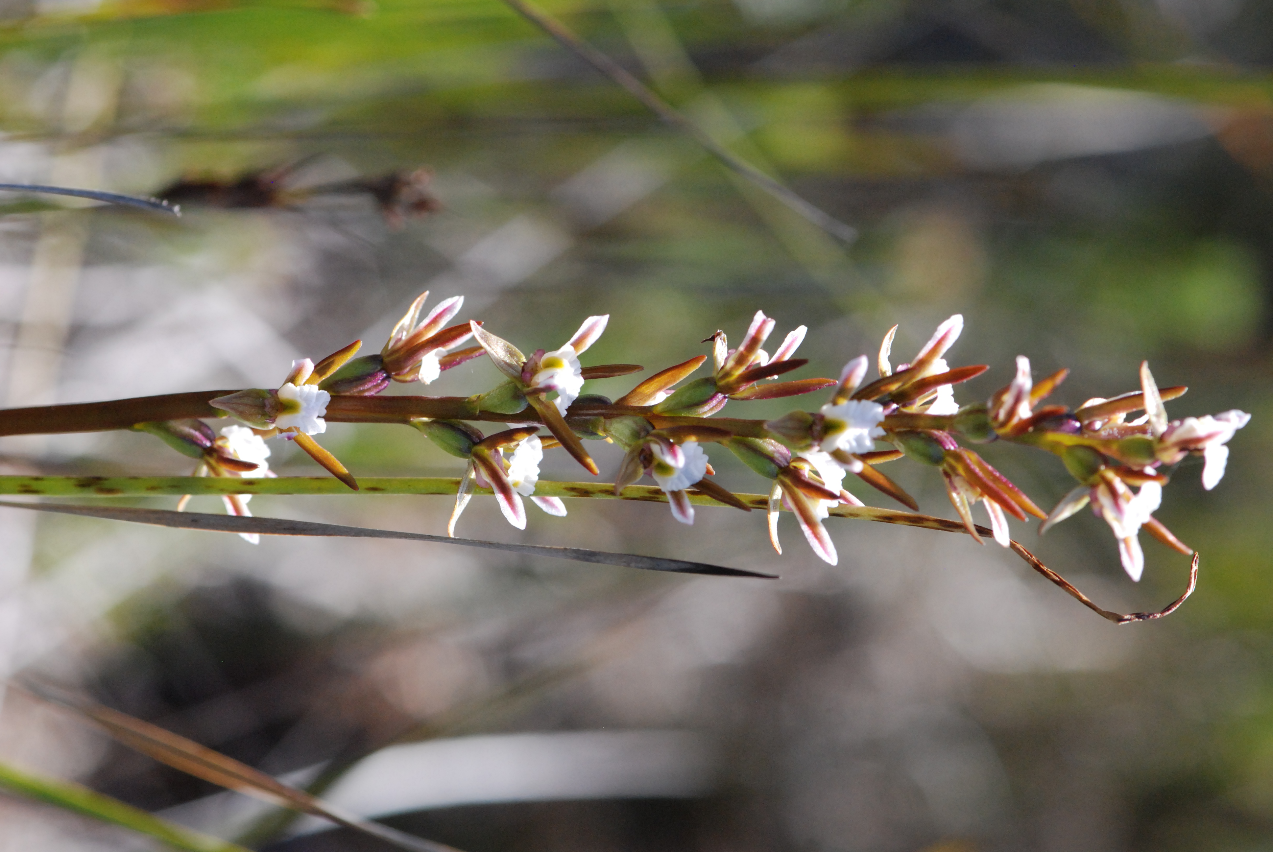

Look-alikes:
Slender Onion Orchid (Microtis parviflora)
Ranges Leek-orchid (Prasophyllum sp. aff. odoratum)
Credit Julia Franco
Updated December 2019

