Fact Sheet

Land classes - Strathewen
This fact sheet describes the Strathewen catchment and land classes in the area.

Landscape of Strathewen
The Strathewen landscape has geology of very old sedimentary rock. It comprises the two main valleys of Arthurs and Chads Creeks and the narrow valleys of their several tributaries, including the Peters Creek. A small area to the east of Harrys Road flows south west to the Running Creek.
These valleys are surrounded by a landscape of predominantly low hills through the central part of the catchment that merge with long ridges of steep hills and rugged terrain, particularly on the northern and eastern boundaries.
Much of the steep land remains in forest, while most of the low hills and flats have been cleared for agriculture.
The indigenous vegetation of the well-drained, exposed areas such as crests and slopes is woodland with Long-leaf Box, Red Box, Messmate, Red Stringybark and Narrow-leaf Peppermint. Yellow Box is found on the lower slopes. Candlebark Gum, River Red Gum and Manna Gum are the dominant trees along the drainage lines. Red Ironbark may occur in small patches of open forest usually on older soils.
The soils of the low hills are light-textured yellow brown or red duplex. Shallow light-textured gradational soils occur on the crests and steeper slopes. Grey clay with a uniform profile occurs along drainage lines and on floodplains.
This landscape is highly vulnerable to erosion due to its hard-setting surfaces, which tend to increase runoff, and the dispersible nature of clay subsoils. Sheet, gully and tunnel erosion occur on sloping land, although tunnel erosion generally only occurs in cleared areas. Where drainage lines have little protective vegetation cover, erosion of the beds and banks is occurring.

Land capability
Land capability is the inherent potential of the land to provide for and sustain uses for which it is assessed. It is measured according to geology, soil type, topography and climate, which influence the character of the land.
Assessing land capability or ‘land class’ allows us to gauge the inherent risks and opportunities for our land to provide for and sustain our current and/or proposed land uses. Land capability varies according to the geology, soil type, topography, aspect and climate.
In general terms, land with a high capability rating (e.g. land class 1), will be more suitable to being modified for agricultural use.

Land management units
Land Management Units (LMUs) provide us with a means for systematic review of land characteristics and are broad measures of land capability. The aggregation of lands with common characteristics into LMUs provides us with a general indication of the capacity of our land to sustain various land uses.
Five LMUs can be identified in the Strathewen catchment, as follows:
Floodplain LMU: Very gently sloping to flat land with gradient <1% - 3%
Gently undulating LMU: Gradient 3% - 15%
Moderately undulating LMU: Gradient 15% - 25%
Steep LMU: Gradient 25% - 35%
Rugged terrain LMU: Gradient 35% - >40%.
The hilly landscape and soil type (see section 3.3 of the CERAP) of the Strathewen catchment facilitates a significant erosion hazard. Specifically:
- All sloping land has high to moderate hazard for sheet, gully and tunnel erosion.
- The steeper slopes have a moderate to high hazard for mass movement (land slips).
- All streamlines have a high hazard for streambed and bank erosion and sedimentation.
The location of each LMU is identified in Figure 1.

Figure 1: Strathewen land management units
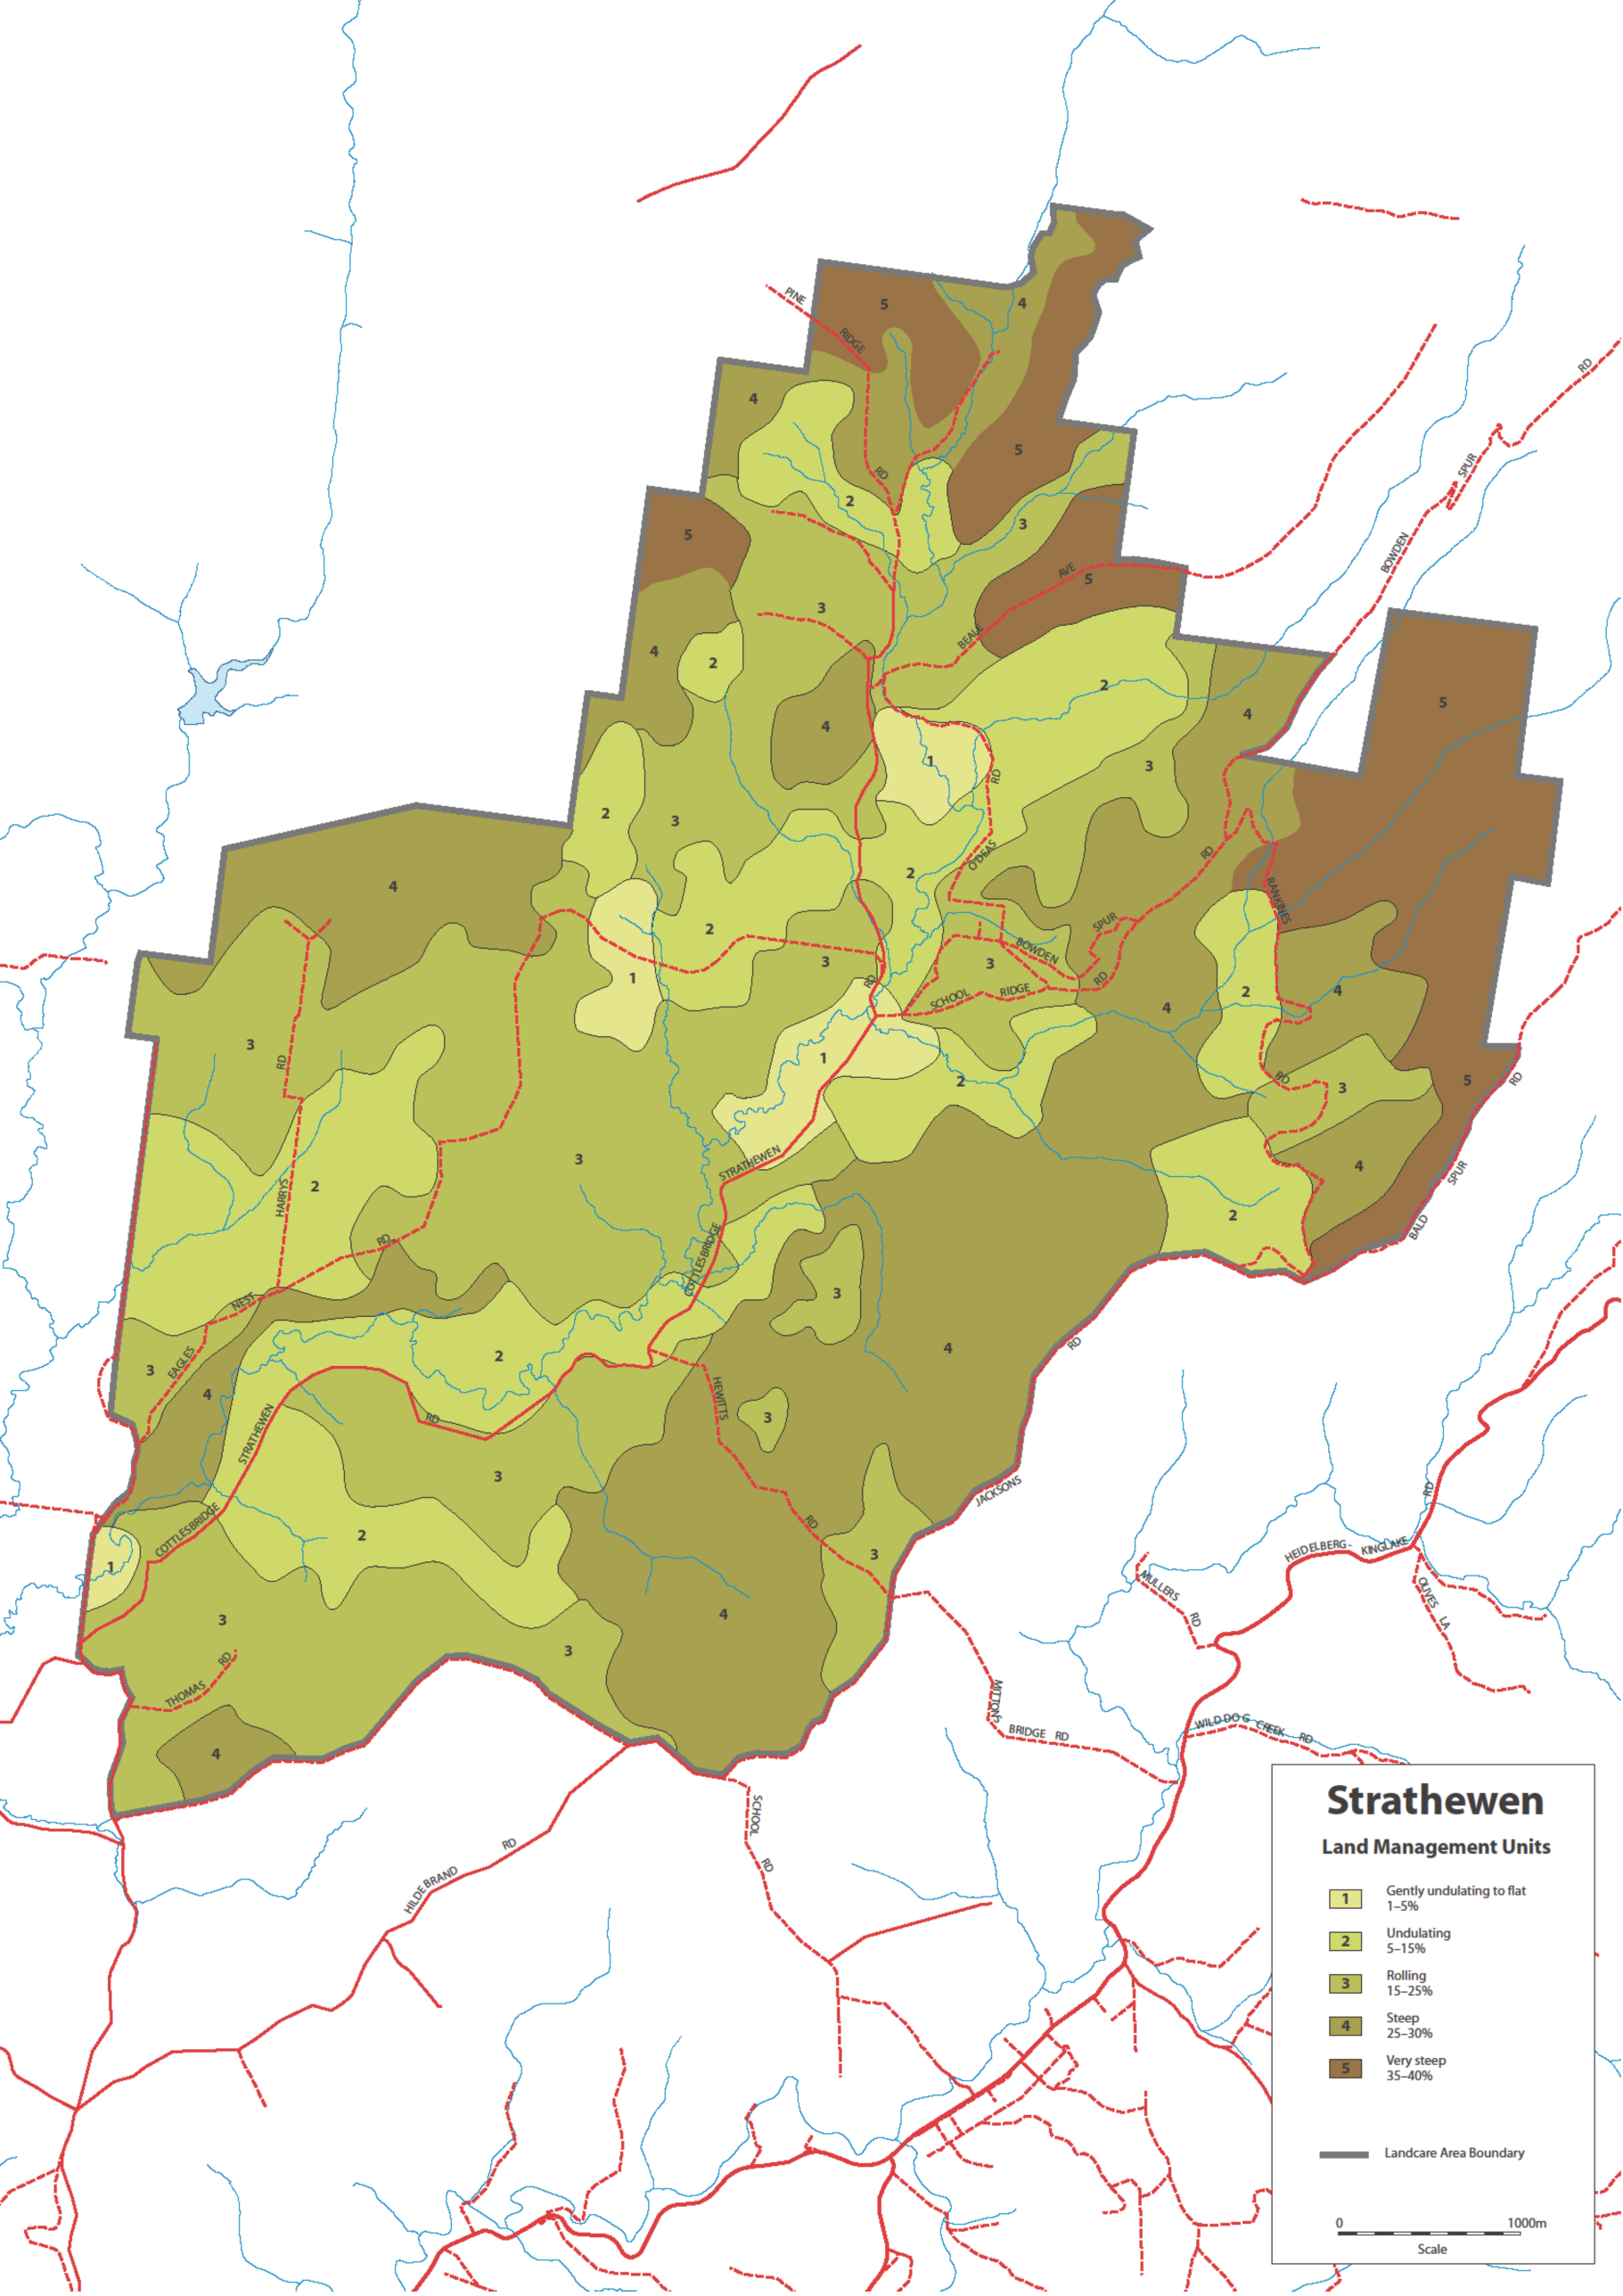

Agricultural land quality
This section expresses the degree of agricultural versatility and production potential across the Strathewen catchment in terms of five classes of agricultural land quality. It is important to note that this only provides a broad guide and should not be used to justify significant changes in land use.
Prior to undertaking any significant change to land use, or if you have only recently purchased your land, it is strongly recommended that you prepare a detailed land capability assessment of your land. This is best achieved as a component of a detailed ‘Property Management Plan’ (sometimes referred to as a ‘Whole Farm Plan’). The Shire can assist landholders with the preparation of such plans.
Table 1 presents a five-class description of agricultural land quality across the Strathewen catchment and the map at Figure 2 depicts a broad special interpretation of this information. This mapping is largely based on slope classes and hence does not incorporate important components of land capability such as local hazards (e.g. known tunnel erosion), variation in remnant vegetation cover, aspect, soil type, soil moisture and the presence of minor drainage lines. The agricultural land quality map for Strathewen is shown in Figure 3.
Table 1: Agricultural land quality rating description
Class 1  Very high | Agriculturally versatile land, with high inherent productive potential because it has deep, permeable, friable, structurally resilient and fertile soils, a flat to gently undulating land form, and a growing season of up to 11–12 months under either natural rainfall or irrigation. It is suitable for intensive irrigated cropping and grazing.
Class 2  High | Agriculturally versatile land, although it requires more inputs to achieve the same productivity as Class 1. Slope is greater, soils are more variable, and the growing season is limited to 9–10 months, which may be extended to 12 months if irrigation water is available. It is suitable for high-production intensive cropping and grazing, and irrigation.
Class 3 Moderate | Sound grazing land but limited in versatility. Generally unsuited to cropping due to steepness of slope, drainage limitations, lack of topsoil depth, weaker structure, poor water-holding capacity, or presence of rock. Fertility levels are moderate to low. Growing season may be limited to about 7-8 months due to dryness or wetness. With high inputs, moderate to high animal production may be achieved.
Class 4  Low | Land capable of supporting grazing under moderate to low stocking rates where clearing has occurred. Slopes are moderate to steep, with shallow infertile soils that need care. Fertility levels are generally low. High inputs may not be economical. Erosion hazard is high. Forest is often the best and most stable form of land use.
Class 5  Very low | Land unsuited to agriculture. Constraints may be steepness of slope, shallow, sandy, or rocky soils, or high erosion susceptibility. Environmental stability may be best achieved by isolating areas and strictly controlling or eliminating agricultural land uses.

Figure 2: Strathewen’s Agricultural land quality
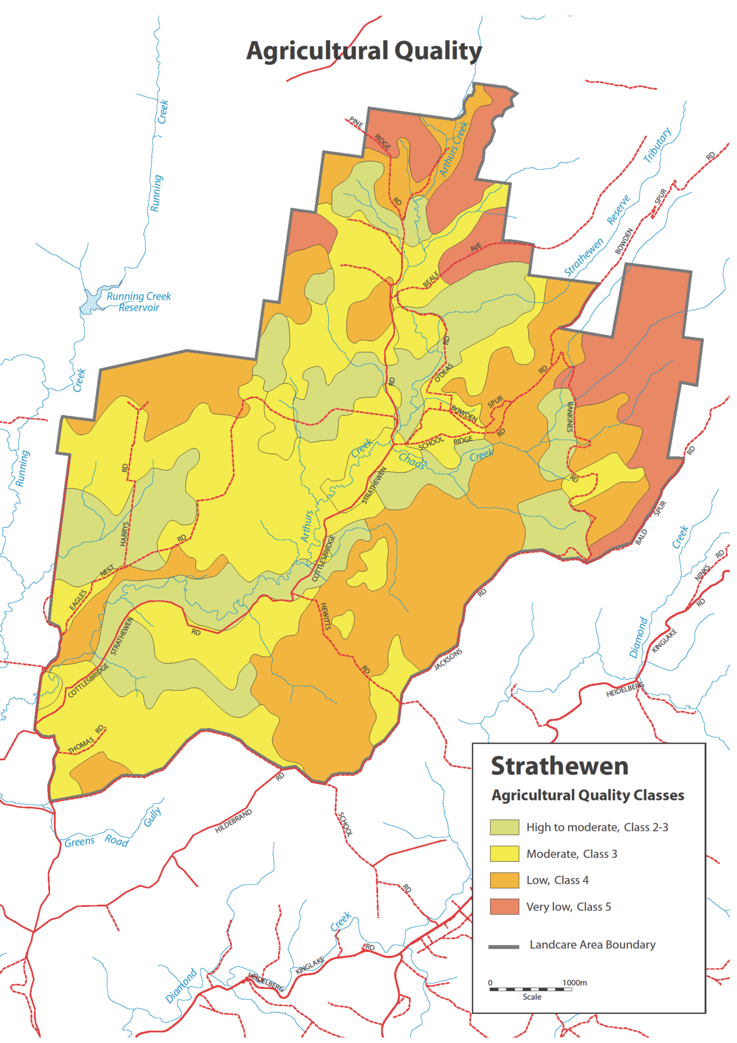

Case Study
Feeding and breeding are the keys to success on Barrie and Rae Tully’s, Strathewen beef cattle farm.
Barrie and Rae Tully graze beef cattle on their 100 hectare farm in O'Deas Road.
The property was purchased 50 years ago as an extension to their Doncaster orchard and cool store.
In 1983, when the suburbs reached them, they moved to Strathewen with their young family. Until eight years ago Barrie and Rae operated a mixed orchard of 30 hectares on their Strathewen property as their main business. Then they decided on a business and lifestyle change.
In 2003, they discontinued orcharding and began their Angus beef breeding and fattening enterprise.

2009 Bushfires
They coped with the recent long drought and up until the 2009 fires they had built their herd to 100 head, including 60 cows.
The fire severely damaged their house, and they lost 12 head of cattle, 90 percent of fencing (14 kilometres), sheds, stockyards and most farm machinery – most of the pastures were burnt, including 1 kilometre of windbreak/shelterbelt trees.
Faced with no pasture, ineffective fencing and cows beginning to calve, Barrie made the decision to sell all his surviving cattle and put all his effort into reestablishing the farm infrastructure, which is now complete.
Importantly, the Tullys were insured, but Barrie chose to rebuild the fences himself with help from CFA and VFF volunteers who built the boundary fences. As Barrie was injured during the fire, he ruptured a tendon, a contractor replaced some corner posts. Barrie observed that the surviving fences were in fencelines previously sprayed with Roundup. This was an important lesson and he now sprays most fencelines annually.
In the meantime, he also purchased a further 50 cattle and a bull and intends to increase the herd to the former 100 head in the near future. Barrie says he wants to produce as much as he can from the land and judges that the property remains well understocked. He intends to purchase more cows when prices moderate in the autumn of 2012, to bring numbers back up to about 70 cows.
To avoid overcapitalization, he decided not to replace all destroyed machinery but to use contractors for such operations as hay production and fertiliser spreading.
Pasture has not been improved since the fire but the last two years have seen good rainfall and prolific pasture growth. Most pastures contain a perennial grass base that can include Cocksfoot, Perennial Ryegrass or Phalaris, with White and Subterranean Clovers.
Hill pastures tend to contain a high proportion of annual grasses and the lower slopes and flats more perennial grass. The main pasture weed is Bent grass, which competes strongly with pasture species, particularly when soil fertility is low.
Barrie says, “There are three ways to deal with Bent grass; maintaining a strong vigorous pasture, over-sowing with pasture grasses and clover, or if the situation is very bad, spray out the area and re-seed with pasture species. Where we have the problem, we intend to over-sow some areas and re-seed others.” He says, “We don’t worry too much about annual pasture weeds such as capeweed. Grazing management keeps them under control.”
Blackberry is a serious weed on the property. “Before the fire, Blackberry was virtually under control, and now young bushes are everywhere, particularly along sprayed fencelines and the creek, so I spend a lot of time spot spraying Blackberry at the moment,” Barrie says.
He also commented that the main pest animals are wild ducks and kangaroos. “They do more damage to pasture than rabbits, which are not a big issue on this property.”
Barrie tests the soil and has regularly fertilised pastures with phosphorus, potassium and molybdenum to a point were fertility levels now only require maintenance fertilising. Barrie also applies lime to counter soil acidity. Testing showed that soils were very acidic and reducing pasture growth.
Barrie believes his orcharding background taught him the importance of proper plant nutrition in achieving high production pastures. He says, “Growing grass is much cheaper than making hay.” When he does make hay, he applies urea in September to the locked up paddocks to maximise production. He says it’s worth it. “We get a 33 per cent increase in hay yield from applying nitrogen fertiliser.”
Water supply is plentiful with two large dams of 18 and 14 megalitres built during orcharding days. The dams supply all stock and garden water, which is gravity-fed by pipelines to troughs in most paddocks and the garden.
The property comprises four of the Strathewen Land Management Units, including Gently Undulating Land of high agricultural quality, Floodplain of moderate agricultural quality, Moderately Undulating Land of moderate agricultural quality and Steep Land of low agricultural quality.
The steep land and creekline remain in native bush and are fenced from the grazing land. Barrie rotationally grazes all paddocks to maximise pasture productivity according to the capability of the land.
To facilitate rotational grazing and pasture management, all 11 paddocks on the property are fenced along Land Management Unit boundaries. Barrie says, “We are very careful about our stocking rates and do not overstock. We would rather understock than have too many cattle.”
Barrie considers land conservation as a management priority. He said, “Soil erosion was very serious after the fires and the best way to control it was to grow grass for ground cover. Our creek is fenced under the Melbourne Water Stream Frontage Management Program and the creekline is in good condition despite the fire and flood of 2009.”
Barrie says, “We have had great success running cattle. We do it by the book. Feeding and breeding are the keys to success. We grow the right pastures with the right species and fertilise them. Our cattle are well-bred and well-fed with a balanced and sufficient diet of pasture and hay.”
Barrie always buys well-bred cattle. He considers the better genetics offers the greatest rate of weight gain. And he believes that, “top quality stock in the market always impresses the buyers.”
