Fact sheet

Land classes – St Andrews
This fact sheet describes the St Andrews catchment and land classes in the area

St Andrews catchment area
The St Andrews catchment comprises part of the catchment and valley of the Diamond Creek and its tributaries, including Black Calf and Wild Dog Creeks. Diamond Creek has some small areas of floodplain.
The creek valleys are surrounded by a landscape of mainly moderate to steep hills that merge with long ridges of rugged terrain on the northern, western and southern boundaries.
Most of the steeper, more rugged hills remain forested, while most of the low hills and flats have been cleared for agriculture.

Geology and soils
The geology of St Andrews is very old sedimentary rock. The soils of the hills are light-textured yellow, brown or red duplex. Red duplex soils have two distinct layers: a topsoil or A-horizon and a subsoil or B-horizon in the top 10 centimetres of the soil.
Shallow light-textured gradational soils occur on the crests and steeper slopes. Grey clay with a uniform profile occurs along drainage lines and floodplain areas. This landscape is highly susceptible to erosion due to the hard-setting soil surfaces, which tend to increase runoff and the dispersible clay subsoils.
Sheet, gully and tunnel erosion occur on sloping land. Where drainage lines have little or no protective vegetation cover, erosion of the stream bed and banks is common.

Waterways
Diamond Creek is a tributary of the Yarra River originating in the Kinglake Ranges. It runs through the St Andrews catchment in a north-east to south-east direction.
The Port Phillip and Westernport Regional River Health Strategy (Melbourne Water 2007) identifies this waterway as being of Very High regional importance.
Diamond Creek supports a diverse biological community of fish, vertebrates, invertebrates and streamside vegetation (Melbourne Water 2003).
Within the St Andrews catchment, native vegetation is generally present along the length of Diamond Creek with some areas supporting only patchy vegetation.

Land capability
Assessing land capability or ‘land class’ allows us to gauge the inherent risks and opportunities for our land to provide for and sustain our current and/or proposed land uses. Land capability varies according to the geology, soil type, topography, aspect and climate.
In general terms, land with a high capability rating (e.g. land class 1), will be more suitable to being modified for agricultural use.

Land management units
Land Management Units (LMUs) provide us with a means for systematic review of land characteristics and are broad measures of land capability. The aggregation of lands with common characteristics into LMUs provides us with a general indication of the capacity of our land to sustain various land uses.
The five LMUs in St Andrews catchment are as follows:
- Floodplain LMU: Very gently sloping to flat, gradient <1% - 3%
- Gently undulating LMU: Gradient 3% - 15%

Figure 1: St Andrews Land Management Units
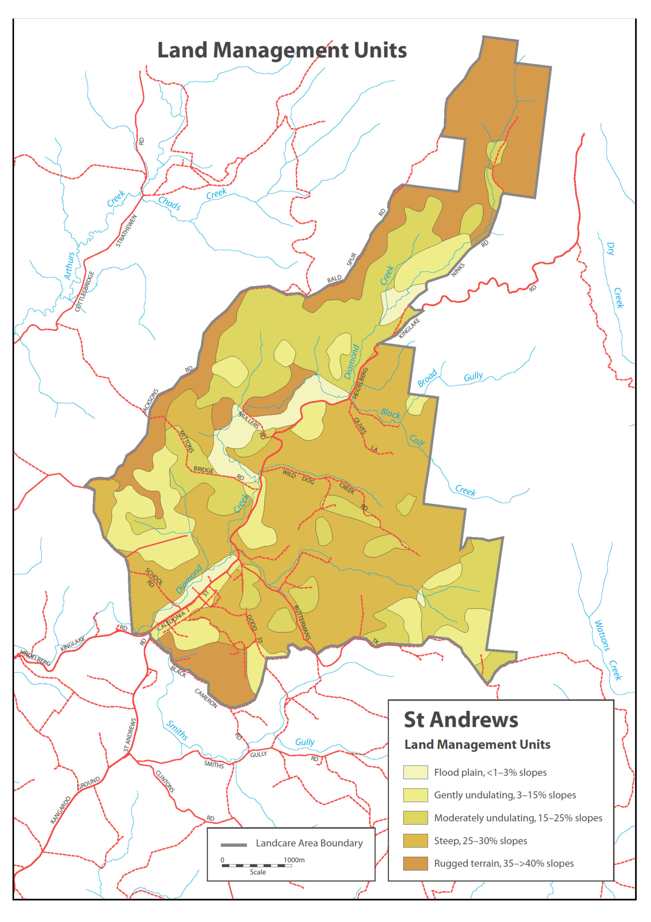
Source: Community Environmental Recovery Action Plan St Andrews Catchment.
- Moderately undulating LMU: Gradient 15% - 25%
- Steep LMU: Gradient 25% - 35%
- Rugged terrain LMU: Gradient 35% - >40%.
The hilly landscape and soil type (see section 3.3 of the CERAP) of the St Andrews catchment facilitates a significant erosion hazard. Specifically:
- All sloping land has high to moderate hazard for sheet, gully and tunnel erosion.
- The steeper slopes have a moderate to high hazard for mass movement (land slips).
- All streamlines have a high hazard for stream bed and bank erosion and sedimentation.
The LMU’s for St Andrews are identified in Figure 1.

Agricultural land quality
In the St Andrews catchment, land capability for agricultural use is described in terms of agricultural land quality. This expresses the degree of agricultural versatility and production potential and provides a broad guide to the types of agriculture that can be supported.
The descriptions and process for assigning agricultural land qualities have been refined over many years by organisations such as the Department of Primary Industries (DPI) and the former Soil Conservation Authority (now within the Department of Sustainability and Environment [DSE]).
Land characteristics used in assigning agricultural land quality ratings include topographic position, soil type, climate and availability of supplementary irrigation water.
Agricultural land quality is often rated according to the five-class system described and interpreted in Table 1, while the map at Map 2 presents agricultural land quality for the St Andrews area.
In summary:
High agricultural land quality: This is highly productive and provides greater flexibility for a range of agricultural enterprises including cultivation and cropping. Its soils are also less subject to erosion and structural deterioration.
Lower agricultural quality: This land is less arable due to rock cover, or steep slopes that require specific cultivation techniques and crop types to avoid land deterioration.

Table 1: Agricultural land quality rating description
Class 1  Very high | Agriculturally versatile land, with high inherent productive potential because it has deep, permeable, friable, structurally resilient and fertile soils, a flat to gently undulating land form, and a growing season of up to 11–12 months under either natural rainfall or irrigation. It is suitable for intensive irrigated cropping and grazing.
Class 2  High | Agriculturally versatile land, although it requires more inputs to achieve the same productivity as Class 1. Slope is greater, soils are more variable, and the growing season is limited to 9–10 months, which may be extended to 12 months if irrigation water is available. It is suitable for high-production intensive cropping and grazing, and irrigation.
Class 3 Moderate | Sound grazing land but limited in versatility. Generally unsuited to cropping due to steepness of slope, drainage limitations, lack of topsoil depth, weaker structure, poor water-holding capacity, or presence of rock. Fertility levels are moderate to low. Growing season may be limited to about 7-8 months due to dryness or wetness. With high inputs, moderate to high animal production may be achieved.
Class 4  Low | Land capable of supporting grazing under moderate to low stocking rates where clearing has occurred. Slopes are moderate to steep, with shallow infertile soils that need care. Fertility levels are generally low. High inputs may not be economical. Erosion hazard is high. Forest is often the best and most stable form of land use.
Class 5  Low | Land unsuited to agriculture. Constraints may be steepness of slope, shallow, sandy, or rocky soils, or high erosion susceptibility. Environmental stability may be best achieved by isolating areas and strictly controlling or eliminating agricultural land uses.

Map 2: Agricultural land quality for the St Andrews area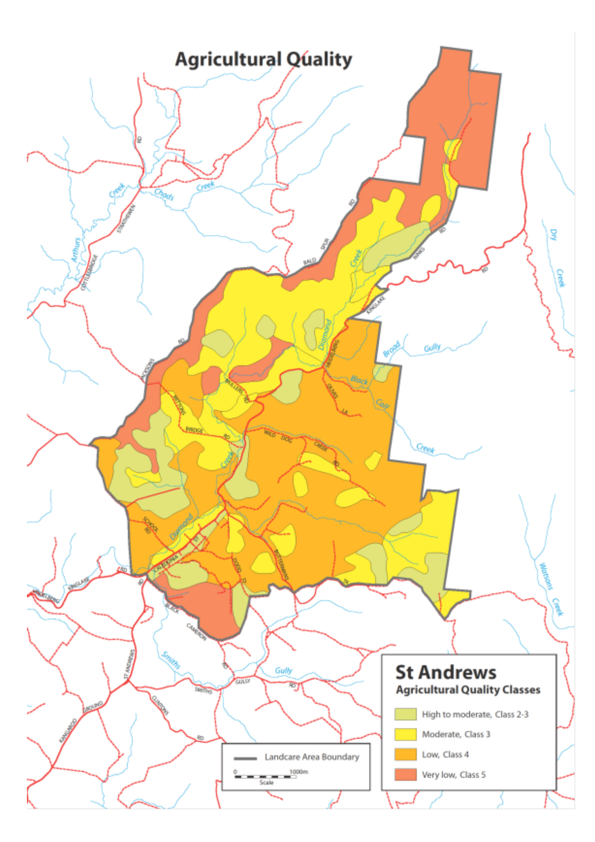
Case Study:
Developing a beef cattle farm at Alf and Joanna Gonnella’s property in St Andrews
Alf and Joanna Gonnella have farmed their 36 hectares property on Mittons Bridge Road for 27 years. They have weathered 10 years of drought, the Black Saturday bushfires and then the more recent floods.
Twenty-seven years ago the farm was in very poor condition. Rabbits were everywhere, the hill was covered in bracken and the lower land was infested with blackberries, tea tree and rushes.
Alf and Joanna’s vision allowed them to see the productive beef grazing property it is today. It took four years to rid the property of weeds and rabbits and to sow all the land to pasture.
The couple says the two most important land management tasks are constant vigilance in controlling and eradicating weeds and sound pasture management.
The property comprises three St Andrews Land Management Units (LMUs):
- Gently Undulating Land (of High agricultural quality)
- Floodplain
- Moderately Undulating Land (both of Moderate agricultural quality).
To assist rotational grazing and pasture management and to maximise production, the farm’s six paddocks are fenced along LMU boundaries. Each paddock has its own stock water, either supplied from dams or reticulated from tanks to paddock troughs.
The 2009 fire burnt out the whole property and seriously weakened the pastures. This allowed pasture weeds including Blackberry, Sweet Vernal Grass, Bent Grass and Capeweed to establish in many areas. Thankfully, all the cattle survived unscathed.
After the fire, serious erosion occurred on the bare soil of the exposed hill paddock and had to be controlled. Alf decided that this was the highest priority paddock for pasture renovation and this occurred in Autumn 2010. The new pasture is a mix of Cocksfoot, perennial Ryegrass, White Clover, Red Clover and Subterranean Clover with very few weeds.
The property currently supports 36 Limousin breeding cows, with numbers limited by the condition of the pastures. However, the success with the new pasture has encouraged Alf and Joanna to continue their pasture improvement program progressively across the remaining paddocks over the next few years. This will start with the two floodplain paddocks in 2012. These are a priority as they are the most productive paddocks on the farm, supporting hay production as well as strong grazing.
Pasture improvement will enable a higher stocking rate, greater production and a stronger more vigorous pasture will minimise weed invasion.
Until three years ago the pasture fertiliser was always super and potash (phosphorous and potassium). The Gonnellas now use a seaweed fertiliser spray and dry-spread chicken manure. Recent soil tests also indicated that the soils were too acidic for pasture, and lime was applied to all paddocks in 2011.
Alf and Joanna are also concerned about the condition of the Diamond Creek and the surrounding vegetation. The fire and flooding seriously damaged both and the protective fencing was destroyed.
There are signs that the creek erosion is healing and native vegetation is recovering, but many weeds have established, including rushes, thistles, Blackberry and willows.
Along with pasture renovation, the priority is weed control and to re-fence and protect the creek and its native vegetation.
Joanna said, “We were not farmers when we started and we’ve made mistakes on the way, but we’ve turned wasteland into a productive farm and it’s given us great enjoyment.”
The Gonnellas’ message to landholders is to keep on top of rabbits and weeds, manage pastures correctly and stick at it. It is consistent work but not hard work. And to prospective landholders they say, “Take your responsibilities for looking after the land seriously. Bad management is not neighbourly and causes problems for the whole community.”
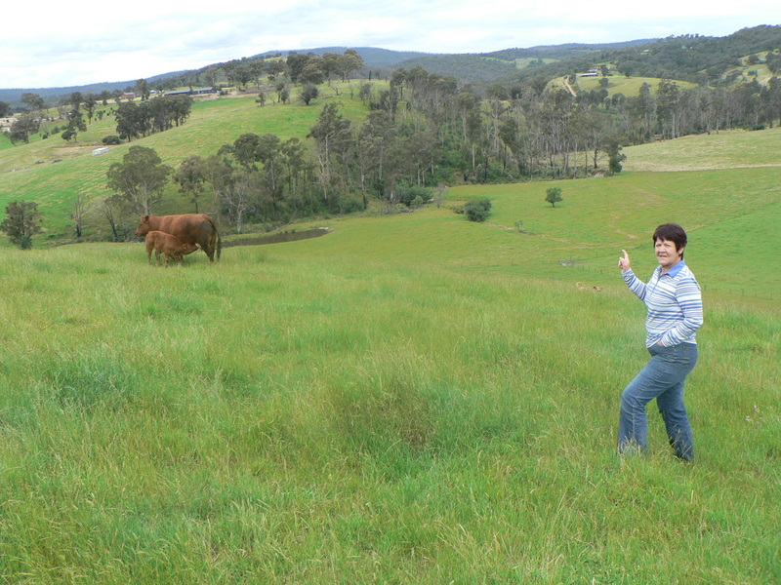
Caption: Joanna Gonnella points towards Diamond Creek and fringing vegetation, which was badly degraded by the 2009 fire and flood, from her pastured hill paddock.

