Fact Sheet

Land classes – Christmas Hills
This fact sheet describes the Christmas Hills catchment and land classes in the area.

Landscape of Christmas Hills
The Christmas Hills landscape has geology of very old sedimentary rock. It comprises the three narrow valleys of Watsons, Reedy and Five Mile Creeks.
These valleys are surrounded by a landscape of predominantly low hills through the central part of the catchment that merge with long ridges of steep hills and rugged terrain on the northern, eastern and western boundaries.
Much of the steep land remains in forest, while most of the low hills have been cleared for agriculture.
The indigenous vegetation of the well-drained, exposed areas such as crests and slopes is woodland with Long-leaf Box, Red Box, Messmate, Red Stringybark and Narrow-leaf Peppermint. Yellow Box is found on the lower slopes, and Candlebark Gum, River Red Gum and Manna Gum are the dominant trees along the drainage lines. Red Ironbark may occur in small patches of open forest usually on older soils.

Land capability
Assessing land capability or ‘land class’ allows us to gauge the inherent risks and opportunities for our land to provide for and sustain our current and/or proposed land uses. Land capability varies according to the geology, soil type, topography, aspect and climate.
In general terms, land with a high capability rating (e.g. land class 1), will be more suitable to being modified for agricultural use.

Land management units
Four discrete Land Management Units (LMUs) have been identified in the Christmas Hills catchment. The aggregation of lands with common characteristics into LMUs provides a general picture of the capability of our land to sustain various land uses.
The four LMUs in Christmas Hills catchment are as follows:
- Gently undulating LMU: Gradient 3% – 15%
- Moderately undulating LMU: Gradient 15% – 25%
- Steep LMU: Gradient 25% – 35%
- Rugged terrain LMU: Gradient 35% – >40%.
The location of each LMU is identified on the following page (Figure 1).
The hilly landscape and soil type (see section 3.3 of the CERAP) of the Christmas Hills catchment facilitates a significant erosion hazard. Specifically:
- All sloping land has high to moderate hazard for sheet, gully and tunnel erosion.
- The steeper slopes display a moderate to high hazard for mass movement (land slips).
- All streamlines display a high hazard for streambed and bank erosion and sedimentation.
Figure 1 - Map: Christmas Hills land management units
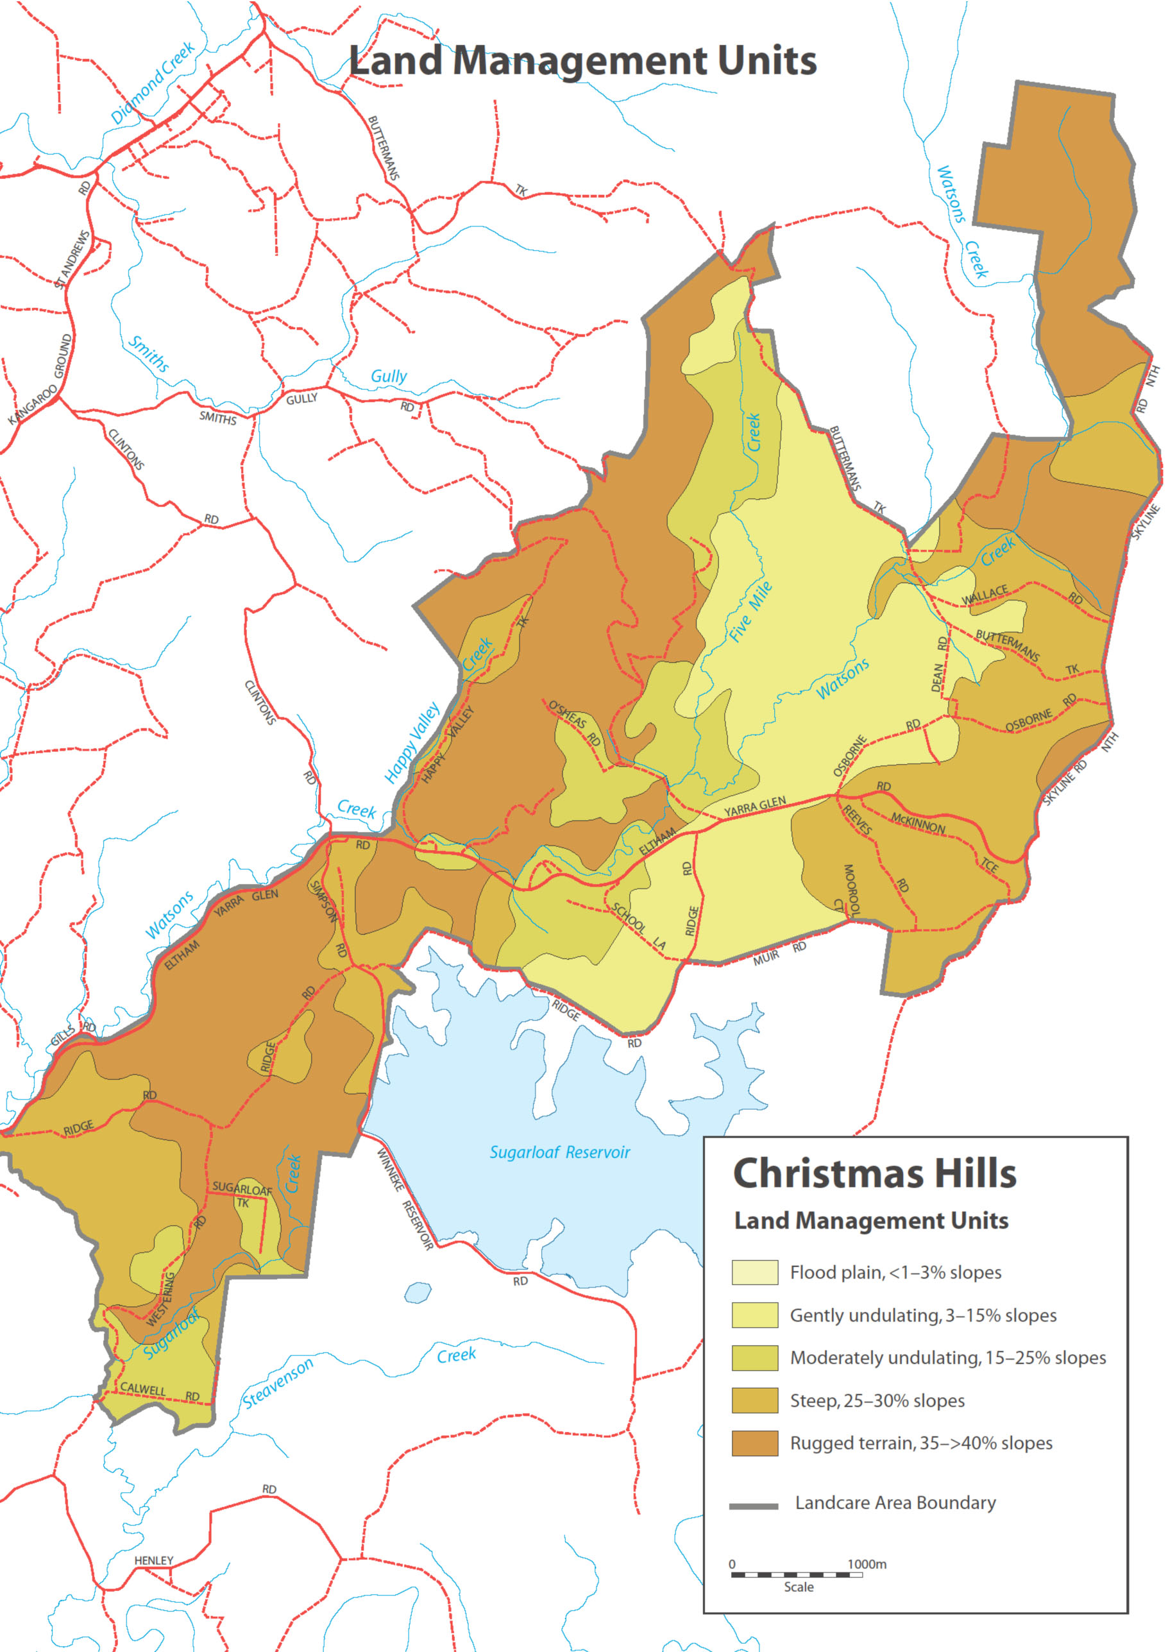

Agricultural land quality
This section expresses the degree of agricultural versatility and production potential across the Christmas Hills catchment in terms of five classes of agricultural land quality. It is important to note that this only provides a broad guide and should not be used to justify significant changes in land use.
Prior to undertaking any significant change to land use, or if you have only recently purchased your land, it is strongly recommended that you prepare a detailed land capability assessment of your land. This is best achieved as a component of a detailed ‘Property Management Plan’ (sometimes referred to as a ‘Whole Farm Plan’).
The Shire can assist landholders with the preparation of such plans. Figure 2 presents a five-class description of agricultural land quality across the Christmas Hills catchment and the map at Figure 3 depicts a broad special interpretation of this information. This mapping is largely based on slope classes and hence does not incorporate important components of land capability such as local hazards (e.g. known tunnel erosion), variation in remnant vegetation cover, aspect, soil type, soil moisture and the presence of minor drainage lines.
Figure 2 – Table: Agricultural land quality rating description
Class 1  Very high | Agriculturally versatile land, with high inherent productive potential because it has deep, permeable, friable, structurally resilient and fertile soils, a flat to gently undulating land form, and a growing season of up to 11–12 months under either natural rainfall or irrigation. It is suitable for intensive irrigated cropping and grazing.
Class 2  High | Agriculturally versatile land, although it requires more inputs to achieve the same productivity as Class 1. Slope is greater, soils are more variable, and the growing season is limited to 9–10 months, which may be extended to 12 months if irrigation water is available. It is suitable for high-production intensive cropping and grazing, and irrigation. .
Class 3 Moderate | Sound grazing land but limited in versatility. Generally unsuited to cropping due to steepness of slope, drainage limitations, lack of topsoil depth, weaker structure, poor water-holding capacity, or presence of rock. Fertility levels are moderate to low. Growing season may be limited to about 7-8 months due to dryness or wetness. With high inputs, moderate to high animal production may be achieved.
Class 4  Low | Land capable of supporting grazing under moderate to low stocking rates where clearing has occurred. Slopes are moderate to steep, with shallow infertile soils that need care. Fertility levels are generally low. High inputs may not be economical. Erosion hazard is high. Forest is often the best and most stable form of land use.
Class 5  Low | Land unsuited to agriculture. Constraints may be steepness of slope, shallow, sandy, or rocky soils, or high erosion susceptibility. Environmental stability may be best achieved by isolating areas and strictly controlling or eliminating agricultural land uses.

Figure 3 - Map Christmas Hills Agricultural Land Quality
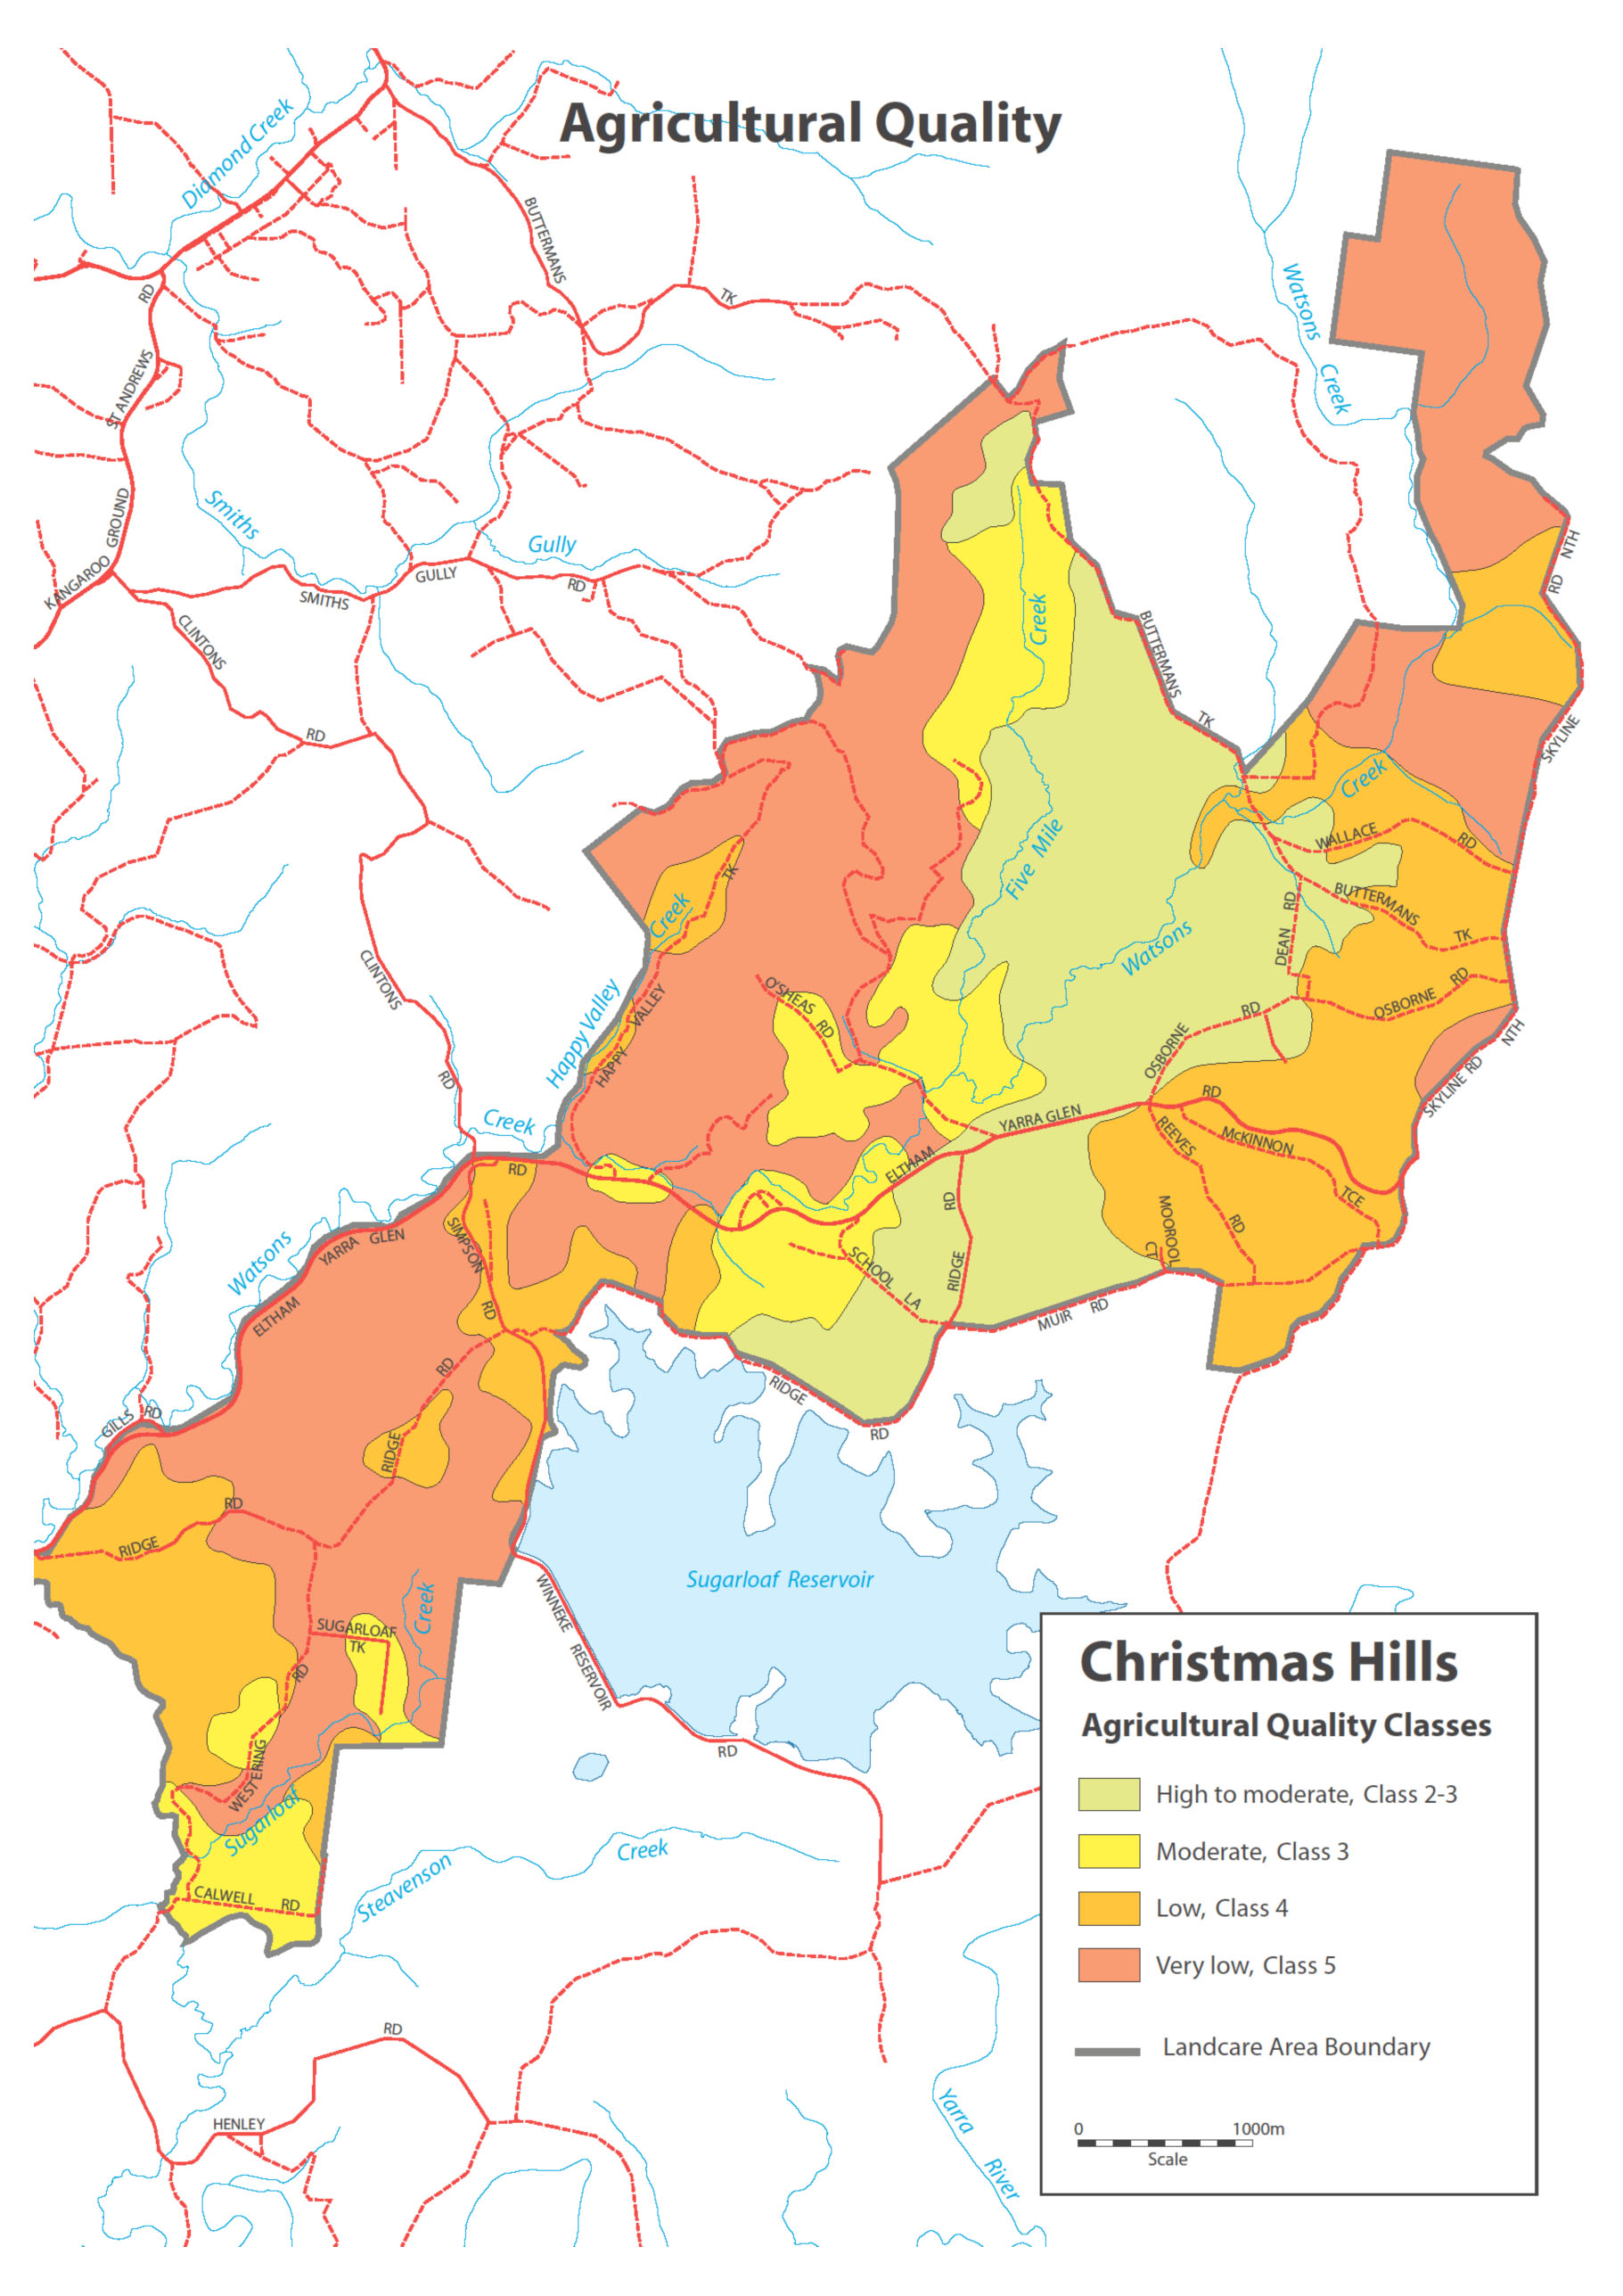
Source: Community Environmental Recovery Action Plan Christmas Hills Catchment

