# Fact Sheet - Dams and Waterways

This fact sheet provides information on how to manage dams and waterways on your property in Nillumbik

Water is a basic need for every living thing and a critical part of every ecosystem. Waterways and wetlands are themselves specialised ecosystems.

## Significant waterways

Nillumbik is a critically important water catchment area for greater Melbourne. There are three significant waterways in Nillumbik:

1. The Yarra River forms the southern boundary of Nillumbik, meandering alongside the Bend of Islands, Kangaroo **Ground and North Warrandyte.**
2. The Diamond Creek runs through the centre of Nillumbik, taking in the townships of Diamond Creek and Hurstbridge.
3. The Plenty River forms part of western boundary of Nillumbik and provides the water supply to Yan Yean Reservoir.

These waterways provide stock and domestic water, form important habitat links and are a recreation resource for current and future generations. (Nillumb**ik Biodiversity Strategy 2012).**

The Arthurs Creek, Running Creek and the Upper Diamond Creek all form the headwaters of the Diamond Creek. The Running Creek meets the Arthurs Creek at the township of Arthurs Creek and the Upper Diamond Creek joins the Arthurs Creek at Hurstbridge.

## Threats to our waterways

The presence and potential spread of weeds is the only major risk to the headwater areas.

Outside the Kinglake National Park, conditions in the creeks decline due to a change in land use. However, the creeks still support important species including freshwater blackfish, mountain galaxias and a breeding population of platypus.

While the continuity of streamside vegetation is one of the creeks’ environmental assets, weeds and stock access continue to pose a risk. Some areas of the creeks are popular for recreation and fishing.

The health of a waterway is closely linked to the surrounding land. Erosion, litter, increased runoff due to development, runoff containing pollution and trampling of soil and vegetation by people and livestock all place stress on waterways.

Water quality in a dam declines when soil from paddocks with inadequate groundcover is washed into it. This creates ideal breeding grounds for bacteria and algae. The water is then unpalatable to stock. Thick scum around the water’s edge may also prevent stock from reaching the water. While the water may not be fatally poisonous, it may still harm young and weak animals.

## What you can do

* Monitor water quality regularly. Measuring pH and salinity is not difficult and equipment is available at a reasonable cost so routine measurements should be part of your water quality management.
* Keep stock away from beds and banks of streams by providing watering points at a distance from them.
* Fence waterways with wildlife friendly fencing.
* Test water quality regularly so you know the overall health of your waterways and can identify any problems with them.
* Participate in the Healthy Waterways Waterwatch, water quality monitoring program for Diamond Creek, Arthurs Creek and their tributaries.
* Establish and maintain complete vegetation cover on the catchment area. Bare soil and patchy vegetation lead to erosion.
* Be careful to use fertiliser only where necessary. Obtain a soil analysis and seek professional advice before applying fertiliser. Some Landcare Groups in Nillumbik have soil testing kits available for loan. Do not spread fertiliser close to drainage lines and dams.
* Manage all stock so that manure, other wastes and run-off are carefully controlled and contained.
* Avoid cultivating steep slopes.
* Shade dams from sunlight by growing trees around them.

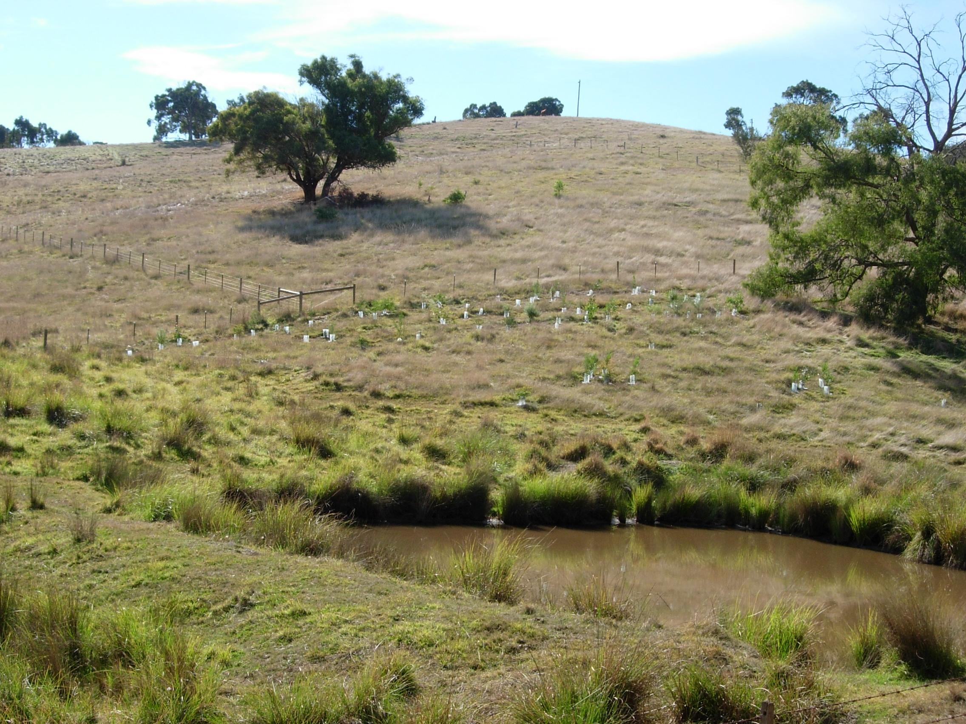

Caption: This image illustrates what you can do to improve water quality in your dam and in the connecting waterway. Grazing has been excluded from the area around the dam and there are many grasses and sedges surrounding the dam filtering sediments. There is revegetation upslope of the dam to provide shade.

Photo source: Tim O’Donnell

## Useful links

[Melbourne Water and Stream Frontage Management Program](http://www.melbournewater.com.au/)   
[Waterwatch Melbourne region](http://www.waterwatchmelbourne.org.au/)

[Yarra River Keepers Association](http://www.yarrariver.org.au/)

[Platypus information](http://www.platypus.asn.au/)

[Department of Economic Development, Jobs, Transport and Resources – Managing Dams](http://agriculture.vic.gov.au/agriculture/farm-management/managing-dams)

     St Andrews Landcare Logo 