Butterflies of Nillumbik
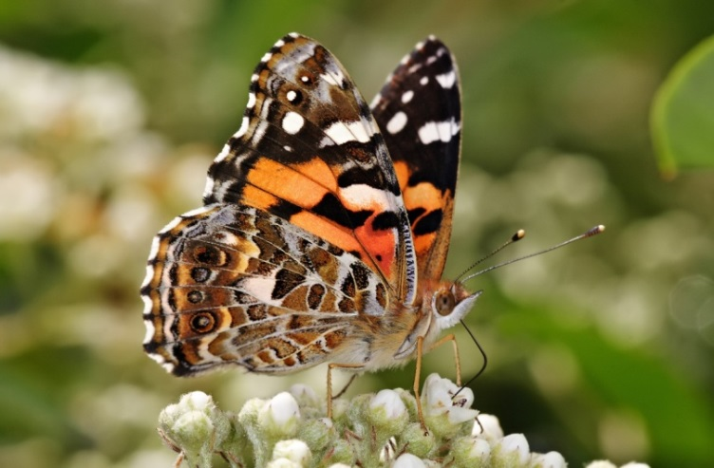 | Australian Painted Lady Vanessa kershawi  - Very common and widespread butterfly.  - Caterpillars feed on a range of indigenous and exotic daisies including thistles and Cape Weed.  - The main emergence is between October and December, but a second smaller flight season occurs from late January through February.
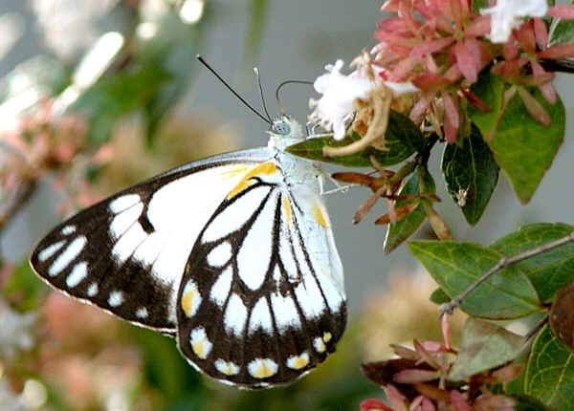 | Caper White Belenois java  - Migratory butterfly common in northern Australia  - The larvae of this species mostly feed  - on Capparis in northern Australia but adults often disperse south in large numbers.  - Often arrives in Victoria October-December.  - Limited breeding in Vic where larval food plants are grown in cultivation.
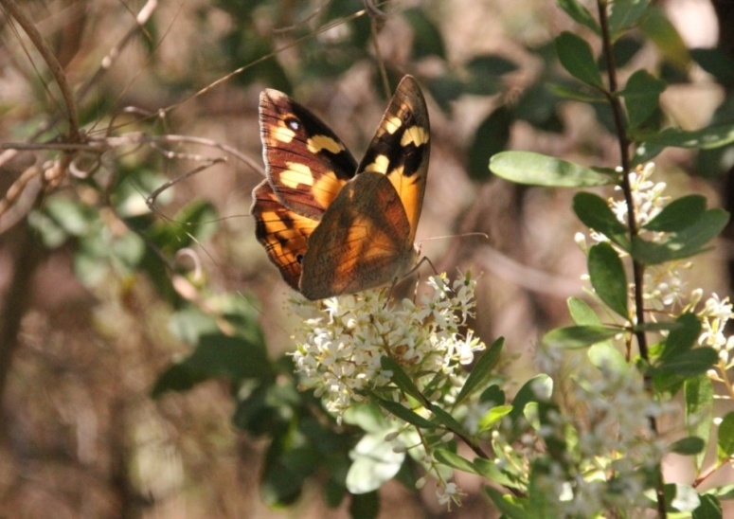 | Common Brown Heteronympha merope  - Common and abundant throughout Melbourne.  - The flight season is from October to May and varies between males and females, with males emerging and dying-off earlier.  - Females have been recorded remaining in diapause for several months before laying eggs as late as April.  - Caterpillars feed on a range of indigenous and introduced grasses including Kangaroo Grass,  - Weeping Grass Microlaena stipoides and Panic Veldt-grass.
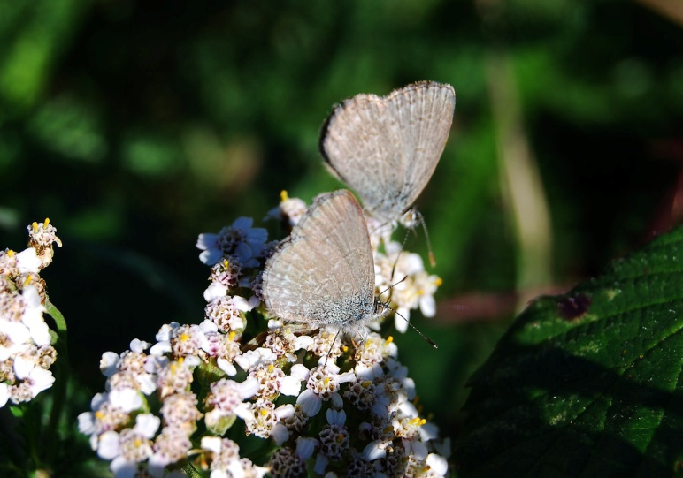 | Common Grass-blue Zizina labradus  - The most abundant and common butterfly throughout Nillumbik and surrounds.  - A long flight season and several generations annually.  - The larvae feed on a variety of indigenous and introduced legumes (Lucerne and garden beans) and are common in suburban gardens.  - Caterpillar occasionally tended by up to five attendant ants.
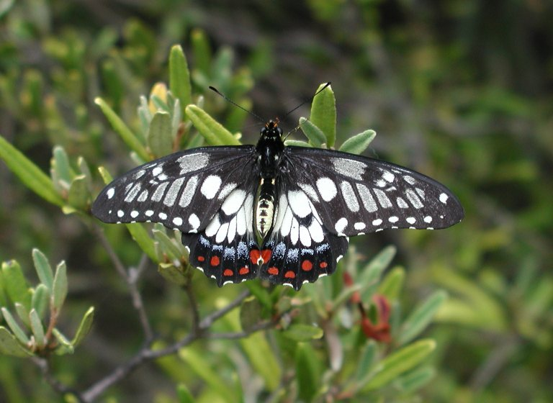 | Dainty Swallowtail Papilio anactus  - Occurs throughout Melbourne, particularly associated with citrus trees in suburban gardens.  - Has been observed breeding in a peppercorn tree Schinus molle at Candlebark (Yarra Valley Parklands).  - Several generations a year (particularly spring/summer)
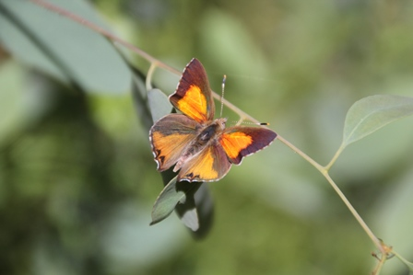 | Eltham Copper Butterfly Paralucia pyrodiscus lucida  - Host plant specific (Bursaria spinosa) and feeds at night  - Cannot survive without Epaulet ants (Notoncus spp.)  - Restricted distribution through Eltham and Greensborough  - Displays 1-2 generations/year, depending on location  - Adults fly November-March
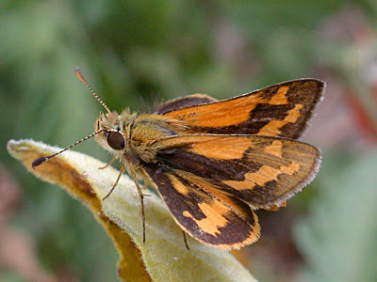 | Greenish Grass-dart Ocybadistes walkeri  - Small skipper common around Eltham  - Caterpillars feed on Dianella (Flax-Lily) and a range of widespread introduced grasses including Couch Grass ,Veldt-grasses  - and Prairie-grasses Bromus spp.  - Several generations a year  - Also known as Yellow-banded Dart.
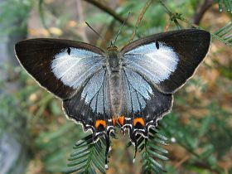 | Imperial Hairstreak (or Imperial Blue) Jalmenus evagoras  - Widespread but uncommon in Nillumbik.  - Caterpillars feed on young wattle species (mostly Black Wattle) and are attended by Iridomyrmex ants.  - The Imperial Hairstreak colonises stands of Acacia that are 2-3 year old (e.g. After planting and fire).  - In a good year they can have several generations between October and March.  - Also known as Imperial Blue.
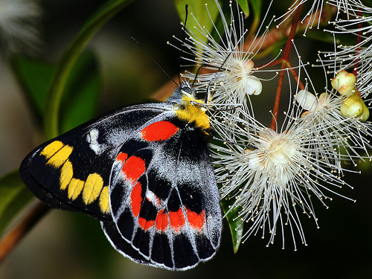 | Imperial Jezebel Delias harpalyce  - Caterpillars feed on Box Mistletoe Amyema miquelii.  - There are two main flight seasons that include August-November and January-April.  - The males are often seen hill-topping and patrolling the canopy.  - Also known as Imperial White.
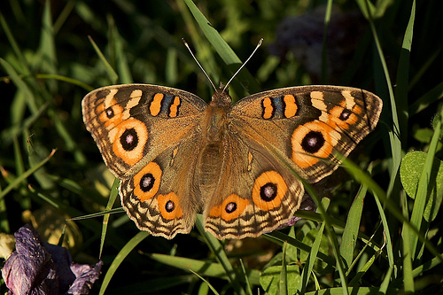 | Meadow Argus Junonia villida  - Common butterfly, particularly abundant in open grasslands, but also found in woodlands and gardens.  - Wide variety of food plants, particularly feeds on the widespread exotic Ribwort Plantago lanceolata.  - Adults feed on Chrysocephalum and other native daisies (Asteraceae).  - There is no pronounced flight season and individuals can be seen in any month between the beginning of September until the end of April, with several generations completed annually.
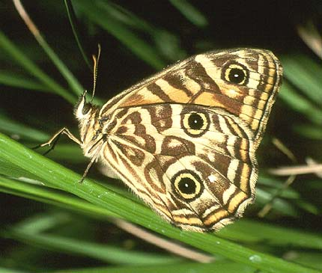 | Ringed Xenica Geitoneura acantha  - Very common around Eltham and surrounds.  - Caterpillars feed on a range of indigenous grasses including Kangaroo Grass, Grey Tussock-grass and Weeping Grass.  - Flies between late December to late February.  - Also known as Eastern Ringed Xenica
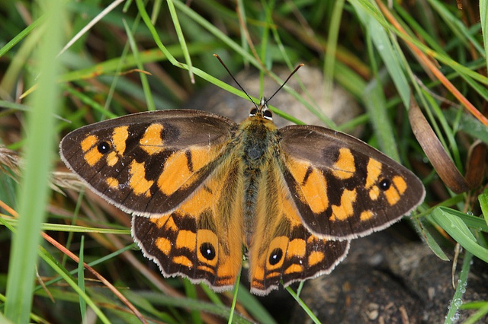 | Shouldered Brown Heteronympha penelope  - The Shouldered Brown is more common in high rainfall upland areas.  - In the local area the species is highly dependent on suitable moist gullies as the eggs are less resilient to dry weather than the other local browns.  - The favoured habitat in north-east Melbourne is relatively moist gullies with a high cover of native grass. Food plants are Kangaroo and Wallaby Grass.  - Adults most abundant in Feb-March
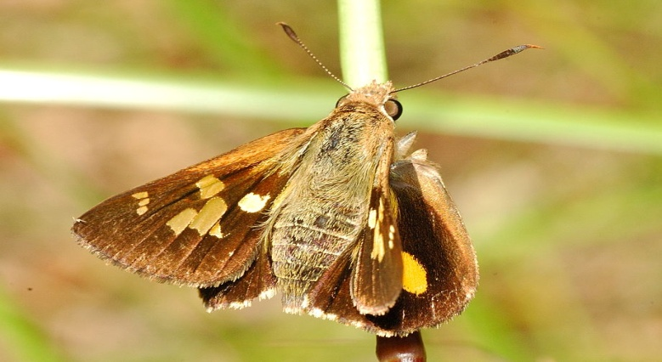 | Splendid Ochre Trapezites symmomus  - Seen at Woodridge Linear Reserve, Eltham  - Occurs at locations supporting the food plant, Spiny-headed Mat-rush Lomandra longifolia ssp. Longifolia  - The flight season is throughout autumn.
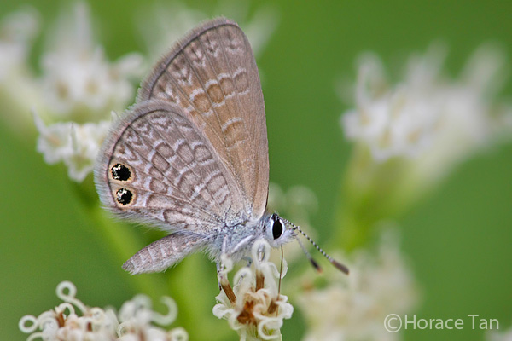 | Two-spotted Line-blue Nacaduba biocellata  - Caterpillars feed on small wattles, particularly Gold-dust Wattle Acacia acinacea, Spreading Wattle Acacia genistifolia and Golden Wattle Acacia pycnantha.  - The larvae feed on flower buds and ripening pods of these Acacias.  - Several generations completed annually.  - Now considered rare in Nillumbik because of drought years.  - One of Victoria’s smallest butterflies, it is also known as Double-spotted Line-blue.
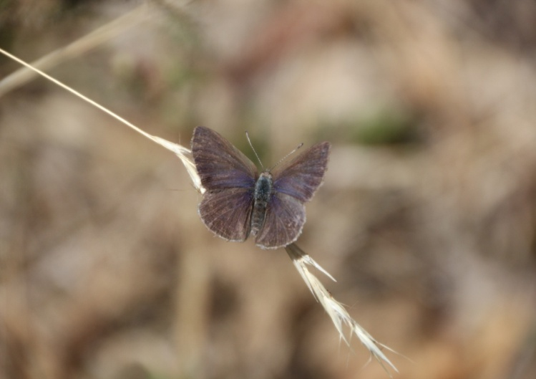 | Varied Dusky Blue Candalides hyacinthina  - The food plant Downy Dodder-laurel Cassytha pubescens or Coarse Dodder-laurel Cassytha melantha.  - Usually associated with The Eltham Copper Butterfly.  - Several generations completed annually.  - Occasionally has an attendant ant (Ochetellus), but can thrive without it
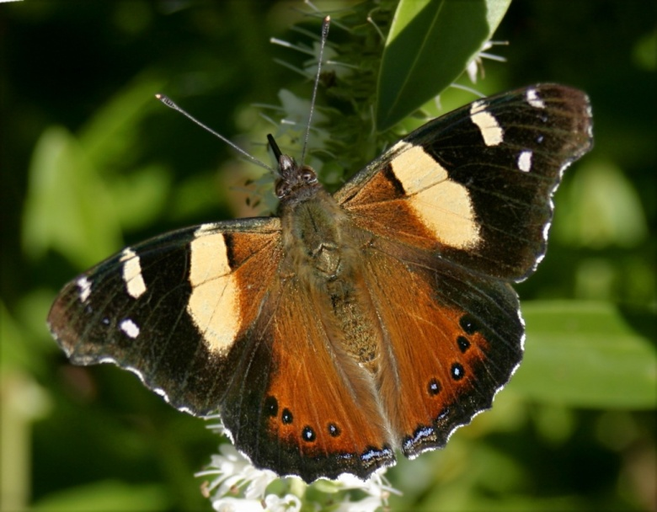 | Yellow Admiral (or Australian Admiral) Vanessa itea  - Very fast flying butterfly  - Caterpillars feed on indigenous and exotic Nettles Urtica spp.  - There is no pronounced flight season and individuals can be seen in any month between the beginning of October until the end of April.  - Common throughout Melbourne
Resources  - Museum Victoria- Phone App or website  http://museumvictoria.com.au/bioinformatics/butter  - Victorian butterflies and their food plants  http://www.viridans.com/butter/VBFP1.htm  - Butterflies: Identification and Life History (Ross Field) Museum Victoria Publ.  - Field Guide to Butterflies of Australia (Michael Braby) CSIRO Publ.  - Field Guides to the Insects of Australia (Paul Zborowski and Ross Storey) Reed new Holland publ.  - CSIRO Insects  http://www.ento.csiro.au/education/index.html | References  Michael Braby (2004). The complete field guide to the butterflies of Australia. CSIRO Publishing, Melbourne.  Karl Just (2014). Threatened Species Management Plan for the  Eltham Copper Butterfly Reserves. Prepared for Nillumbik Shire Council.  Andrea Canzano  aa.canzano@gmail.com

