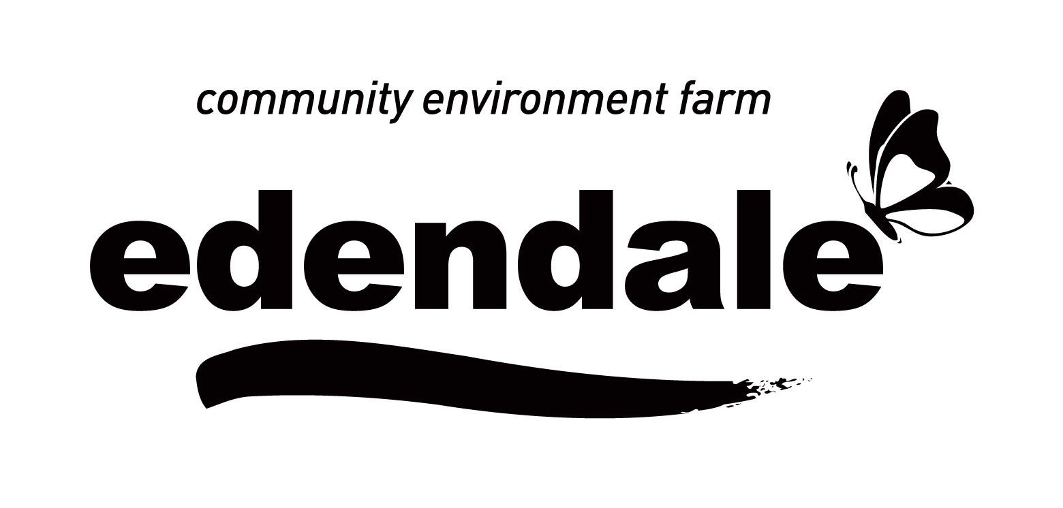Work experience/community work application form

Name:__________________________________Date Applying:_____________________
Email:___________________________________Phone Number:____________________
Date of Birth:_____________School____________________________________Year____
Work experience is for one week only, Monday to Friday. Please consult with your school work experience co-ordinator and provide TWO suitable dates so we can attempt to fit you in to our schedule. We do not offer work experience/community work during school holidays or our very busy times. You will need to be capable of doing physical work with animals and grounds/ gardens maintenance.
Preferred date for work experience OPTION ONE:__________________
Preferred date for work experience OPTION TWO:__________________
Please tell us why you want to come to Edendale for work experience:
____________________________________________________________________________________________________________________________________________________________________________________________________________________________________________________________________________________________________________________________________________________________________________________________________________________________________________________________________________________
Please tell us any experience you have had with animals:
________________________________________________________________________________________________________________________________________________________________________________________________________________________________________________________________________________________________________________________
How would you describe your capabilities with animals? For example: have you ever received instruction in approaching and/or handling animals (large or small) or in ‘reading’ animal behaviour?
__________________________________________________________________________________________________________________________________________________________________________________________________________________________________________
Are there animals in whose presence you don’t feel comfortable or confident?
___________________________________________________________________________________________________________________________________________________________
Do you have any allergies to any animals (e.g. fur, saliva) or feed (peanuts, wheat, grasses, hay etc.)?
____________________________________________________________________________________________________________________________________________________________
Have you ever been injured by an animal? (IF YES: what caused the incident, and how did you react? What would you do to prevent such an incident from happening again?)
____________________________________________________________________________________________________________________________________________________________
How do you feel about working independently, with minimal supervision? This would only happen after you have been trained properly.
____________________________________________________________________________________________________________________________________________________________
Have you any limitations or do you see any challenges? This information is needed so that we can plan your jobs on the farm.
__________________________________________________________________________________________________________________________________________________________________________________________________________________________________________
Is there any other information you think could be relevant in assessing your suitability?
__________________________________________________________________________________________________________________________________________________________________________________________________________________________________________
Please either:-
Deliver to Edendale Reception
Mail to Work Experience Officer
Edendale Community Environment Farm
30 Gastons Rd
Eltham, VIC, 3095
Scan and email to edendale@nillumbik.vic.gov.au

A member of staff will contact and let you know if there is an available placement for you. If there is a place you will need to come in for an interview and site tour. Upon successful completion of the requirements you will be offered a place and we will then require all paperwork to be completed as soon as possible.
Privacy notification - The personal information requested on this form is being collected by Council for the purpose of determining the suitability of the applicant for a work experience or community placement position. This information will be used solely by Council for this primary, or directly related, purpose. The applicant understands that the personal information provided is for this purpose and that they may apply to Council for access to and/or amendment of the information.

