Indigenous Plant Nursery
Plant Species List

Current Stock Available
Updated 23 April 2020

The following plant list contains the local native plants that
we currently have in stock from the Edendale Indigenous Plant Nursery.

edendale.nursery@nillumbik.vic.gov.au | Phone (03) 9433 3703
30 Gastons Road, Eltham VIC 3095

TREES
 | Species | Common Name | Size (H x W) | Description
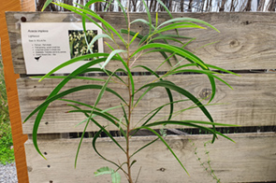 | Acacia implexa | Lightwood | 5 – 15m x  4 – 7m | Fast growing upright tree with cream flowers Jan-Oct. Full sun-semi shade. Tolerates wet or dry. Good erosion control.
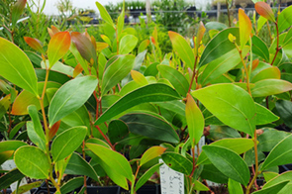 | Acacia pycnantha | Golden Wattle | 3 – 10m x  2 – 5m | Small tree with golden flowers Jul-Oct. Full sun – semi shade. Very hardy. Australian floral emblem.
TALL SHRUBS
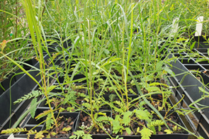 | Acacia mucronata | Narrow-leaf Wattle | 2 – 6m x  2 – 5m | Upright or spreading shrub with yellow flowers Aug-Oct. Quick growing. Full sun – semi shade. Moister soils. Drought resistant after established. Bird attracting.
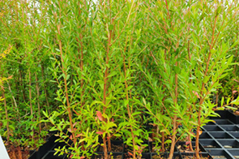 | Leptospermum lanigera | Woolly Tea-tree | 2 – 6m x  1 – 3m | Dense shrub. Masses of white flowers Sep-Jan. Full sun-semi shade. Moist soils. Regular pruning encourages bushiness.
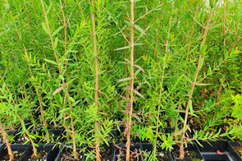 | Melaleuca ericifolia | Swamp Paperbark | 2 – 9m x 3m | Erect open shrub or small tree with cream flowers in spring. Responds well to pruning and requires moist to wet soils in full sun to part shade. Great for bees, birds.
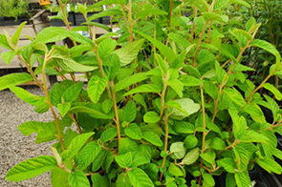 | Pomaderris aspera | Hazel Pomaderris | 3 – 12m x  2 – 4m | Mid storey shrub or small tree requiring moist, well-drained soil and part to full shade. Yellow flowers from Oct-Dec great for bees and other insects.
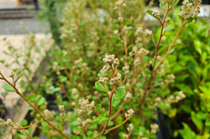 | Pomaderris vacciniifolia | Round-Leaf Pomaderris | 1 – 4m | Requires full sun to part shade with moist, well drained soil. Prune to keep compact. Small sprays of cream flowers in spring attract bees and other insects.
MEDIUM SHRUBS
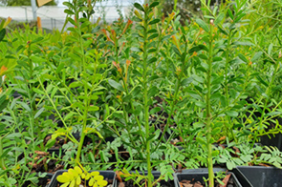 | Acacia acinacea | Gold Dust Wattle | 0.5 – 2.5m x  2 – 4m | Hardy shrub with massed yellow flowers in Aug-Nov. Dry to moist soils. Good bird habitat.
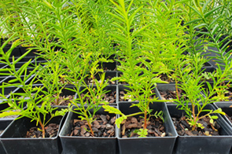 | Acacia genistifolia | Spreading Wattle | 1 – 3m x  1 – 3m | Open shrub with pale yellow flowers Jan-Oct. Full sun – semi shade. Fast growing. Prickly. Good small bird habitat.
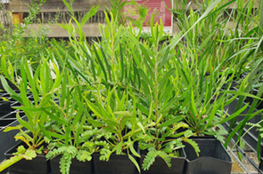 | Acacia lanigera | Woolly Wattle | 0.3 – 2m x  1 – 3m | Open shrub with yellow flowers Aug-Oct. Full sun – semi shade. Rocky and clay soils. Good under established trees. Hardy.
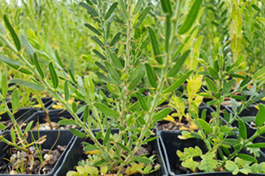 | Acacia paradoxa | Hedge Wattle | 2 – 4m x  2 – 5m | Fast growing dense shrub with yellow flowers Aug-Nov. Full sun-semi shade. Dry to moist well drained conditions. Good bird habitat.
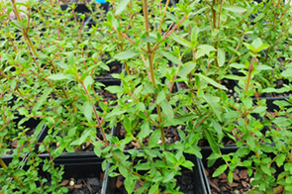 | Coprosma quadrifida | Prickly Currant Bush | 2 – 4m x  1 – 1.5m | Open shrub with small greenish flowers Sep-Jan, small edible berries Jan-Mar. Semi shade – full shade. Moist well drained soil.
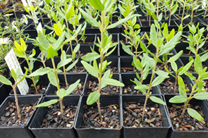 | Correa glabra | Rock Correa | 1 – 3m x  1 – 3m | Dense to spreading shrub with bell shaped green flowers May-Aug. Full sun to full shade. Well drained soil. Hardy.Good screen. Pruning beneficial. Bird attracting.
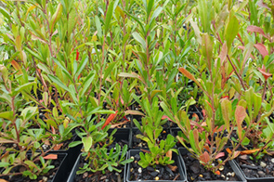 | Dodonaea viscosa | Wedge-leaf Hop Bush | 1 – 3m x  1 – 3m | Spreading shrub with inconspicuous flowers Aug-Nov. Showy red brown seed capsules. Ful sun – semi shade. Very hardy. Good for hedging and screening.
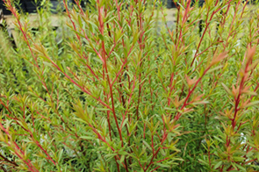 | Kunzea leptospermoides | Burgan | 2 – 5m x  2 – 4m | Dense weeping shrub with masses of white flowers Nov-Jan. Fast growing. Good for hedging and screening. Tolerates hard pruning.
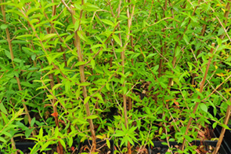 | Leptospermum continentale | Prickly Tea-tree | 1 – 4m x  1 – 2m | Fast growing dense shrub with yellow flowers Aug-Nov. Full sun-semi shade. Dry to moist well drained conditions. Good bird habitat.
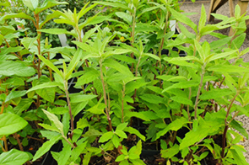 | Olearia lirata | Snowy Daisy Bush | 2 – 5m x  2 – 3m | Great for sheltered spots in part to full shade and moist soils. Beautiful insect-attracting daisy clusters from Sept-Dec. Prune after flowering.
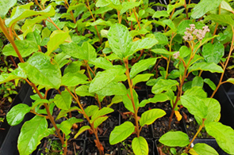 | Pomaderris elliptica | Smooth Pomaderris | 1–4m x 1–3 m | Tall erect or rounded shrub suitable for partly shaded areas with moist, well-drained soils. Clusters of yellow flowers in spring are great for attracting insects.
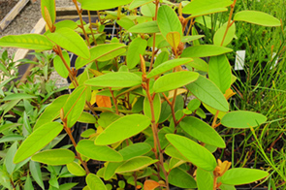 | Pomaderris lanigera | Woolly Pomaderris | 1 – 3m x  1 – 2m | An attractive low screening plant with appealing foliage and flowers. Full sun to part shade with moist, well-drained soils. Large clusters of yellow flowers in spring. Insect attracting.
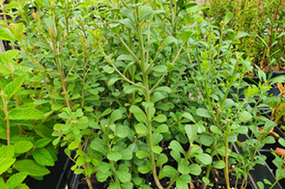 | Pultenaea daphnoides | Large-leaf Bush Pea | 1 – 3m x  0.5 – 2m | Erect branching shrub with pea flowers from Aug-Nov. Full sun to full shade in well-drained soil, and prefers extra water in summer if in full sun.
SMALL SHRUBS
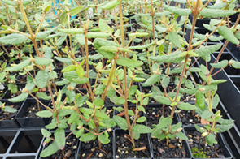 | Correa reflexa | Common Correa | 0.3 – 2m x  1 – 2m | Dense to open shrub with bell shaped red (sometimes green) flowers May-Aug. Full sun to semi shade. Well drained soil. Pruning beneficial. Bird attracting.
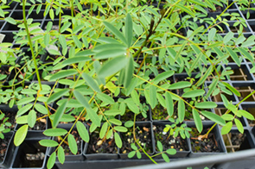 | Indigofera australis | Austral Indigo | 1 – 2m x  1 – 2m | Open spreading shrub with sprays of mauve/pink pea flowers Sep-Nov. Full sun to full shade. Well drained soil. Will benefit from moisture. Pruning beneficial to maintain bushiness.
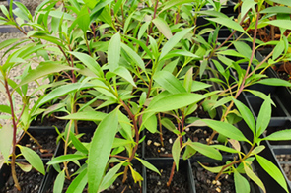 | Myoporum petiolatum | Sticky Boobialla | 0.5 – 2 m x  1.5 – 2m | Dense, hardy shrub with pretty white flowers. Ideal for drier areas in well-drained soils and full sun. Great for birds.
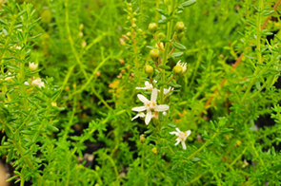 | Olearia ramulosa | Twiggy Daisy Bush | 0.5 – 2.5m  x 1m | Dense, branching shrub with sprays of white flowers from Sept-May. Requires semi-shade and well drained soils.
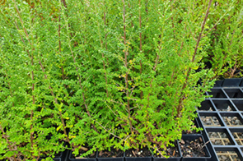 | Ozothamnus obcordatus | Grey Everlasting | 1 – 2m x  1m | An attractive, hardy shrub great for difficult spots. Dry, well-drained soil in a full sun or part shade position. Bright yellow umbels from Oct-Jan.
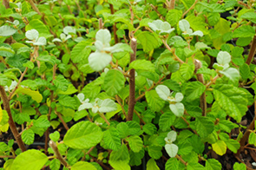 | Spyridium parvifolium | Australian Dusty Miller | 1 – 2m x  1 – 2m | Attractive, dense foliage shrub with ‘dusted’ tips. Great for part to full shaded spots in well-drained soils. Flowers from July-Nov.
RUSHES & SEDGES
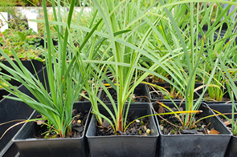 | Lomandra filiformis | Wattle Mat Rush | 0.15 – 0.5m x 0.15 – 0.2m | Grey-green strappy tussock with stems of yellow flowers at base in Oct-Nov. Full sun-semi shade. Moist well drained sites. Will tolerate dry shade once established. Good landscape and rockery plant. Good butterfly food.
GRASSES
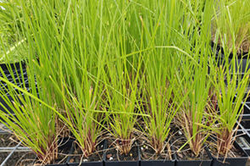 | Poa ensiformis | Purple-sheath Tussock Grass | 0.3 – 0.75m  x 1m | Large tussock grass great for erosion control and habitat. Requires part to full shade and moist soils. Rejuvenates from hard pruning.
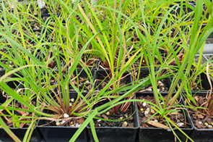 | Themeda triandra | Kangaroo Grass | 0.4m x 0.75m | Attractive erect or sprawling tussock suitable in full sun or shade. Flowers from Sept-Feb and is great for butterflies. Requires moist soils (except waterlogged).
LILIES & HERBS
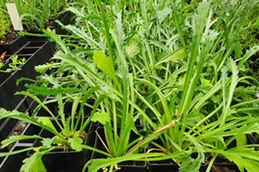 | Brachyscome diversifolia | Tall Daisy | 0.2 – 0.5m high | Perennial herb with large white daisy flowers Oct-Feb. Full sun-semi shade. Well drained soils.
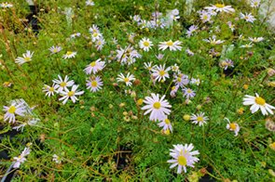 | Brachyscome multifida | Cut Leaf Daisy | 0.1–0.4m x 0.2–1m | Low, suckering, dense groundcover with mauve/white flowers Sep-April. Full sun-full shade. Moist clay soil – tolerates dryn once established. Good for borders, rockeries and pots.
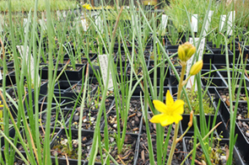 | Bulbine bulbosa | Bulbine Lily | 0.2 – 0.6 x 0.3m | Bulbous yellow lily with edible tuber. Moist clay soil – tolerates dryness once established. Good for borders, rockeries and pots. Plants die back to rootstock in dry weather and will regenerate with additional watering.
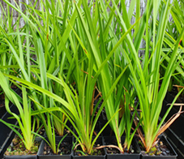 | Dianella laevis (longifolia) | Smooth Flax Lily | 0.3 x 0.8m x 0.5m | Strappy leaved plant with stems of purple flowers Sep-Jan. Moist to dryish well drained clay. Full sun – semi shade. Attractive rockery/container/border plant. Grows well next to trees. Good soil stabiliser. Bee attracting. Koorie use.
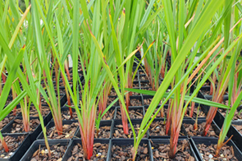 | Dianella revoluta (admixta) | Black Anther Flax Lily | 0.3 – 1m x  0.5 – 2.5m | Grey-green leaves and stems of purple flowers Oct-Jan. Full sun – semi shade. Hardy. Attractive rockery plant. Grows well in drier areas. Bee attracting. Koorie use.
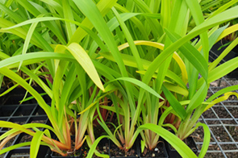 | Dianella tasmanica | Tasman Flax Lily | 0.6 – 1.5m x 0.5 – 2m | Strappy leaved plant with stems of purple flowers Oct-Feb. Moist soils. Semi shade – full shade. Tolerant once established. Will spread into clumps.
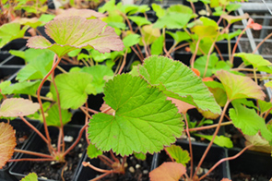 | Pelargonium australe | Austral Stork’s-bill | 0.3 - 0.6m x 0.5 - 1m | Attractive herb for full sun-part shade areas. Moist well-drained soils with pink-white flowers from Oct-Feb. Older leaves turn a beautiful red-orange.
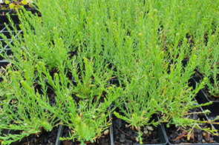 | Rhodanthe anthemoides* | Chamomile Sunray | 0.2 - 0.3 m x 20-60 cm | Perennial herb with white paper daisy flowers from Sep-Feb. Requires full sun to part shade in well-drained soil, great for butterflies.
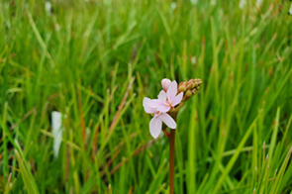 | Stylidium armeria | Thrift-leaved Trigger Plant | 0.2-1m x  20-40cm | Grass-like herb with beautiful pink spike of triggering flowers. Full sun-part shade in moist soils, tolerating dry and wet periods once established. Great for rockeries.
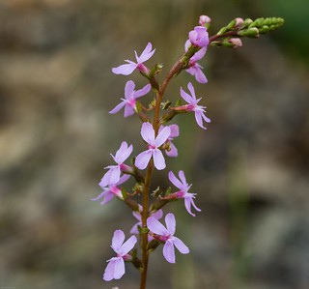 | Stylidium graminifolium | Grass Trigger Plant | 0.2 – 0.6m x 0.2 – 0.3m | Grass-like herb with beautiful pink spike of triggering flowers. Full sun-part shade in moist soils, tolerating dry and wet periods once established. Great for rockeries.
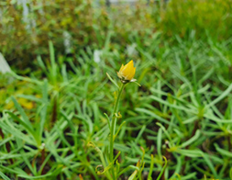 | Xerochrysum viscosum | Sticky Everlasting | 20 – 90 cm x 0.3 – 1 m | Erect herb with vibrant yellow paper daisies from Aug-April. Full sun-part shade in well-drained soil. Prune after flowering. Great cut flower, attracts butterflies.
GROUNDCOVERS & CLIMBERS
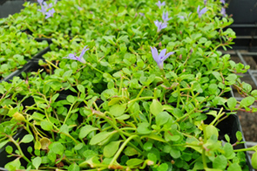 | Isotoma fluviatilis | Swamp Isotome | Prostrate x 1m | Dense matting groundcover with small rich blue flowers Oct-Nov. Full sun- semi shade. Moist to seasonally wet areas. Good for damp areas and frog bogs.
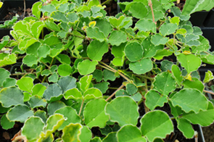 | Kennedia prostrata | Running Postman | 0.1 – 0.3m x 0.3m | Open trailing or densely matted groundcover with red pea flowers Aug-Dec. Full sun-smi shade.Well drained soils.
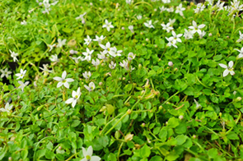 | Lobelia pedunculata  (Syn. Pratia pedunculata) | Matted Pratia | Prostrate x  2 – 3m | Dense matting herb with profuse white star flowers from Oct-Feb. Moist to wet soils in full sun to full shade. Great for rockeries or around paving.

* These species are from Greater Melbourne Area not Nillumbik Shire

