Weed mapping and monitoring
Control of weeds is rarely simple. Often land managers need to manage a number of weed species over a number of years, with competing priorities.
Developing weed maps and monitoring changes over time allows land managers to plan and implement an effective strategy.
This fact sheet outlines what you should think about when planning weed control, mapping weed locations and using ‘photopoints’ (explained below).
Weed control cycle:

Planning weed control
If you have several weed species on your property that may take years to control, planning is essential.
The best plans constantly evolve based on the outcome of control works and changes in weed cover.
Weed mapping and monitoring are important throughout the cycle of planning, undertaking and reviewing control works.

To plan weed control
- Identify the areas affected by weeds on your property; for example, bushland areas, agricultural areas or garden beds. It is useful to mark these on a map. Each of these areas may have different weeds and different priorities for control. Start weed control in the best areas (e.g. the highest quality bushland).
- Make a list of which weeds you want to control based on your priorities for management (weed threat, vegetation type, slope, ease of control, threatened species, cost).
- For each weed:
- Set a goal (e.g. to remove all blackberry in bush area and reduce blackberry to less than 5 per cent cover on rest of property)
- Choose appropriate control methods
- Plan the actions you need to take each year to achieve your goal
- Check that you have the suitable licences, equipment and herbicides to control the weeds. Landcare groups regular offer subsidies to gain the Agricultural Users Permit.
- Each year, record the actual actions completed. Keeping a good record allows you to develop a site history and cost and plan future works.
- Review the plan each year based on the weed control achieved and changes in weed mapping.
Note: You are legally required in Victoria to keep records of chemicals used, according to the Department of Economic Development Jobs Transport and Resources (DEDJTR) standards. For more information, visit the DEDJTR website.

Weed mapping
Weed mapping is important to see changes over time and the impact of control works.
Here is a simple method.
- Make a list of weeds you want to map, generally those you want to control or are concerned about.
- Get a map of your property. You may need several copies depending on the number of species you want to map.
Options include:
- Property plans
Mapping sites on the internet, such as DELWP Interactive Maps, Google Maps and NearMap
- Sketching your property with relevant features, e.g. fence lines, houses, bushland and so on.
- Mark the extent of all priority weed infestations on your map and record:
- Date
- Common name
- Scientific name
- Cover (Trace <1%, Light 1-10%, Medium 11-50%, Dense >50%)
- Age class for woody weeds (Seedlings, Juveniles, Mature, Resprout)
- Comments
- Control method (if controlling weeds at the same time).
Make sure there is a reference to the weed location on the map in your record about the weed infestation.
- Update weed mapping annually or as required.
A weed map (example only):
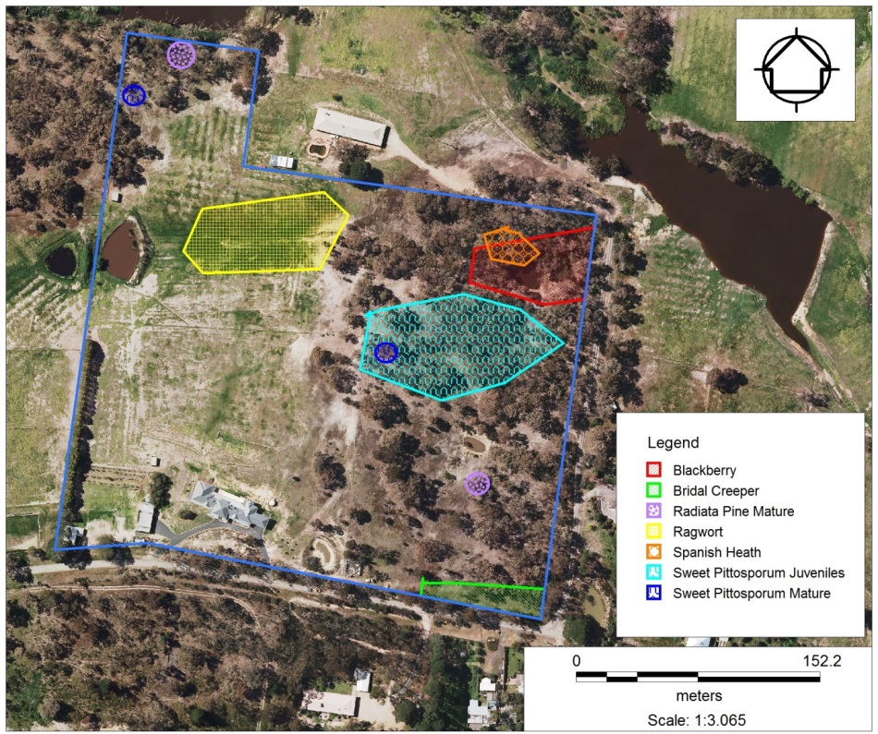

Photopoints
Photopoints provide a visual record of changes over time. By taking photos at one place over several years you can see visual changes in weed cover and the condition of native vegetation.
There are many internet resources that provide advice on where to place photopoints, how to use them and how to take the photos, in particular, DSE’s Bush Tender Photopoint Monitoring.
When setting up a photopoint, make sure you mark the location clearly on a map or with a durable marker so you can easily relocate the point for a repeat photo.
Record:
- Date
- Time
- Description of location of point
- Direction (North, East, etc.)
- Description of photo
- Comments
Example a photopoint (growth of grassy weeds before a wet year):
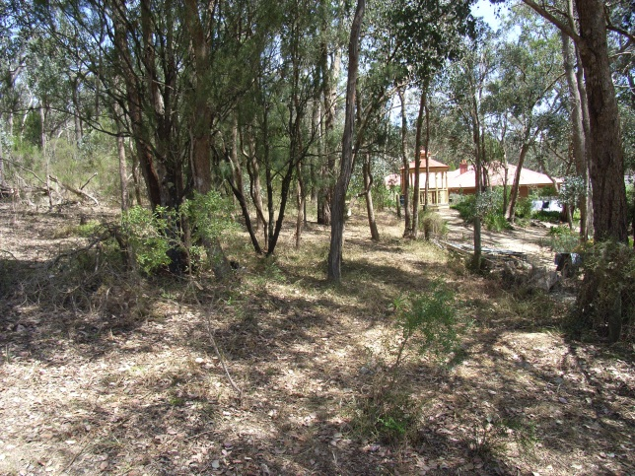
Example of a photopoint (growth of grassy weeds after a wet year):
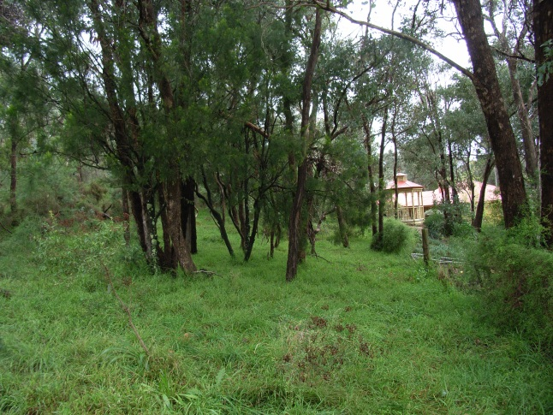

Useful links
DELWP Interactive Maps
NearMap
Department of Economic Development Jobs Transport and Resources
Google Maps

