## Nillumbik Conservation Corridors

Nillumbik’s Conservation Corridors seeks to engage the local community to protect and improve habitat for a range of threatened plants and animals in the Shire. Support and assistance will be provided for on-ground and coordinated management works including weed control, pest animal control, fauna monitoring and biodiversity enhancement. This will allow the local community to continue to take action to reverse the decline of significant populations of threatened species and to conserve, maintain and enhance biodiversity in our unique and important area.

Nillumbik’s Landcare groups from Cottles Bridge, Dunmoochin, Arthurs Creek, Strathewen, St Andrews, Christmas Hills, Smiths Gully, Bend of Islands, and North Warrandyte Osborne Peninsula, and Queenstown Cemetery Friends of group have been successful in receiving funding for this project from the Department of Sustainability and Environment under the Communities for Nature grants program.

For further information, we encourage you to contact your local Landcare group or Julia Franco (Biodiversity Officer) at Nillumbik Shire Council on 9433 3328.

Brush-tailed phascogale - vulnerable in Victoria

Above: Brush-tailed phascogale - vulnerable in Victoria

Common Dunnart - vulnerable in Victoria

Above: Common Dunnart - vulnerable in Victoria

Charming Spider-orchid - endangered in Australia and Victoria

Above: Charming Spider-orchid - endangered in Australia and Victoria

Rosella Spider-orchid - endangered in Australia and Victoria

Above: Rosella Spider-orchid - endangered in Australia and Victoria

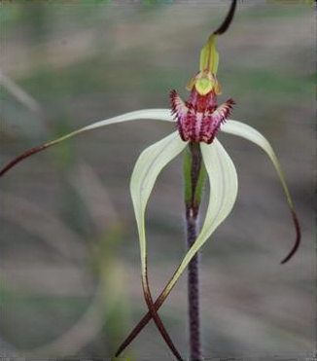

Above: Wine lipped Spider-orchid - vulnerable in Victoria

Communities for Nature and Department of Sustainability and EnvironmentNillumbik Shire Council